Whole School Mental Health and
Emotional Wellbeing
Audit tool
for
Mental Health Champions Plus (MHC+) Schools

November 2021

Produced by Bradford Mental Health Champions Team,
based on a document written by Kerry Clarke (Public Health), Tracey Williams (Educational Psychology, Brighton & Hove) and Dr. Pooky Knightsmith (Charlie Waller Memorial Trust)

Introduction
The emotional, mental health and wellbeing of Children and Young People (CYP) is as important as their physical health and wellbeing. Over recent years it has been recognised that changes need to be implemented to mental health services for CYP to identify CYP’s needs early and enable them to access timely, appropriate mental health services that support them to build resilience.
Mental health problems in CYP can result in lower educational attainment, poor physical health, poor social relationships, school exclusion and limited future employment prospects as well as behaviours such as smoking, using drugs and drinking alcohol. The impact of improving emotional wellbeing and mental health is seen at an individual and family level:
- 1 in 10 children have a diagnosable mental health disorder – that’s roughly 3 children in every classroom.
- 1 in 5 young adults have a diagnosable mental health disorder.
- Half of all mental health problems manifest by the age of 14, with 75% by age 24.
- Almost 1 in 4 children and CYP show some evidence of mental ill health (including anxiety and depression).
- Suicide is the most common cause of death for boys aged between 5-19 years, and the second most common for girls of this age.
- 1 in 12 CYP self-harm at some point in their lives, though there is evidence that this could be a lot higher. Girls are more likely to self-harm than boys.
Key stats: Young Minds 2017

The Mental Health Champions approach aims to develop skills and knowledge in schools and to work with schools and key partners to help CYP to be resilient and mentally healthy. This audit is intended to help educational settings identify ways in which they can improve mental health/emotional wellbeing provision.
Moreover, it is hoped that improvements in provision as a result of action planning and implementation will justify the continued commissioning of the project.

Key principles
The audit is based on eight key principles for emotional, mental health and wellbeing as recognised by Public Health England:
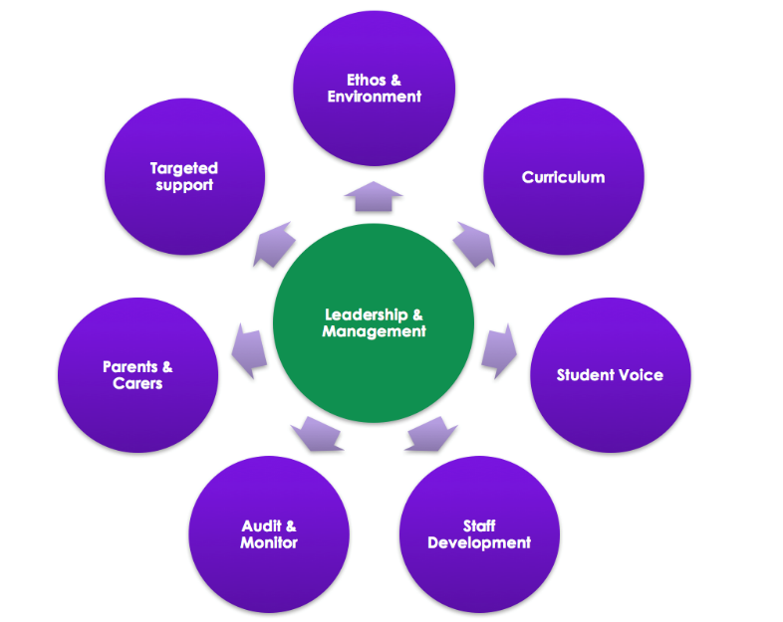

1. Leadership & Management:
We aim that every school in Bradford will have leadership and management that support efforts to promote emotional, mental health and wellbeing.

2. Ethos & Environment
We aim that every school in Bradford will have an ethos and environment that promotes respect and values diversity

3. Curriculum, teaching & learning
We aim that every school in Bradford will have curriculum, teaching and learning for CYP that promotes resilience and support social and emotional learning.

4. Student (CYP) Voice
We aim that every school in Bradford will enable student voice to influence decisions.

5. Staff Development
We aim that every school in Bradford will have staff development to support their own wellbeing and that of CYP

6. Audit & Monitor
We aim that every school in Bradford will identify need and monitor impact of interventions.

7. Parents & Carers
We aim that every school in Bradford will develop positive relationships with parents and carers

8. Targeted support
We aim that every school in Bradford is able to identify CYP at risk or with mental health/emotional wellbeing issues, and gain consent to access the appropriate emotional wellbeing and mental health intervention suitable to their needs.

How the audit works
The audit tool is comprised of 3 phases, an initial self-evaluation, an action planning and implementation phase, then a review of the initial evaluation in light of changes made:
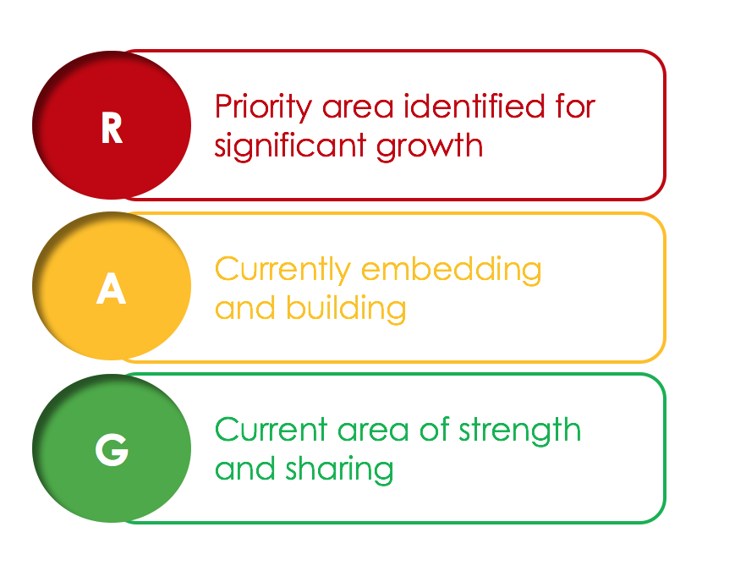
Phase One: School Self-Evaluation:
The process will begin with the school completing the self-evaluation.

Schools will RAG rate (see Figure 2) on each of the key elements.

It is likely that all schools will have elements of red, amber and green within their self-evaluation.

Phase two: developing an action plan
The self-assessment will provide a broad overview and a starting point for development of a School Action Plan.
The action plans will be simple documents showing suggested steps against each of the eight core elements and showing clear priorities for development.
It is recognised that each school should have a clear focus and there is an expectation that no school will target more than four areas at one time. Leadership and management goals will always form the backbone of any current planning. We recommend this graduated approach is adopted and builds on the strengths identified in the self-assessment.

Phase three: Review
Schools will repeat the RAG ratings at the end of the year. If action planning and implementation has been successful, at least some ratings will be improved.
Results will be fed back to the MHC Team and, in turn, Commissioners for the project, in order to justify continued funding for the project.

Self-evaluation

Name of School:

Date of initial evaluation:

Staff members completing the evaluation:

Date of review:

Staff members completing the review:

(We suggest you use the same document for the initial evaluation and the review, and identify which is which by colour coding or dating your responses)

1. Leadership & Management:

How is the school providing visible senior leadership for emotional, mental health and wellbeing? | Red | Amber | Green
1.1 Your setting has a named member of staff from SLT with overall responsibility for emotional, mental health and wellbeing.
1.2 The school/setting has a named Governor for SEMH
1.3 Named lead for school has regular communication with named Mental Health Champion.
1.4 All staff know how and when to report child/young person mental health/emotional wellbeing concerns to appropriate member of SLT (or designated lead)
1.5 MH and EW is included in improvement plans, policies, systems and activities.

Prompts if required:
- Can everyone in the school community – CYP, staff, parents, external agencies, etc. – identify the SEMH lead(s)?
- Does everyone in the school community know how to raise concerns about SEMH?
- Whole school approach is shared with and bought into by the senior leadership team?
- Are there clear information sharing pathways with other relevant professionals, enabling joint planning and response to care plans?

2. Ethos & Environment

How does the school or college’s culture promote respect and value diversity? | Red | Amber | Green
2.1 Mental Health and emotional wellbeing considerations are strongly embedded into the school ethos.
2.2 CYP are actively encouraged to form and maintain healthy relationships.
2.3 Specific and planned opportunities to develop empathy and interpersonal skills are provided.
2.4 Information about ways to find support is visible and easily accessible to all.
2.5 The school/setting has ongoing, visible anti-stigma work

Prompts if required
- Is the school a kind and welcoming place?
- Does everyone in the school community feel safe and have a sense of belonging?
- Do they feel supported and know how to access additional support if they need it?
- Are emotions and mental health talked about openly and freely?

3. Curriculum, teaching & learning

What focus is given within the curriculum to social and emotional learning and promoting personal resilience, and how is learning assessed? | Red | Amber | Green
3.1 Opportunities exist to develop and promote social and emotional skills through dedicated PSHE lessons.
3.2 Mental health/emotional wellbeing lessons are practical and relevant for pupils and encourage them to adopt emotionally healthy habits.
3.3 CYP are taught about mental health and stigma.
3.4 PSHE curriculum is clearly outlined on school website
3.5 Key staff have been trained in how to teach difficult topics safely and sensitively

Prompts if required:
- Are sources of support signposted in relevant lessons?
- Is the academic resilience framework utilised?
- How is mental health/emotional wellbeing learning assessed?
- Do CYP have access to high quality additional learning relevant to mental health/emotional wellbeing via extra-curricular activities?
- Are there opportunities to develop and promote social and emotional skills across the broader curriculum?

4. Student (CYP) Voice

How does the school or college ensure all CYP have the opportunity to express their views and influence decisions? | Red | Amber | Green
4.1 CYP have the opportunity to be involved in planning and decision making (e.g. in development of PSHE curriculum).
4.2 CYP are encouraged to express their views and to develop strong social networks.
4.3 CYP feedback is regularly gathered and analysed to monitor the effectiveness of emotional wellbeing support, and to identify improvements.

Prompts if required:
- What means are there to engage with student voice?
- Do all CYP have the opportunity to have their voice heard?
- Are CYP actively involved in the development of EHWB policy and procedures?
- How is the knowledge and experience of CYP utilised and reflected upon?
- Are CYP involved in staff training and development?

5. Staff Development

Key question: How are staff supported in relation to their own health and wellbeing and to be able to support CYP’s wellbeing? | Red | Amber | Green
5.1 Staff feel a sense of belonging at the school and feel valued and supported.
5.2 Staff wellbeing is recognised as fundamental to whole school health.
5.3 Staff in key roles are suitably trained and engage in regular supervision/reflective practice.
5.4 A range of mental health/emotional wellbeing staff training is available to staff and they are given the opportunity and encouragement to participate.
5.5 Information signposting to sources of support for staff are well displayed/regularly communicated
5.6 Staff have a safe and or quiet space they can access when needed, away from students and parents.

Prompts if required:
- Can staff participate in relevant CPD (including books, face to face training and shadowing opportunities) to further their skills, knowledge and understanding of emotional wellbeing/mental health?
- Do staff report feeling supported in developing a reasonable home-school balance?
- Does line managers’ performance include their team’s wellbeing?
- Does the HT’s performance management include whole staff wellbeing?
- Does the school support its staff to adopt physical and emotional wellbeing habits?
- Has the school accessed Attachment Aware Training or Emotion Coaching?
- Has the school had access to mental health first aid training/Psychological First Aid training?

6. Audit & Monitor

How does the school or college assess the needs of CYP and the impact of interventions to improve wellbeing? | Red | Amber | Green
6.1 Local/regional data about mental health is accessed and analysed.
6.2 School level data that indicates emotional wellbeing is gathered and analysed.
6.3 Data is used to identify strengths and areas for improvement.

Prompts if required:
- Are there clear outcomes when introducing mental health/emotional wellbeing resources or interventions? How are they measured?
- How are the views of CYP, parents, and staff captured when reviewing mental health/emotional wellbeing need and the impact of interventions?
- How are the measures of impact used to inform future planning?

7. Parents & Carers

How does the school or college work in partnership with parents and carers to promote emotional, mental health and wellbeing? | Red | Amber | Green
7.1 Parents/carers are provided with accessible information about emotional wellbeing policies, procedures, and how to access services.
7.2 Parents/carers are offered opportunities to participate in events at school that deepen their understanding of how the school promotes emotional wellbeing.
7.3 The school identifies ways in which it can support and work with parents/carers to promote emotional wellbeing and mental health.
7.4 All parents are informed about the Mental Health Champions Team parent events
7.5 Staff are able to identify families who might benefit from MHC parental events, and are proactive in signposting.

Prompts if required:
- How are parents/carers provided with information about student mental health/emotional wellbeing? Is this effective?
- Are parents/carers given specific guidance about how best to support PSHE curriculum learning beyond the classroom?
- What efforts are made to understand and overcome barriers to engagement for parents/carers?
- How do parent/carers know what support is available via the school?
- Are resources accessible to parents/carers to help them improve their skills and understanding?
- Are both formal (mental health/emotional wellbeing workshops) and informal (social activities) available to parents/carers on a regular basis?
- How does school work with external agencies to proactively support families experiencing mental health issues?

8. Targeted support

How does the school or college ensure timely and effective identification of CYP who would benefit from targeted support and ensure appropriate referral to support services? | Red | Amber | Green
8.1 School staff are aware of and understand risk factors for mental health difficulties.
8.2 School staff are aware of, and can recognise, basic warning signs that a student might need mental health/emotional wellbeing support and know how to report any concerns.
8.3 There is effective communication with external agencies to understand how the school can support a child/young person.
8.4 School staff are aware of which members of staff can refer CYP to external agencies.
8.5 Relevant staff know how to make referrals and enquiries to outside agencies and link with a wide range specialist services (e.g. Educational Psychology Team, Substance Misuse Services, School Nurse)
8.6 Relevant staff know how to make referrals and enquiries to a range of 3rd Sector and voluntary organisations.

Prompts if required:
- Do CYP know who to talk to if they have concerns about themselves or a friend and what will happen if they raise a concern?
- Are CYP aware of the range of support available from school, locally and nationally, including confidential helplines?
- Are CYP aware of confidentiality procedures?
- Are CYP critical consumers of online content and can they name reputable sources or types of support for issues such as self-harm and eating disorders?
- Does the school have a counsellor, school nurse or other respected non-teaching adult who CYP can confide in?
- Are non-specialist support staff who work regularly one-to-one with CYP trained to support mental health/emotional wellbeing issues and provide supportive listening?
- Is there a directory of local support available to staff and parents?
- Are plans in place for key issues (e.g. self-harm, suicidal ideation, panic attack, substance misuse, CSE etc.)
- Is planned and available support targeted at vulnerable times? e.g. Lead up to exams, Transition, Following critical incident (at school, local or high profile).

Action Plan

Areas selected to target | RAG rating at initial audit | Next Steps & Actions | RAG rating at review | Outcomes & Evidence

