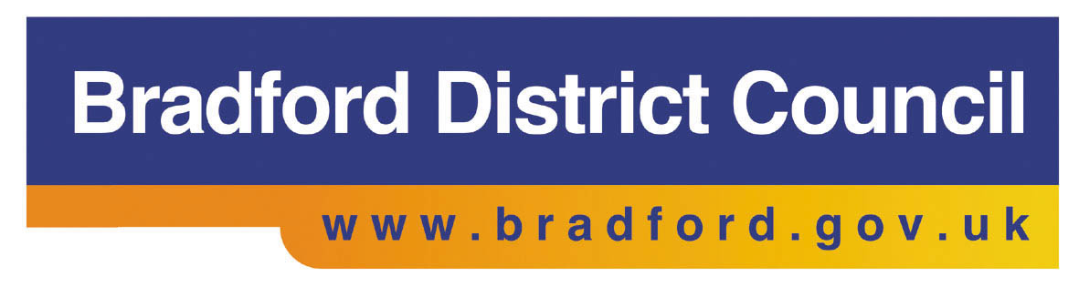

**What happens next?**

To access the programme individuals should contact their JCP Advisor at their local jobcentre or your Skills for Work adviser.

**Assessment Day**

Over view of the programme and employer information

Individual sessions with Aspire-i (National Careers Service supplier)

Team building session

**Recruitment Selection Week**

Four days of training followed by guaranteed interview on the Friday.

Receive training pertinent to role as well as employability training

Details of dates and times given on assessment day if successful

**What is the Head Start programme in Bradford?**

The Head Start programme offers employment of up to 30 weeks, paid at minimum wage with mentoring support. Incommunities is the lead delivery organisation and employer. It runs from March 2014 to September 2015.

The 30 week work placement contracts are 30 hours per week (part time roles are available subject to employer requirement but must be a minimum of 16 hours).

A total of 276 jobs will be provided within Incommunities and other organisations. Mentoring support is provided to help people develop their skills and secure permanent employment. Accredited training is available to address skills needs.

All participants are Incommunities staff and partnership arrangements with local employers are serviced through a service level agreement.

**Criteria**

JSA 18-24 year olds unemployed between 26 & 39 weeks (pre Work Programme). Participants must have a Bradford Postcode.

**For further information contact:**

EOF Team: 01274 257788

[eof@incommunities.co.uk](mailto:eof@incommunities.co.uk)

**Bradford Intermediate Labour Market – Head Start**

