EBSA: Whole School Audit

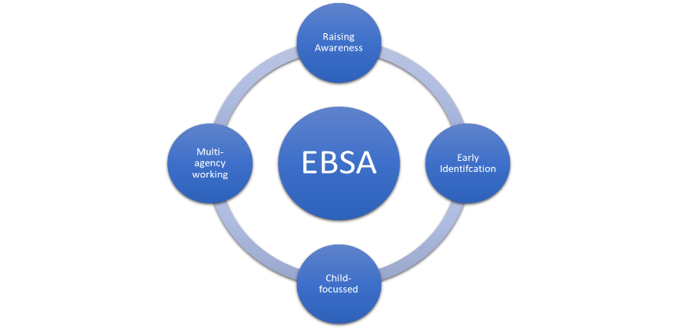
EBSA Lead Practitioner |  | School
Click here to enter your name. |  | Click here to enter school.

Date of initial Audit: Click or tap here to add date.
Review of Audit: Click or tap here to add date.

The EBSA Whole School Audit is an assessment and reflective tool to demonstrate thinking and the development of school practice over time. The intention of the tool is to create long term systemic change in the provision and support for children who experience Emotionally Based School Avoidance.
Please read each statement and use the self-evaluation tool to mark on the scale of 1-5 current practice within school (with 5 being the most desirable score). Within each section, there is a space to consider strengths as well as next steps. The audit should be completed in collaboration with school staff and members of the pastoral and senior leadership team (where possible) and reviewed at the end of each term during which progress can also be recorded on the scale.

Raising Awareness
- The school has an EBSA Horizons Practitioner(s), who is/are involved in the planning of provision for children experiencing EBSA and provide support to colleagues. | 1 | 2 | 3 | 4 | 5
What makes school at this stage?

Even Better If…

- There are/has been continuous professional development opportunities for staff to increase knowledge and understanding around EBSA. | 1 | 2 | 3 | 4 | 5
What makes school at this stage?

Even Better If…

- Staff across the school are able to identify children within the classroom who may be at risk, or showing the early warning signs of EBSA, as well as those who display more entrenched patterns. | 1 | 2 | 3 | 4 | 5
What makes school at this stage?

Even Better If…

- The language of EBSA is used consistently across the school community and with families. | 1 | 2 | 3 | 4 | 5
What makes school at this stage?

Even Better If…

School Context and Best Hopes from completing the audit:
Click or tap here to enter text.
Raising Awareness
 | 1 | 2 | 3 | 4 | 5 | Strengths | Next steps
The school has an EBSA Lead Practitioner(s), who is/are involved in the planning of provision for CYP experiencing EBSA, and support colleagues.
There are/has been continuous professional development opportunities for staff to increase knowledge and understanding around EBSA.
Staff across the school are able to identify children within the classroom who may be at risk, or showing the early warning signs of EBSA, as well as those who display more entrenched patterns.
The language of EBSA is used consistently across the school community and with families.
Relevant policies and provision within school reflect an understanding of EBSA (i.e. attendance policy, behaviour/relationships policy/ inclusion/ SEN policy and provision offer/transition).
Information is available to families and young people about EBSA and the support available within school and externally.

Early Identification
 | 1 | 2 | 3 | 4 | 5 | Strengths | Areas for development
There are clear processes to identify whether an attendance concern could relate to EBSA and these are applied consistently. Procedures include monitoring for ‘at risk’ groups.
There are clear policies on attendance and how non-attendance due to EBSA should be categorised and marked, acknowledging the likely corresponding social emotional and mental health needs.
Staff know who the school’s EBSA Lead is and are aware to whom they should report any concerns.
Appropriate screening and assessment tools are used with families, young people and school staff identify strengths and risks and these used to inform intervention and provision.
A ‘plan-do-review’ cycle is initiated in a timely way as soon as an EBSA concern is confirmed and includes shared support plans and agreed review dates.
Where there has been a period of non-attendance, support is implemented for some form of return to school as soon as possible.
School staff are aware of the strategies and provision in place to support a child experiencing EBSA and able to discuss these with the EBSA Lead(s).

Child focussed
 | 1 | 2 | 3 | 4 | 5 | Strengths | Areas for development
The child’s voice is actively sought and attempts are made to understand the EBSA, including pertinent risk and resilience factors, from the perspective of the child.
The child’s strengths and values are seen as central to planning and support.
There has been consideration of social support networks for the child and how to maximise these where appropriate.
Associated strategies, interventions and reintegration plans, are co-constructed with the child and aligned with the strengths and needs identified by the child and their family.
Support and interventions are applied consistently across the school day, with shared understanding and regard to pupil voice (e.g. using tools such as one page profiles/ agreed communication scripts). This should include approaches to manage impact on learning.
Where needed, reintegration plans follow the principles of a graduated return to school/lessons and are in place alongside any agreed support/adjustments.
School SEN provision includes sufficient facilities and resources to respond to the needs of the individual (e.g. mentor, meet and greet, later start, quiet space, corridor pass).
A member of staff has been identified to provide the child with the time, attention and compassionate care required to support resilience
The wider curriculum includes teaching around emotional well-being, mental health, resilience and coping strategies on a small group or individual basis.

Multi-agency response

 | 1 | 2 | 3 | 4 | 5 | Strengths | Areas for development
There is close liaison between home and school and a member of school staff has been designated to liaise with the family regarding the child’s experience of EBSA.
School facilitate support for families via sign-posting or in-house offers.
There is consistency in key communication between home/staff in school/ child (particularly communication around attendance or behaviour concerns).
Staff are aware of the role of external agencies and local arrangements with regard to supporting children experiencing EBSA.
Where possible (and appropriate) support is enlisted from Educational Psychologists, and/or health and social care colleagues to support the child to return to school and/or attend school more consistently.
There are regular meetings involving the family and professional network, to review provision and strategies, and to assess whether these remain appropriate/successful.
School seek support from external services where needed to review their provision offers in school to meet the needs of their individual cohorts.

Action Plan

Current strengths

Priorities for development

Key Actions | By whom | Agreed Monitoring (including date)

