Supporting Children And Young People Who Have
Special Educational Needs And Disabilities (SEND) in Bradford

Introduction

The following information has been designed in line with the Children & Families Act (C&FA), 2014, the Equality Act, 2010 and the SEND Code of Practice(CoP), 2015. It is anticipated that approximately one in five children will have a learning difficulty at some stage in their school career. Many of these difficulties are temporary and can be effectively dealt with in mainstream settings through the resources that are made available to them (funding elements 1 and 2). Formal procedures, i.e. statutory assessment, and specialist services provided via the local authority are targeted at those children and young people with the most significant and complex needs.

The Children & Families Act (C&FA), 2014, the Equality Act, 2010 and the SEND Code of Practice(CoP), 2015 provide detailed information about the statutory responsibilities schools have in relation to children and young people with SEND. These are summarised in Appendix 1 of this document.

Meeting Children’s Special Educational Needs in Bradford

The SEND Code of Practice (CoP) suggests that there is a continuum of SEND and that, where necessary, increasingly specialist expertise should be brought to bear on a child or young person’s difficulties. The CoP describes this as a graduated approach to addressing SEND.

Bradford Matrix of Need

Bradford Matrix of Need provides an overview of how children should be supported through the graduated approach as outlined in the Code of Practice. It has recently been revised in consultation with LA staff, school staff, health colleagues and parents to ensure it provides clear and consistent guidance.

The Matrix should be referred to in order to establish identification / assessment, appropriate intervention strategies and levels of provision that should be put in place. The examples of interventions and resources are not exhaustive; they will vary depending on the individual and/or cohort needs and may require adapting accordingly.

Similarly whilst there is a clear definition regarding levels of provision, there is leeway within this for schools to create bespoke flexible solutions that work within their setting.

Summary of Bradford Graduated Approach

1. Developing High Quality Teaching within an Inclusive Setting
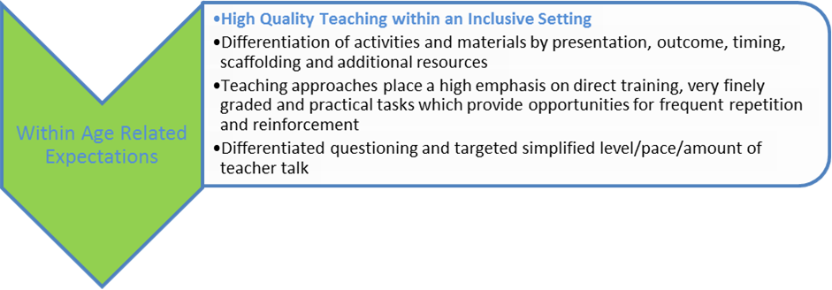
Bradford is committed to high educational standards for all children and young people, paying particular attention to the most disadvantaged groups. This means working with partners to promote prevention and early intervention and offer early help so that emerging problems are dealt with before they become more serious. Bradford LA is committed to ensuring that those with SEND can access high quality provision that meets their needs.

What is inclusion?
Inclusion “is described by some as the practice of ensuring that people feel they belong, are engaged, and connected. It is a universal human right whose aim is to embrace all people, irrespective of race, gender, disability or other attribute which can be perceived as different.
It is about valuing all individuals, giving equal access and opportunity to all and removing discrimination and other barriers to involvement.”1
The most common definition of inclusion expressed by both local authorities and schools was “children with SEND being able to attend their local school.” The government’s SEND Code of Practice sets out commitments around inclusive education and removal of barriers preventing children and young people with SEND from learning and participation in mainstream education.

SEND Code of Practice (2015)
Para 1.26: As part of its commitments under articles 7 and 24 of the United Nations Convention of the Rights of Persons with Disabilities, the UK Government is committed to inclusive education of disabled children and young people and the progressive removal of barriers to learning and participation in mainstream education. The Children and Families Act 2014 secures the general presumption in law of mainstream education in relation to decisions about where children and young people with SEN should be educated and the Equality Act 2010 provides protection from discrimination for disabled people.
Para 1.31: The leaders of early years settings, schools and colleges should establish and maintain a culture of high expectations that expects those working with children and young people with SEN or disabilities to include them in all the opportunities available to other children and young people so they can achieve well.

Inclusive Culture
The first stage in meeting SEN is developing an inclusive culture in which all staff understand the importance of inclusion and are driven to achieve it. Pre-requisites to developing an inclusive culture include the school having a vision of what it wants to achieve, taking a whole school approach to supporting children with SEND, and funding.

Developing expertise, models and structures
Once the culture and the aspirations for inclusion are in place, the expertise, models and structures of the school need to be developed in order to ensure that the school is equipped to support children with a wide range of needs. This would involve constant up skilling of all staff, flexible use of Teaching Assistants, access to a range of available interventions and strategies to support children with SEND, and an appropriate physical environment. The matrix of Need and the LA SEND Training offer will support you with this.

Developing individualised responses
Once the expertise, strategies and structures are in place, it is important that these are adjusted and tailored to meet the needs of individual students. A few specific examples of ways of ensuring that the response to children with SEND is individualised are as follows: Information sharing and staff briefings around the needs of children with SEND, student profiles, flexible behaviour policies, flexible ways of helping children with SEND to access mainstream classes, and catering for children’s needs outside the classroom. The matrix of Need and the LA SEND Training offer will support you with this.

2. Additional to and Different from Interventions and Strategies

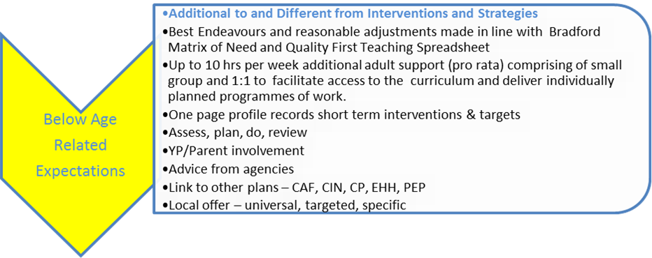

Within each class, there will be some children who are operating below age related expectations. The Matrix of needs supports you to identify these children and suggests ways of enhancing their progress. These children do not necessarily have special educational needs and do not need to be placed on the SEND register.

When children are operating below age related expectations they continue to require access to high quality teaching within an inclusive setting but they may also need some Needs-specific practice or adaptations which are additional to and different from those which are normally available.

This may include putting a monitoring system in place to assess the young person’s needs, identify outcomes, implement support and monitor and evaluate progress, for example an IEP or One Page Profile. The teacher will take responsibility for devising, delivering and evaluating a personalised programme that accelerates learning.

The school should put in place additional adult support amounting up to 10 hrs per week (pro rata) from DSG, comprising of small group and 1:1 support to facilitate access to the curriculum and deliver individually planned programmes of work.

3. SEN Support

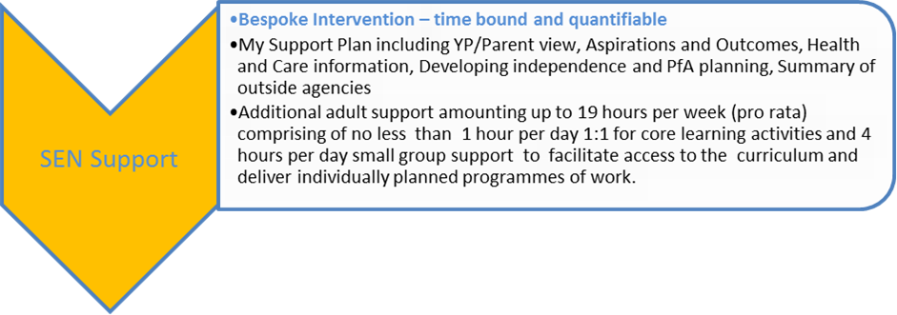

Where a child or young person does not make sufficient progress through the previous interventions, staff should decide on more Bespoke Intervention – time bound and quantifiable
‘additional to’ or ‘different from’ interventions.

These interventions should be recorded on a My Support Plan including YP/Parent view, Aspirations and Outcomes, Health and Care information and reviewed regularly.

Additional adult support amounting up to 19 hours per week (pro rata) comprising of no less than 1 hour per day 1:1 for core learning activities and 4 hours per day small group support should be put in place to facilitate access to the curriculum and deliver individually planned programmes of work.

Alternatively the school may choose to support the young person flexibly through the use of smaller teaching groups to facilitate access to an appropriately differentiated / modified or alternative curriculum and deliver individually planned programmes of work for example: enhanced adult child ratio (no more than 1:12) for up to 15 hours per week, plus additional adult support (1:6) to facilitate access to an appropriately differentiated / modified or alternative curriculum and deliver individually planned programmes of work

If little or no progress is made through the ‘assess, plan, do, review’ cycle (APDR), school staff should consider seeking external support. At that stage, external support services should be helping to develop interventions aimed at addressing continuing barriers to achievement. The CoP is clear that the involvement of external specialists can also play an important part in the very early identification of SEND and in advising schools on effective provision designed to prevent the development of more significant needs.

Where a child with SEND continues to make little progress over time, even with the support of external specialists such as the Educational Psychology Team or the Social Communication and Interaction Team (SCIL), the school may consider asking the local authority to undertake a statutory assessment of the child's SEND, through a request for an education, health and care needs assessment.

There is an expectation that interventions have been implemented for a n appropriate period, e.g. two cycles of APDR, before a request for additional resources is made. The request should be made with consent of the parent / carers and young person with the understanding that once it has been submitted, it does not necessarily lead to statutory assessment or EHCP.

This request will be contingent on meeting the two legal test regarding statutory assessment ie that the child may have SEND and that they may require provision in line with an EHCP (ie over and above that which is normally available). It is the school’s responsibility to provide evidence so that panle can judge against these two criteria. The request should include details of the support provided through the school’s SEND provision over time, including external support and advice. There should also be evidence that the child has special educational needs.

4. Additional support in line with EHCP

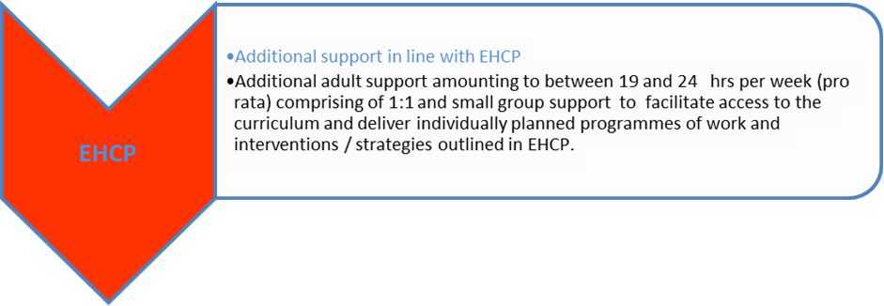

If an EHCP is issued, the plan will detail the outcomes to be achieved and the type and level of support that needs to be put in place. This will be within either a mainstream or a resourced / specialist provision, as identified through the assessment process and in line with parental preference.
The plan will detail additional adult support amounting to between 19 and 24 hrs per week (pro rata) comprising of 1:1 and small group support to facilitate access to the curriculum and deliver individually planned programmes of work and interventions / strategies outlined in EHCP.

Support from Bradford Local Authority

Bradford LA is committed to supporting schools to develop their capacity to manage children with a wide range of needs. This support falls into three key areas:

Providing schools with support that enables them to effectively include children with SEND

Bradford LA encourages inclusive practice in mainstream schools through providing direct support to help them work effectively with children with SEND. This support includes a training offer for schools, setting up school networks, and providing standardised resources. These can be found here

Challenging schools to ensure that they are taking responsibility for offering appropriate provision
Challenging schools to support children with SEND more effectively, and driving up schools’ expectations of one another, is a key way in which the LA facilitates inclusion This may include creating a sense of collective identity, empowering parents to better understand the rights and entitlements of their children, and clarifying schools’ duties around supporting children with SEND.
Empowering schools to respond flexibly to children’s needs
This may include giving schools financial flexibility, enabling schools to access timely external support for children, ensuring that schools have the flexibility to meet children’s needs, offering schools the opportunity of setting up an Additional Resourced Provision (ARP), and better involving schools in decisions relating to SEND.
Appendix 1
The Head Teacher’s Responsibilities

Schools have numerous responsibilities in relation to children and young people, the following being specifically in relation to those with SEND. In short schools must:

Appoint a SEND governor to have oversight of the arrangements for SEND in school
Identify how many pupils in the school have SEND and ensure provision is made in accordance with the SEND CoP
Know how much money the school gets for SEND and ensure an appropriate budget arrangement is in place to discharge its duties to arrange provision for pupils with SEND and/or disabilities
Review and approve the SEND policy and any other relevant policies
Monitor the progress of children and young people with SEND and ensure that the provision specified in statements of SEN and EHCP’s are made
Ensure that SEND provision is integrated into the school improvement plan
Publish on their website the school SEND policy and a description of the arrangements and specialist provisions made for children and young people with SEND
Appoint a SENDCo who is a qualified teacher (alternatively, the headteacher may take on this role)
Invest in whole school and targeted training for staff
Ensure inclusive teaching and support is embedded throughout the school and that all teachers understand that they are responsible for pupils with SEND
Provide information on school arrangements for SEND to parents and governors
Consider pre-emptive arrangements for pupils (present and future) with a disability

The Governors’ role

The governing body of the school has ultimate responsibility for this, and should be using their best endeavours to secure special educational provision, including;

Ensuring that where the head teacher or a nominated governor has been informed by the LA that a pupil has SEND, those needs are made known to all who are likely to teach or support that pupil
Ensuring that teachers are aware of the importance of identifying and providing for pupils who have SEND
Ensuring that a pupil with SEND joins in the activities of the school together with other pupils, so far as is reasonably practical and compatible with the child receiving the special educational provision their learning needs call for, the efficient education of the pupils with whom they are educated and the efficient use of resources
Reporting to parents on the implementation of the school's policy for pupils with SEND
Having due regard to the statutory guidance within the current SEND code of practice when carrying out duties toward all pupils with SEND
Ensuring that school notifies parents of a decision by the school that SEND provision is being made for their child This Bradford’s Graduated Approach outlines how children with Special Educational Needs and Disabilities have their needs met within the District.

The Special Needs Coordinators’ (SENDCo) Role

All schools are required to have a special educational needs coordinator (SENDCo). The SENDCo must be a qualified teacher working at the school. A newly appointed SENDCo, where they have not previously been the SENDCo at that or any other relevant school for a total period of more than twelve months, must achieve a National Award in Special Educational Needs Co-ordination within three years of appointment. The SENDCo has an important role to play, along with the head teacher and governing body, in determining the strategic development of SEND policy and provision in school. The SENDCo has day-to-day responsibility for the operation of SEN policy and co-ordination of specific provision made to support individual pupils with SEN, including those who do and do not have EHC plans. Schools should ensure that the SENDCo has sufficient time and resources to carry out these functions. This should include providing the SENDCo with sufficient administrative support and time away from teaching to enable them to fulfil their responsibilities in a similar way to other important strategic roles within a school.

The SENDCo’s role includes:

Overseeing the day-to-day operation of the school’s SEND policy
Co-ordinating provision for children with SEND
Advising on the graduated approach to providing SEND support
Advising on the deployment of the school’s delegated budget and other resources to meet needs effectively
Being a key point of contact with external agencies, especially the LA and its support services
Working with the head teacher and school governors to ensure that the school meets its responsibilities with regard to reasonable adjustments and access arrangements (Equality Act, 2010)
Ensuring that the school keeps the records of all pupils with SEND up to date
Liaising with: Designated teachers where a looked after pupil has SEND, Parents of pupils with SEND, Early years providers, Other schools, Health and social care professionals, Independent or voluntary bodies, Potential next providers of education to ensure smooth transition

The Class Teacher’s Role

The class teachers’ role is to make the education of all of their pupils their first concern and to enable them to achieve the highest possible standards. As well as providing inspiring learning experiences. Teachers are also at the forefront of forging positive professional relationships with parents so that they can work in the best interests of their pupils. Teachers are responsible for setting targets that stretch and challenge pupils of all backgrounds, abilities and dispositions. In relation to all pupils, teachers are expected to:

Be accountable for attainment, progress and outcomes
Be aware of pupils’ capabilities and their prior knowledge, and plan teaching to build on these
Adapt teaching to respond to the strengths and needs of all pupils
Know when and how to differentiate appropriately, using approaches which enable pupils to be taught effectively
Have a secure understanding of how a range of factors can inhibit pupils’ ability to learn, and how best to overcome these
Demonstrate an awareness of the physical, social and intellectual development of children, and know how to adapt teaching to support pupils’ education at different stages of development
Have a clear understanding of the needs of all pupils, including those with special educational needs; those of high ability; those with English as an additional language; those with disabilities; and be able to use and evaluate distinctive teaching approaches to engage and support them.
Manage classes effectively, using approaches which are appropriate to pupils’ needs in order to involve and motivate them (Teachers’ standards, 2011 (updated 2013))

