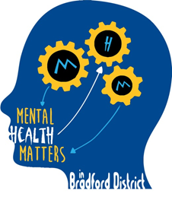
Mental Health Champions in Bradford Schools: A Future in Mind Initiative
Aims and Benefits for Schools
The aim of the project
The aim is to build capacity to address mental health matters within schools, as research evidence consistently demonstrates that most young people and their parents feel most confident in accessing support from within the communities in which they live and learn, and that school staff are the professionals in whom they have the greatest trust. (Me and My School: National Evaluation of TAMHS DfE 2013)
The initiative should enable children and young people to receive early intervention and effective support when and if they experience mental health distress or difficulties, and that those pupils who also require specialist mental health support can access this through close collaboration between MHCs and specialist CAMHS.
The Mental Health Champions in Bradford Schools will benefit schools through:
Building capacity and confidence to address mental health in schools
Ensuring that up to date information and resources can be cascaded to all relevant members of the school community
Providing resources and guidance to engage parents and community partners in addressing mental health matters, in ways which are age appropriate and culturally sensitive
Facilitate multi-agency work and swift and easy access to specialist CAMHS professionals
Providing a framework for disseminating up to date and culturally relevant information about mental health matters
Offering clinical group supervision and training to designated members of staff
Ensuring that all therapeutic individual and group programmes delivered in schools have a robust evidence base, and a clear framework to ensure appropriate implementation
Offering a training route for informal and accredited training

