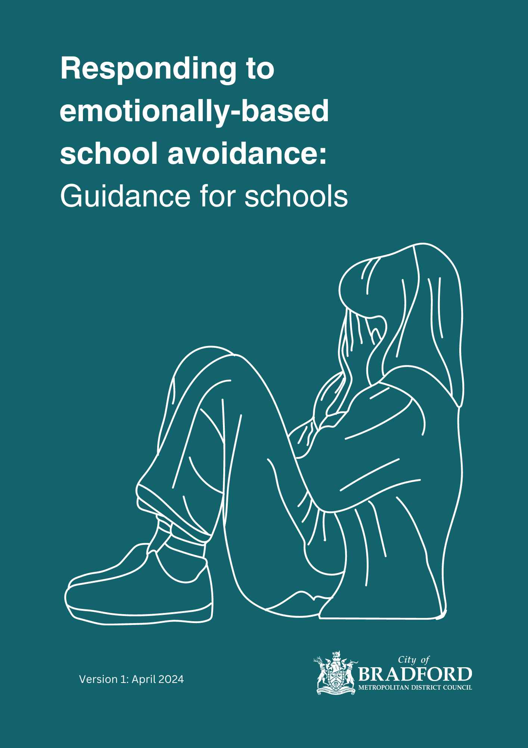

Contents

Introduction 4

Relevance 4

Persistent Absence Rates 4

Severe Absence Rates 4

Absence and EBSA 4

Wider Context 5

Local Voice 6

Using this guidance 7

Acknowledgements 7

CHAPTER 1: What is EBSA? 8

Prevalence of EBSA 8

EBSA as a continuum 9

Local context 9

Why does EBSA happen? 10

The role of anxiety in EBSA 10

EBSA over time 12

Risk Factors in EBSA 12

Triggering Events 13

Maintenance Factors 14

Push and pull factors in the maintenance of EBSA 15

The Importance of Resilience Factors 15

EBSA and Attendance Expectations 16

CHAPTER 2: Whole School Approach 17

Local Offer to Promote Emotional Well-being 18

Whole School Approach: EBSA 20

Implementation 21

Raising Awareness 21

Early Identification 21

Transition 22

Identifying Vulnerable Students 22

Communication and Support 23

EBSA and Autism 24

A Graduated Response 26

CHAPTER 3: Early identifcation & Information Gathering 28

Information gathering 28

Assess 29

Working with parents/carers 30

Working with Staff 31

Working with children 32

From Information Gathering to Formulation 36

CHAPTER 4: Targeted Support 38

What does the evidence say? 38

Support Plans 38

Responding to Anxiety 39

Addressing unmet needs 41

Interventions and strategies based on the four-factor model 42

Peer Support 45

‘In-School School Avoidance’ 45

Modified Timetables 46

Support for parents/carers 47

CHAPTER 5: Review Processes 49

A message of hope: Success Stories 50

Toolkit/Appendix 51

Appendix 1: Whole School Approach 51

Appendix 1.1 Whole School Audit Tool 51

Appendix 1.2 Information for school staff 51

Appendix 1.3 Information leaflet for families 51

Appendix 1.4 Information leaflet for students (Primary) 51

Appendix 1.5 (Information leaflet for students (Secondary) 51

Appendix 1.6 Transition 51

Appendix 1.7 EBSA and Autism 52

Appendix 2: Early Identification and Information Gathering 53

Appendix 2.1 Gathering information from parents/carers 53

Appendix 2.2 Round Robin 53

Appendix 2.3 Risk and Resilience Scales and scoring from EdPsychEd 53

Appendix 2.4 My School Timeline Activity 53

Appendix 2.5 Example of ‘Zones’ and ‘Incredible 5-Point Scale’ Activities 53

Appendix 2.6 Pupil Voice activities 54

Appendix 2.7 West Sussex activity booklet: Planning a return to school 54

Appendix 2.8 Card Sort Activity 54

Appendix 2.9 Ideal School Activity 54

Appendix 2.10 Bradford’s Formulation Proforma 54

Appendix 3: Targeted Support 54

Appendix 3.1 Support Plan Template 54

Appendix 3.2 Psychoeducation / therapeutic resources 54

Appendix 3.3 Interventions to increase flexibility when considering change 55

Appendix 3.4 Avoidance Hierarchy Template 57

Appendix 3.5 Examples of a One Page Profile 57

Appendix 3.6 Emotion Coaching 57

Appendix 4: Support Services 58

Appendix 4.1: Local Support Services 58

Appendix 4.2 Resource List for supporting Families 58

References 59

# Introduction

This document has been created through a collaboration of Bradford Council’s Educational Psychology Team, Attendance Team, and Medical Needs and Hospital Education Service. The guidance was prepared as part of an ongoing project funded by the Department for Education to improve attendance and ensure that young people, schools, families, and services are working together to support those who are experiencing emotionally-based school avoidance.

We have drawn on the best evidence and guidance available in current literature, informed by research from around the UK and abroad. This research sits alongside the data and evidence available to us in Bradford district, and the experiences of the children, schools, families, and professionals working here. Wherever possible, we have tailored this document to the distinctive challenges and opportunities in Bradford district, and we will be providing further support around implementation and making adjustments where needed to maximise the use of this guidance.

## Relevance

Improving school attendance is a national and local priority with rates of persistent and severe absence that have grown significantly post-covid. Bradford district has some of the highest rates of severe and persistent absence rates nationally.

## Persistent Absence Rates

|  |  |  |  |  |  |
| --- | --- | --- | --- | --- | --- |
|  | 2017/18 | 2018/19 | 2020/21 | 2021/22 | 2022/23 |
| Bradford | 15.84 | 16.23 | 18.49 | 33.27 | 33.20 |
| National | 13.58 | 12.74 | 11.73 | 26.65 | 25.18 |

## Severe Absence Rates

|  |  |  |  |  |  |
| --- | --- | --- | --- | --- | --- |
|  | 2017/18 | 2018/19 | 2020/21 | 2021/22 | 2022/23 |
| Bradford | 0.83 | 1.45 | 1.70 | 2.50 | 2.99 |
| National | 0.72 | 0.81 | 1.08 | 1.52 | 1.89 |

Data from Bradford Attendance Team indicates that at the time of writing (academic year 23/24) roughly 25.2% of learners in the Bradford district experience persistent absence (defined as being below 90% attendance). Within this group, 3.6% have an absence rate below 50% (severe absence). The rates of persistent and severe absence for students with identified Special Educational Needs (SEN), including those with an EHCP, are even higher (34.8% and 6.5% respectively).

## Absence and EBSA

For some young people who experience difficulties attending school, it is recognised that this may relate to emotionally based factors (i.e. anxiety). Although there is no official way to measure this number, research suggests that it is between 1 and 5 % (Elliot 1999, Gulliford & Miller, 2015).

## Wider Context

**The Department for Education**’sattendance agenda stipulates that:

‘*8. Some pupils find it harder than others to attend school and therefore at all stages of improving attendance, schools and partners should work with pupils and parents to remove any barriers to attendance by building strong and trusting relationships and working together to put the right support in place…It cannot solely be the preserve of a single member of staff, or organisation, it must be a concerted effort across all teaching and non-teaching staff in school, the trust or governing body, the local authority, and other local partners’ (p.6)*

School attendance is positively correlated with higher attainment and can be a protective factor for more vulnerable students (DFE, 2022). The need for a supportive school ethos and culture, joined up working, listening to the views of students and parents/carers, effective data monitoring and removing barriers and facilitating support have been emphasised within this guidance.

**The current evidence base** highlights the following as effective practice in relation to EBSA:

* Early intervention
* Systemic working: working with families, school staff and the young person
* Formulating and intervening according to individual case presentation
* Emphasis on the need for a rapid return to accessing education* alongside intervention, support and adaptations with the school and home environment

(Baker and Bishop, 2015).

* Autonomy, agency and belonging as key themes in emerging research on effective intervention (O’Hagen et. al, 2023; Sawyer and Collingwood, 2023).

**Emerging evidence base for entrenched non-attendance**

* A shift towards prioritising engagement/’readiness for adulthood’ as a broader goal, rather than a narrow focus on attendance as a basis for intervention. (Heyne et. al, 2024; Kearney et. al. 2022).
* There is an emerging evidence base indicating that where non-attendance is entrenched and prolonged, the initial focus should be on recovery and well-being as a means for re-engagement. (Heyne and Brouwer-Borghuis, 2022).

This aligns with the current guidance which highlights the need for an individualised approach according to need, which would mean that there may be a minority of cases where it is not appropriate to have an immediate focus on a return to school. External professional support would be anticipated in these cases.

## Local Voice

In producing this guidance, we have gathered views from families, young people and professionals in schools.

**What schools told us:**

* Survey responses indicate that school staff generally understand that EBSA relates to difficulties attending school which have an emotional basis and could also relate to SEN needs
* There is some variation in terms of the impact on attendance (from some identifying this as a prolonged absence and some as a dislike of school)
* The use of language is not yet consistent (‘refusal’ vs ‘unable’)
* There is evidence of an understanding of the complex factors contributing to EBSA (home/child/school), which is in line with research (Gregory and Purcell, 2014)
* There is evidence of a graduated and joined-up approach which includes collaborative working with parents/carers and obtaining pupil voice
* 81% report EBSA concerns are increasing. (19% feel there is no change)
* 57% report a good knowledge of the challenges associated with EBSA
* Only 32% report they have the necessary skills and confidence to support EBSA

**What parents/carers told us:**

* The most common age of onset of concerns is at Key Stage 2-to-Year 7, but the impact on attendance is more likely in Y7
* Most parents/carers reported an underlying SEN Need (80%). Most commonly, this was in the area of Social, Emotional and Mental Health (SEMH) or Communication and Interaction
* Less than a quarter of parents/carers indicated that these needs had already been identified prior to EBSA concerns
* Almost half reported that their child’s needs were still not formally identified
* It was reported that half of the students waited at least 1-2 terms before school responded to concerns

|  |  |  |
| --- | --- | --- |
| **What helps?** | **What is unhelpful?** | **What could help?** |
|  |  |  |
| Relationships | Lack of consistent support (internal and external) | Better relationships |
| Understanding | Lack of understanding from school | Support from services |
| Reasonable adjustments | Fines/pressure | Reasonable adjustments |
| External support (MNHES) |  | Better understanding |

What young people told us:

A series of speech bubbles in blue or green containing white text of comments from young people.
Comments are:
• We want to learn
• Too much focus on academic standards
• I worry what other people are thinking
• It’s too busy and noisy
• Yelling doesn’t help
• I have been coming in a bit more now the adults I’m working with understand me
• It’s not a choice
• I can have good days


Using this guidance**:**

This guidance has been divided into chapters with links to a comprehensive EBSA Toolkit to support whole school approaches and awareness raising, identification and targeted support. We begin by focusing on raising understanding and awareness and reviewing the whole school approach, before providing tools and resources for individual cases through following the plan, do and review process. Information from the wider research community (Office for Statistics Regulation, 2023), national trends and local data indicates that students experiencing EBSA often have an underlying SEND need. This means that schools should make reference to the [SEN Code of Practice](https://assets.publishing.service.gov.uk/media/5a7dcb85ed915d2ac884d995/SEND_Code_of_Practice_January_2015.pdf) and [Bradford’s Matrix of Need Guidance](https://bso.bradford.gov.uk/userfiles/file/EPT/Bradford%20Matrix%20of%20Need%20v2_2%20RD260421.pdf)  alongside this toolkit.

Acknowledgements**:**

With thanks to West Sussex Educational Psychology Service and Sheffield Educational Psychology Service for supporting our work, sharing their resources and giving permission for us to use these as a basis for our own local guidance. We would also like to thank [EdPsychEd](https://www.edpsyched.co.uk/about) who have signposted us to resources which they have created and made available for schools to use for free.

# CHAPTER 1: What is EBSA?

The discourse and terminology surrounding school non-attendance has continually been evolving in response to emerging literature and research findings. Previous terms include ‘school phobia’, ‘school refusal’, ‘school withdrawal’ and ‘truancy’ (Kearney, 2008, Pellegrini, 2007). More recent definitions used within practice include ‘emotionally based school avoidance’ as coined by West Sussex Educational Psychology (2022). Emotionally Based School Avoidance (EBSA) refers to significant difficulties faced by children and young people in attending school due to emotional-based needs.

*EBSA can be described as:*

*‘a broad umbrella term used to describe a group of children and young people who have severe difficulty in attending school due to emotional factors, often resulting in prolonged absences from school’ (West Sussex Guidance, 2022).*

Although both can be considered to be highly associated with emotional wellbeing, it is important to differentiate between young people absent from school due to factors such as ‘truancy’ and those absent due to specific emotional distress related to school attendance when identifying EBSA (Thambirajah, Grandison & De-Hayes, 2008). While the term "School Refuser" is commonly used in literature, it may be misleading, implying that the young person has control over their school non-attendance. This terminology is problematic as it places the 'issue' solely on the young person, neglecting environmental factors that play a crucial role in supporting their return to school.

*Defining factors of EBSA:*

* *Significant difficulties attending school, often resulting in absences from school*
* *Emotional distress when faced with the prospect of attending school*
* *Staying at home with the knowledge of parents/carers and school staff*
* *Absence of anti-social behaviours within the community*

*Berg et al (1969), adapted from Holder (2022)*

## Prevalence of EBSA

Rates of Emotionally Based School Avoidance are generally estimated to be between 1 and 5% of the overall school population (Elliot 1999, Gulliford & Miller, 2015). However, as the emotional component of EBSA is difficult to measure, an accurate picture of the prevalence of EBSA nationally is not known but, given current data on persistent and severe absence rates, is likely to be much higher. Current research indicates that there are no significant links between EBSA and gender, with an equal prevalence of males and females experiencing difficulties (Ingles et al, 2015; Kearney, 2008). In addition, there does not appear to be a link between EBSA and socioeconomic status (King & Bernstein, 2001). The literature suggests that EBSA prevalence is higher amongst secondary-aged students (Elliott, 1999; Gulliford & Miller, 2015) with rises around periods of transition between school phases (King & Bernstein, 2001). There is also evidence that increased rates of EBSA are more likely in young people who have Autism (Munkhaugen et al, 2017). The onset of emotionally based school avoidance may be sudden or gradual.

## EBSA as a continuum

EBSA is typically identified when a young person has been absent from school for an extended period. However, in the initial stages of EBSA, the student may continue to attend school. This might range from consistent attendance with visible signs of anxiety, to patterns of non-attendance for specific lessons or times of the day.

It is important to intervene at the earliest possible stage before avoidant behaviours, emotional distress and patterns of school avoidance become entrenched.

Diagram showing seven circles with text in the middle laid out in a horizontal line with arrows flowing between from left to right. 

Inside the circles are the following 7 statements:
School attendance with anxiety (somatic symptoms).
Behaviour in the mornings to avoid school.
repeated lateness followed by attendance.
periodic absences or missing classes.
repeated absences/missing classes mixed with attendance.
Complete absence from school for a period of time.
Complete absence for an extended period of time.

Beneath the seven circles are three blue boxes with white text inside.
The boxes flow into each other from left to right.
The text in the boxes say:
Difficulties transitioning into school.
In school, school avoidance.
Severe and sustained absence (entrenched EBSA).


Although some young people may gradually move along the above continuum, there may also be cases where there is a sudden onset of non-attendance as a result of a difficult or distressing event, or due to a build-up of anxiety over-time which may have gone undetected due to ‘masking’. ‘Masking’ refers to when an individual hides or suppresses symptoms, behaviours, or difficulties they are experiencing (Marschall 2022.)

## Local context

Schools involved in the EBSA pilot report concerns across the continuum. This guidance and toolkit is relevant at **all stages**, because it is based on a principle of individualised assessment and intervention and a ‘plan – do – review’ process. It is anticipated that by raising awareness and intervening early, cases of severe and sustained absence as a result of EBSA will be reduced over time.

## Why does EBSA happen?

EBSA does often not have a singular cause; instead, there are multiple contributing factors that can make it challenging for a young person to attend school. Research widely acknowledges that EBSA is typically influenced by various complex and interconnected elements, involving the young person, their family, and the school environment (Thambirajah et al, 2008).

Kearney and Silberman (1990) propose that there are four main reasons, or functions, for school avoidance:

**1. To avoid uncomfortable feelings brought on by attending school, such as feelings of anxiety or low mood.**

**2. To avoid situations that might be stressful, such as academic demands, social pressures and/or aspects of the school environment.**

**3. To reduce separation anxiety or to gain attention from significant others, such as parents or other family members.**

**4. To pursue tangible reinforcers outside of school, such as going shopping or playing computer games during school time.**

Reasons 1 and 2 may be considered to be **negative reinforcers**, whereby the young person attempts to *avoid* uncomfortable feelings or stressful situations. In contrast, reasons 3 and 4 could be considered **positive reinforcers**, where the young person is *seeking* something that elicits more pleasurable feelings.

## The role of anxiety in EBSA

Anxiety is a defining factor of EBSA. Although a degree of anxiety is essential in our lives to keep us safe, when levels of anxiety become unmanageable, this can cause us to withdraw from particular situations in order to avoid uncomfortable feelings. Whilst the avoidance of the situation provides short-term relief, this can then perpetuate and maintain the cycle of anxiety longer-term, as reflected in the following diagram.

**Case Study**

Halima is in Year 7 and has found the transition to secondary school difficult to manage. Halima particularly worries about finding her way to lessons and she is struggling to get used to meeting so many different teachers and students. After having some time off school recently due to a stomach ache, Halima felt much calmer and less anxious at home, and she was able to spend more time with her parents and watch her favourite television shows. When Halima returns to school, she worries about how far behind she might have fallen in her work, and whether her teachers will be angry with her. Halima also feels that she has missed out on making friends with other students while she has been off. Wanting to avoid the uncomfortable feelings this has brought on, Halima begins to spend more time at home and increasingly feels unable to come into school. This is further reinforced by Halima’s thoughts that ‘I don’t have any friends’, ‘I hate the busy corridors’ and ‘I’ve missed loads of work’, which exacerbates her feelings of anxiety towards school. Halima’s attendance gradually deteriorates throughout the school year and, by Year 8, her attendance is at 47%.

**This demonstrates how, without intervention, the anxiety cycle can lead to a more entrenched form of EBSA.**

## 

## EBSA over time

To help us to understand how EBSA develops and is maintained over time, it is useful to consider predisposing risk factors that can make a young person vulnerable to EBSA, alongside events that can trigger the onset of EBSA and maintenance factors which perpetuates the avoidance of school.

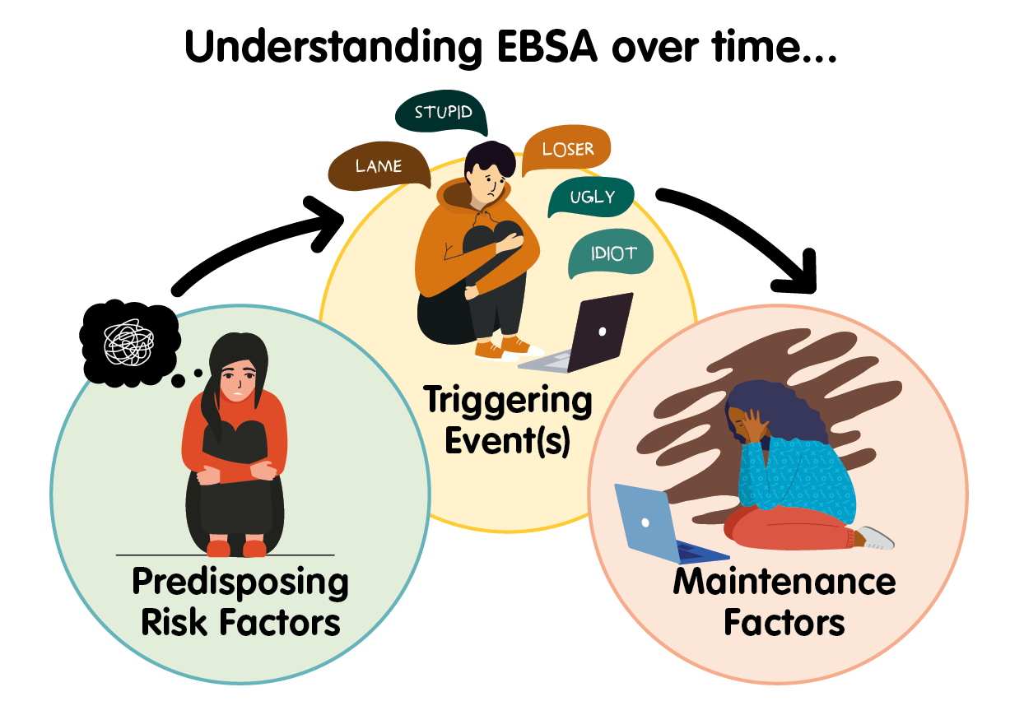

## 

## Risk Factors in EBSA

EBSA is often complex and multi-faceted. Research typically shows that EBSA is the result of a combination of predisposing factors which are largely unique to the individual child, their family and school context, and which interact with a particular trigger. This means that it cannot be treated as a single condition (Maynard et al., 2015). Different children will be hesitant to attend school for different reasons. It is usually a unique combination of various factors and their interaction rather than a single cause that leads to EBSA.

Being alert to these factors in relation to an absence from school can act as an early warning system enabling preventative action to be taken.

**Predisposing risk factors** may be associated with *child-based factors* (e.g. separation anxiety; prior trauma; key transition points), *family-based factors* (e.g. parental mental or physical health; family dynamics) or *school-based factors* (e.g. peer issues and/or social isolation; learning needs; difficulties with particular subjects).

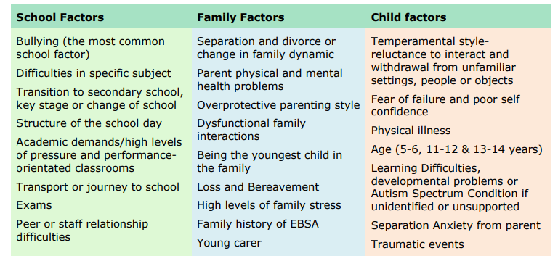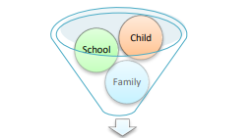

**What young people and families in Bradford told us:**

**A blue speech bubble containing the following five statements.
Unidentified/unmet needs
School too busy/noisy.
Struggling with friendships or relationship with teachers.
Events such as loss/separation in the past.
Learning not useful/interesting.
**

A key theme for both parents/carers and young people in relation to **predisposing risk factors** was a sense that there were **unidentified and unmet needs** and this impacted on feelings about school.

## 

## Triggering Events

These may be specific and obvious or subtle and gradual, and could also include a series of triggering events rather than an isolated incident. Triggering events may also take place within different aspects of the young person’s environment (e.g. a change in family dynamics at home; experiences of bullying in school).

**What young people and parent/carers in Bradford told us….**

A blue speech bubble with the following six comments inside:
Peer group difficulties.
Changes at home.
Bullying.
Traumatic event.
Transition
Build-up of social and academic pressure.

## Maintenance Factors

Once the young person is out of school or not attending lessons, **maintenance factors** may include feelings of disconnection and isolation from their peers; anxieties regarding the work they have missed; opportunities to engage in more pleasurable activities, including hobbies and time with a caregiver; and greater emotional stability in the absence of the social, physical and sensory demands of a school setting.

**What young people and parent/carers in Bradford told us….**

A blue speech bubble with the following statements written inside;
Missing learning/getting behind.
I prefer to be at home.
Worried what people say/think.
Inconsistent/lack or support.
People not believing/understanding increases in anxiety.

**The Integrated Model of** EBSA (Dr Jericah Holder, olderHEd Psych Ed, 2022) provides a helpful visual to represent how predisposing factors and triggering situations feeds into, and maintains, the anxiety cycle in school avoidance.

## Push and pull factors in the maintenance of EBSA

The literature suggests that the factors influencing school avoidance, categorised as 'risk and resilience,' can be conceptually divided into 'push' and 'pull' factors:

* 'Push' factors: These are elements that push the child to attend school (e.g. friendships; positive relationships with teachers; strong academic ability)
* 'Pull' factors: These are factors that draw the child away from attending school (e.g. the events detailed above: predisposing risk factors, triggering events and maintenance factors).

*EBSA can occur when ‘stress exceeds support, when risks are greater than resilience and when ‘pull’ factors that promote school non-attendance overcome the ‘push’ factors that encourage attendance’ (Thambirajah et al, 2008: p. 33).*

## Drawing of a balanced see saw with a sun on one side and storm cloud on the other. Beneath the sun it says Push factors. Factors that push a young person towards attending school. Underneath the storm cloud it says Pull factors. Factors that pull a young person away from attending school.

## The Importance of Resilience Factors

The factors that pull a child away from attending school are the predisposing and maintenance factors discussed above. However, there will also be unique factors which promote school attendance. Any assessment and intervention should pay as much attention to these as the factors that are maintaining difficulties with attendance (pull factors).

This may include:

• Developing ambition, aspiration and motivation

• Increasing confidence, self-esteem, self-efficacy and value in themselves

• Developing feelings of safety, security and a sense of belonging

• Having positive experiences where they can succeed

• Holding positive relationships with peers or staff

• Feeling listened to and understood

• Understanding the relationship between thoughts, feelings and behaviour

• Willingness to work in partnership between school, family and external professionals

• Developing parenting skills and understanding

• Flexibility of approaches within school

• Person-centred approaches, including listening to the voice of the child

**What young people and parent/carers told us helped or could help them:**

**A blue speech bubble containing the following statements;
Understanding from others
Lessons/teachers we like
Feeling listened to
Rewards and trips
Reasonable adjustments
A safe place
Having a friend/support network
Key adult/link/mentor
**

Schools need to reflect on their curriculum and pastoral systems, alongside universal and targeted offers, to consider what makes school a motivating place to attend.

## 

## EBSA and Attendance Expectations

EBSA can make attending school extremely difficult for some children and young people.  The government places an expectation on schools, local authorities and parents/carers to make sure children attend school regularly so that they can benefit from the education they are entitled to.  This guidance helps explore the possible ways of supporting children who are suffering from EBSA, and it is our expectation that schools will authorise absence, using the I Code (Illness) due to EBSA where:

1. The parent/carer has made the school aware the child is struggling with EBSA
2. The child appears to show signs and symptoms of EBSA
3. The school, together with the parent/carer and any supporting professionals, have a plan in place to treat/minimise the impact of EBSA on the child
4. The parent/carer continues to effectively engage with this plan and attends further meetings

Where any of the above are not met, then schools may choose to unauthorise the absence and consider applying the staged intervention approach if appropriate.

Further information from the Local Authority attendance team can be found here: [Attendance | Bradford Council](https://www.bradford.gov.uk/education-and-skills/school-support-services/attendance/)

# CHAPTER 2: Whole School Approach

In order to enable children and young people to flourish and to reduce EBSA, it is vital that schools have a broad whole school approach to emotional wellbeing and mental health. The eight principles of a whole school approach are key areas where schools can take action at a systemic level to promote emotional health and wellbeing for all young people. The key principles are summarised in the diagram below. Many of our school locally are already working developing practice in these areas as part of the Emotional Wellbeing Chartermark ([Bradford Healthy Minds Chartermark | Bradford Schools Online](https://bso.bradford.gov.uk/content/mental-health/healthy-minds/bradford-healthy-minds-chartermark)).

A wheel-shaped diagram. 
In the centre of the wheel it says Leadership and management that supports and champions efforts to promote emotional health and wellbeing. 
There are seven spokes coming off the centre of the wheel which separate the following seven statements. 
* curriculum,, teaching and learning to promote resilience and support social and emotional learning. 
* Enabling student voice to influence decisions.
* Staff development to support their own wellbeing and that of students.
* identifying need and monitoring impact of interventions.
* Working with parents and carers.
* Targeted support and appropriate referral.
* An ethos and environment that promotes respect and values diversity. 


Eight principles to promoting a whole school or college approach to mental health and wellbeing (Public Health England, 2015).

## 

## Local Offer to Promote Emotional Well-being

**Bradford’s Thrive Framework**

The Thrive framework helps to create coherent and resource-efficient communities of mental health and wellbeing support for children, young people and families. It aims to talk about mental health and mental health support in a common language that everyone understands.

The Framework is needs-led. This means that mental health needs are defined by children, young people and families, alongside professionals, through shared decision making. Needs are not based on severity, diagnosis or health care pathways. The THRIVE framework is for all children and young people aged 0–25 within the Bradford and Craven area.

A square graphic divided into four quarters. The top left quarter is green. The top right quarter is blue. The bottom left quarter is orange and bottom right quarter is purple. 

In the centre of the graphic is a large  circle. Within that circle is a smaller, yellow circle. 

In the central yellow circle are the words 'Thriving. Those whose current need is support to maintain mental wellbeing through effective prevention and promotion strategies.'

The larger circle outside the yellow circle is split into four sections which go into the four quarters of the main graphic with. The sections of the circle are the same colour as the quarter of the square it covers.

The green quarter of the main square  contains the words 'Those who need advice and support signposting'. The section of the outer circle in the green quarter contains the words 'of the Getting Advice'

The blue quarter of the square contains the words 'Those who need focused goals-based input.' The section of the outer circle in the blue quarter contains the words 'Getting Help'.

The orange quarter of the square  contains the words 'Those who have not benefitted from or are unable to use help, but are of such a risk that they are still in contact with services.' The section of the outer circle in the orange section contains the words 'Getting Risk Support'.

The purple quarter of the square contains the words 'Those who need more extensive and specialised goals-based help'. The purple section of the outer circle contains the words 'Getting More Help'.

A square graphic divided into four quarters. The top left quarter is green. The top right quarter is blue. The bottom left quarter is orange and bottom right quarter is purple. 

The green quarter contains the words 'Signposted to information and support to promote emotional wellbeing including 3rd sector'.

The blue quarter contains the words 'School based goal orientated support via graduated approach and matrix of need'.

The orange section contains the words 'Specialist services from CAMHs'.

The purple section contains the words 'specialist goal based wellbeing suport from SCIL teacher / educational psychology / CAMHs'.

In the centre of the graphic is a yellow rectangle containing the words School environment promotes good emotional wellbeing'. 

**DfE Senior Mental Health Lead Training**

Bradford Educational Psychology Team continues to be registered as an approved DfE trainer and feedback from delegates has been extremely positive. We are currently able to offer Beginner Training. This is appropriate when the senior mental health lead is new to the role or has not previously completed senior mental health leadership training. To find out more about the course please visit - <http://skills4bradford.co.uk/Training> - filter by ‘Educational Psychology’.

**Healthy Minds Emotional Wellbeing Chartermark**

The purpose of the Bradford Healthy Minds Chartermark is to celebrate best practice in relation to the implementation of a sustained whole school approach to emotional wellbeing and mental health. Schools receiving an award (Silver, Gold or Platinum) have embedded evidence-based practice, based on the eight key principles for mental health and wellbeing, as recognised by Public Health England. There is no financial cost to schools, and on achieving the award they will receive a trophy, banner and certificate at an award ceremony attended by the Mayor of Bradford. The award is gaining in popularity throughout the Bradford District and sign up at the beginning of the academic year is recommended. <https://bso.bradford.gov.uk/content/mental-health/healthy-minds/bradford-healthy-minds-chartermark>

**Mental Health Champions Project**

The Mental Health Champions project provides support for educational staff in meeting the needs of children and young people who may experience low to medium level mental health or emotional wellbeing difficulties. Through Termly Network Meetings, we provide updates and key information from the DfE and other services and organisations both locally and nationally. We also offer workshop events for parents and carers who would like to understand more about mental health and emotional wellbeing in children and young people. The MHC team now also offers training for school governors three times a year on matters relating to mental health and emotional wellbeing. [Mental Health Champions (MHC Core) | Bradford Schools Online](https://bso.bradford.gov.uk/content/mental-health/healthy-minds/mental-health-champions-(mhc-core))

**Mental Health Champions Plus**

The Mental Health Champions Plus (MHC+) project provides an enhanced offer of support and guidance for MHC Champions in schools who are actively seeking to develop their whole school offer in relation to mental health and wellbeing. MHC+ Champions begin by completing an Audit of current practice in relation to one aspect of this, and then develop an action plan to address identified areas for development. MHC+ Champions receive individual support from the Educational Psychology Team in relation to their role, as well as termly training on a range of topics related to mental health and wellbeing. MHC+ Champions can also access the Healthy Minds training packages which can then be incorporated into whole-school practice. Schools who wish to join the MHC+ project should be actively engaged at MHC Core level and be committed to developing a robust whole-school approach to emotional wellbeing. [Mental Health Champions Plus | Bradford Schools Online](https://bso.bradford.gov.uk/content/mental-health/healthy-minds/mental-health-champions-plus)

**The Education based Emotional Wellbeing practitioners (EEWP) Team**

The Educational Emotional Wellbeing Team is part of the Educational Psychology Team and aims to provide early intervention for children and young people who are presenting with mild to moderate mental health needs.

EEWP practitioners will provide support to children and young people on a one-to-one or small group basis. They will work in schools and early years settings and will also liaise with parents and carers, providing low intensity, evidence based interventions such as guided self-help based on cognitive behavioural therapy (CBT) [| Bradford Schools Online](https://bso.bradford.gov.uk/content/mental-health/healthy-minds/education-based-emotional-wellbeing-practitioners-(eewp)-team)

**The Mental Health Support Team (MHST)**

The Mental Health Support team provides support to children and young people (school age), school staff, parents, and carers. They offer therapy and support to young people who may be struggling with mild to moderate mental health difficulties as well as supporting their schools to adopt a whole school approach to mental health and wellbeing. [Mental Health Support Team – Healthy Minds](https://www.healthyminds.services/services/mental-health-support-team-281)

**Whole School Approach: EBSA**

As well as an effective whole school approach to support emotional well-being, it is recognised in the research literature that a whole school approach specifically tailored towards EBSA is important (Baker and Bishop, 2015).

Adapted from Holder (2022), a whole school approach should consider the strategic response in the following four areas: **raising awareness**, **early identification**, **child-focused approaches** and **multi-agency working**.

This is consistent with local feedback, which has highlighted the importance of understanding and awareness, identifying needs early and working with the child, family and other support services.

A round graphic with EBSA in the centre.  

Around the centre are four circles containing the words Raising Awareness; Early Identification; Child-Focussed and Multi-Agency Working. 

Next to the Raising Awareness are three oval shapes containing the words whole school awareness; named lead and policies reflect understanding.

Next to Early Identification are three oval shapes containing the words identification processes; Information gathering and plan review. 

Next to Child-Focussed are three oval shapes containing the words well-being/resilience, intervention child-centred and pupil voice.

Next to multi-agency working are three oval shapes containing the words family, school and other agencies.

## 

## Implementation

An Audit Tool has been created as part of the current pilot project to support schools to review their current response to EBSA (EBSA Toolkit: Appendix 1.1).

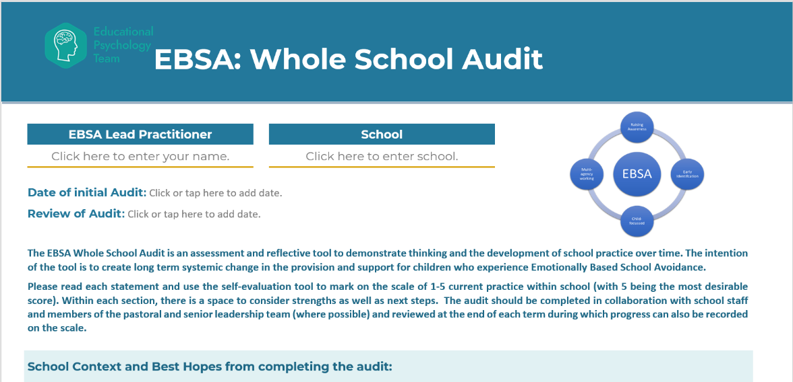

It is recognised that EBSA can fall under the remit of a number of teams within schools and, therefore, a good starting point would be to work across these teams to ensure a joined up and holistic approach. This will also give schools the opportunity to create clear pathways of support, clarify roles and responsibilities and reduce duplication or inconsistencies.

## Raising Awareness

A short summary for all staff has been created (EBSA Toolkit: Appendix 1.2) for you to share (consistency of response and approach was highlighted by local young people as a key factor in relation to experiencing EBSA).

Information leaflets for families (EBSA Toolkit: Appendix 1.3) and young people (EBSA Toolkit: Appendix 1.4 and [1.5](#_Appendix_1.5_(Information)) can also be found in the toolkit.

## 

## Early Identification

We know from research literature and from local data that transition is a significant risk factor in terms of the onset of EBSA (Miller, 2015). Young people who have Autism are also more likely to experience EBSA (Munkhaugen et al, 2017). The next sections will therefore consider how schools can take a proactive approach in response to these identified risk factors.

## 

## Transition

Eight blue cloud shapes each with white text inside.
The eight pieces of text are;
School size.
Number of students.
Teaching approaches.
Increased sensory demands.
Academic expectations and workload. 
Timetabling.
Movement between environments.
School ethos and culture
Research indicates that there is a correlation between incidences of EBSA and key transition points, particularly in terms of educational phases. This is often seen during the transition from primary to secondary school, for example, and is associated with the number of changes that young people face during this time period.

**Successful Transition**

To facilitate a successful transition, some young people require more support than others to adjust to a new environment. This is particularly important for young people who experience some of the risk factors for EBSA (e.g. higher levels of anxiety, experiences of loss or separation) and children with lower Key Stage 2 attainment data have also been found to be more at-risk of a difficult transition than other cohorts (Rice et al, 2015).

## 

## Identifying Vulnerable Students

It is crucial for schools and parents/carers to offer appropriate support, with particular attention to identifying and addressing any vulnerabilities in young individuals early on. The feeder school plays a key role in recognising and flagging potential issues, adopting a personalised approach when needed. Effective transition practices include sharing of both pastoral and academic information between primary and secondary schools. Feeder schools should proactively identify and communicate any early separation difficulties or past EBSA, even if the concerns were mild and attendance has since improved. To enhance this process, we recommend that secondary schools explicitly enquire about such information in their transition gathering forms.

An effective way for primary schools to provide information quickly regarding their predictions of each young person’s likelihood of an effective transition is through [UCL's START questionnaire](https://www.ucl.ac.uk/pals/sites/pals/files/start_questionnaire.pdf). This can also be used by secondary schools to collate information quickly regarding their new starters, and to flag up any possible concerns at an early stage.

Research also suggests that, in addition to utilising information from primary school, providing support for social skills and relationships and extending transition support beyond the first week are effective in facilitating an effective transition from Year 6 to Year 7 (Rice et al 2015).

## Communication and Support

Furthermore, successful transitions involve clear and open communication with the young person and their parent/carers, including providing them with practical information and supports.

A table of two columns headed Key information required and practical supports. 
There are eight rows of statements in each column.
For each statement under key information there is a corresponding statement under practical support with an arrow linking the two. 
Travel to school - Go through journey to school, practice this, identify and companions.
Key people in school - Give a simplified structure chart, provide photos, identify a key person.
Environment -  Layout of school. provide maps, give tours, colour-code subjects to building areas.
Structure of the day timetables, break and lunchtime systems - provide timetables, colour code these, break and lunchtime systems.
Social time supporting interactions and those more vulnerable, bullying policies - Identify how pupils will be supported to make new friendships, access to supported social activities.
Academic demands, how lessons are structured & homework - Give information about how lessons are structured and homework expectations.
Support systems in place - pastoral SEN support - Set out how young people will be supported, provide one-page profile.
Equipment need - provide checklist for each day.  

(West Sussex, 2022, p. 35-36)

Familiar members of school staff should engage in discussions with both the young person and their family, exploring aspects of school they are looking forward to and any concerns they may have, so that any worries can be individually addressed.

Please refer to the Toolkit (EBSA Toolkit: Appendix 1.6) for information and resources to support transitions for young people.

## EBSA and Autism

Many young people with autism experience anxiety, with around 40% of this cohort having at least one diagnosed anxiety disorder (Van Steensel et al., 2011). Feelings of anxiety for these young people often worsen during adolescence, which has implications for their transition from primary to secondary school. This can be attributed to many reasons, including increased complexities in social relationships, language and interactions, alongside managing the organisational and sensory demands of different environments (Ozsivadjian and Knott, 2016; Gaus 2011; McLeod et al, 2015; Ting and Weiss, 2017). Consequently, evidence suggests that the incidence of EBSA is higher for young people with autism in comparison to their neurotypical peers (West Sussex, 2022).

A drawing of a bucket of water. The water is splashing out of the bucket. Written on the bucket is the word anxiety. 
Around the bucket are eight statements each with an arrow pointing towards the bucket. 
The eight statements are;
Poor concept of time.
Does not know/understand rules.
Sensory differences.
Literal interpretation of situation.
Difficulties with communication.
Unsure what is going to happen. Changes in routine.The typical school environment often encompasses many social and sensory demands that young people with autism can find overwhelming and exhausting to manage. This can lead to these pupils spending much of their energy across the day trying to cope with various aspects of the school environment, leading them to ‘fill their emotional bucket’ and increasing the risk of EBSA. This can also be true for young people who are adept at masking their needs within school but communicate their emotions more openly in the home environment.

(West Sussex, 2022, P. 39)

Early intervention and adjustments to the young person’s sensory and learning environments are essential for neurodivergent young people, alongside promoting their social understanding, emotional well-being, resilience, and self-regulation. Tailored approaches, such as visual supports and structure, can also help to reduce anxiety. In addition, recognising individual expressions of distress and involving the young person's voice in support strategies are crucial.

It is important to recognise that autistic people may show their emotions in ways that are different to their neuro-typical peers e.g. quiet and compliant behaviour can be a sign of distress.

**Key Factors**

Doctoral research undertaken by Higgins (2022), identified the following factors as being important to young people with Autism when thinking about how they feel about school:

|  |  |
| --- | --- |
| Choice | Sense of decisions being made by school and having no autonomy or agency within school and about their education  What helps: more opportunities for autonomy |
| Relationships | Positive relationships with adults and peers are key to positive school experiences  What helps: opportunities to engage with like-minded peers, more autism awareness |
| Environment | The need for a comfortable school environment which was not sensorily overwhelming  What helps: unlimited access to separate spaces, newer resources, time in nature/with animals. |
| Individualised adjustments | Students identified there are not enough adjustments for individual needs  What helps: increased flexibility, reduced pressure, personalised approaches |
| Hope | Students wanted to attend school and learn  What helps: adults who understand them and are supportive and hopeful |

**Working with the Young Person**

The young person’s voice is key to finding out what works for each individual and tailoring support. Activities such as using [‘Talking Mats’](https://www.talkingmats.com/) (visual approaches) are particularly useful.

There are a range of tools for working with all young people within the Toolkit (EBSA Toolkit: Appendix 2) which are equally appropriate for young people with autism.

**Working with Parents/Carers**

Collaborative working partnerships with families is essential and are in the best interests of all children, especially those experiencing anxiety and/or who are autistic. Recent studies, (Reaven et al, 2012; Steensel, Zeger and Bogels, 2017; Ting and Weiss, 2017) emphasise the importance of the relationship between parental anxiety and anxiety in children and young people. Many parents/carers of children with autism report that they notice their own emotions have an impact on their child’s emotions and vice versa.

Parents/carers may not have accessed advice and support regarding strategies to support their child and schools should consider training courses and support groups that may be available to parents/carers. Details of these agencies and services can be found within the Toolkit (EBSA Toolkit: Appendix 1.7). It is worth remembering that Autistic children and young people may mask or camouflage their natural emotional and sensory reactions and behaviours as a coping strategy whilst at school. This can create a ‘shaken pop bottle’ effect, whereby the child shows very different emotions and behaviour at home with parents and care-givers than at school, having contained their anxiety throughout the school day. For this reason, it is important for school to work closely and supportively with parents/carers and the child to understand the whole picture and to find solutions.

Resources to promote collaboration and supporting parents has been included within the toolkit. Toolkit (EBSA Toolkit: Appendix 4.2)

## A Graduated Response

The following steps can be followed to support young people with autism who are at risk of EBSA (EBSA Toolkit: Appendix 1.7)

1. **Awareness and understanding of Autism** at a whole-school, classroom and peer level
2. **Assess** to develop an understanding of the young person’s strengths and support needs, ensure opportunities for pupil voice
3. **Plan and Implement** approaches and strategies to support the young person
4. **Review** the impact of the young person’s response to intervention

A graduated approach is key not only for young people who are at risk of EBSA due to Autism, but for all young people who have been identified as at risk of, or experiencing, EBSA.

**The Graduated Approach**

Adopting a graduated approach to emotionally based school avoidance means taking step-by-step actions to help students who are experiencing EBSA to gradually increase their attendance and re-engagement with school. Universal support, including whole-school approaches, should be considered as a first step, with targeted support for the young person implemented in response to early identification of possible EBSA. Further support, including involving external agencies and/or consideration towards statutory assessments, may be sourced in response to persistent and severe patterns of non-attendance. However, a thorough graduated response to meeting the student’s needs should be implemented and reviewed by schools prior to this stage.

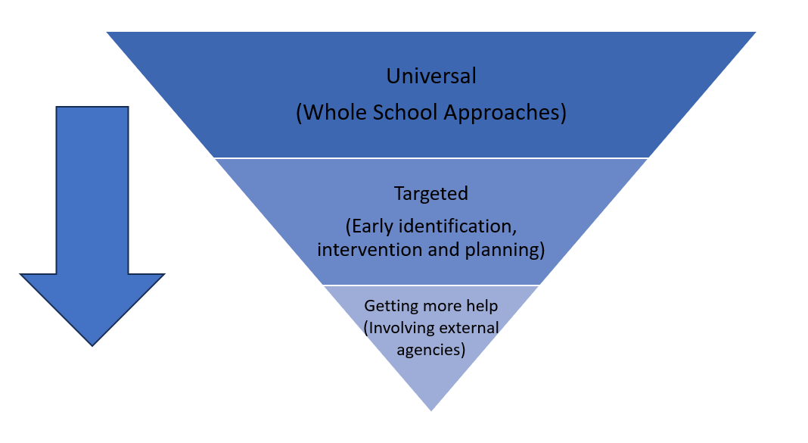

**School Support Offer: SCIL Team**

The Social Communication Interaction and Learning (SCIL) team can offer support across all stages of the graduated approach. All schools can request a link professional within the team to support whole school approaches and early intervention, as well as seeking individualised support as part of a graduated approach when appropriate. Information regarding the SCIL Team offer can be found here: [About SCIL Team | Skills 4 Bradford](https://www.skills4bradford.co.uk/Page/18029)

# CHAPTER 3: Early identifcation & Information Gathering

Early identification of emotionally based school avoidance (EBSA) is crucial for providing timely support to students experiencing emotional challenges that may lead to school avoidance. This is because responding to needs at the earliest time will reduce the risks of EBSA becoming more entrenched.

## Information gathering

Schools play a crucial role in identifying children who are presently facing, or are at risk of, experiencing EBSA. It is imperative for schools to establish comprehensive systems that effectively support young individuals, remain attentive to early warning signs, and implement a thorough assess, plan, do, review cycle, with a focus on placing the young person at the centre of any interventions and support plan.

We recommend you consider pathways in your school to show your staged response and what support and resources will be used at each part of the process.

A diagram showing an arrow facing right. On top of the arrow are five blue boxes containing white text. 

From left to right the boxes contain the following words;
Identify - What processes will you use to identify EBSA?
Assess - What tools and approaches will you use to gather risk and resilience information from home/school /young person?
Plan - How will you use this information to plan next steps? Who will be involved/what provision could be implemented?
Do - Who will be responsible for actions? How will you ensure consistency?
Review - How soon will this be? Who will be involved? Are there triggers for earlier reviews?


**Identify: Possible indicators of EBSA include:**

|  |
| --- |
| Difficulty attending school with periods of prolonged absence |
| Child reluctant to leave home and stays away from school with the knowledge of parent/carer |
| For younger children, a reluctance to leave parents/carers or get out of the car |
| Regular absence without indication of anti-social behaviours |
| Frequent absences for minor illnesses |
| Patterns in absences, e.g. particular days and/or subjects, after weekends and holidays |
| Reluctance to attend school trips |
| The young person expresses a desire to attend classes but is unable to do so |
| Anxiety on separation and inappropriate dependence on family members e.g., worry expressed about the safety of those at home |
| Evidence of under-achievement of learning potential |
| Social isolation and avoidance of classmates or peer group |
| Challenging behaviours, particularly in relation to specific situations at school |
| Severe emotional upset with excessive fearfulness, outbursts of temper and complaints of feeling ill on school days |
| Depression and sense of isolation resulting in, low self-esteem and lack of confidence |
| Confusion or extreme absent mindedness shown in school due to lack of concentration resulting in, lower attainments |
| Physical changes i.e. sweating, sickness, aching limbs, headaches, panic attacks, abdominal pain, rapid weight loss or gain |

(West Sussex guide, 2022, page 10-11)

**Identification Processes**

The following processes should be used to help identify children and young people who may be experiencing EBSA:

* Monitoring attendance, including lateness
* Communication with parents/carers and initial exploration of emotional factors when concerns emerge regarding persistent absence (attendance below 90%)
* Monitoring of somatic symptoms (such as reports of feeling ill in school)
* Attendance letters which include information regarding EBSA and key contacts in school
* Enhanced focus on attendance patterns for students identified as ‘at risk’ at transition or in relation to SEND needs
* Systems for collaboration within school between attendance/pastoral and inclusion teams to ensure clear roles and responsibilities.

## Assess

When a difficulty has been identified, it is essential to initiate an investigation into the underlying reasons. A comprehensive understanding of the varied factors causing and perpetuating EBSA behaviours is crucial, in order for any intervention or support plan to yield effectiveness.

Thambirajah et al. (2008) state that the main aims of this investigation are:

* To confirm that the child is displaying EBSA, as opposed to truancy or parentally condoned absence
* To assess the extent and severity of (a) school absence, (b) anxiety and (c) the type of anxiety
* To gather information regarding the various child, family and school factors that may be contributing to the EBSA
* To integrate the available information to arrive at a practical working hypothesis as a stepping stone to planning effective interventions

As discussed in Chapter 1, there are usually a complex range of factors which impact on the onset and maintenance of EBSA (school, home and child factors). When assessing EBSA, it is important to remain curious and avoid language which could infer blame and break down the communication which is essential to a joined-up approach.

## Working with parents/carers

Parents/carers may find it difficult to openly discuss the concerns they have around their child’s experiences of school. By involving parents/carers in a collaborative and supportive manner, schools can create a more comprehensive and effective approach to addressing emotionally based school avoidance and promoting the overall well-being of students.

An initial meeting/call is helpful to gather parent/carers’ views around their concerns and any background information which will help to create a holistic picture of the factors affecting school attendance. Regular meetings with a key staff member can help build rapport with parents/carers and work towards better outcomes for children. These meetings may also help school to gain an understanding of any support parents/carers may need and provide opportunities for signposting to appropriate agencies and resources.

**Initial meeting/call**

After initial contact with the family has identified that there are some emotional factors impacting upon attendance, it important to arrange a time to gather more information from the parent/carer to ensure a holistic understanding of the concern.

This should be done sensitively, and active listening skills should be employed. An example of questions to consider are included in the Toolkit (EBSA Toolkit: Appendix 2.1).

Be aware that a parent/carer may have had past experiences of education which may impact upon their own feelings about school. Where possible, be flexible in terms of how you facilitate communication so that a foundation can be set for a positive working relationship (for example, keeping to meeting times; giving them prompts to think about in advance; offering a virtual meeting/phone call/neutral location; inclusion of friend or family support or an advocacy service).

Mcnaughton & Vostal’s (2010) findings state that, when working collaboratively, parents/carers want:

* To be listened to and have time and space to do this
* Their contributions about their child’s education to be validated
* Their children to be discussed in a humane/sensitive way
* The quality and quantity of communication to be improved

It is important that staff use active-listening approaches which allow a parent/carer to feel as though there is a safe space for their voice to be heard. Finding time for parents/carers within the busy demands of a school context can be challenging. However, being able to be focused and authentically present with the parent/carer can be powerful in terms of building relationships and managing understandable parental anxiety.

A diagram with the heading 6 key active listening skills. 

There are six drawings, each with a title underneath. 

Beneath a head is says pay attention
Beneath a hand it says withhold judgement
Beneath a head it says reflect
Beneath a magnifying glass on paper it says clarify
Beneath a person at a desk it says summarize 
Beneath a bowl it says share 

## Working with Staff

It is essential that representatives from schools seek information from members of staff who work most closely with the child or young person. We all respond differently according to the environment, situation or task and with different people. Each member of staff may have valuable information to help identify triggers for the anxiety and strategies the young person responds positively to.

It is important to seek out the views of any members of staff the young person speaks positively about and any member of staff where relationships may be more difficult. Key information to gather includes:

• The young person’s strengths

• What is going well

• Any difficulties they have noticed

• Peer relationships

• Relationships with adults

• Response to academic tasks

• If they have witnessed emotional distress, what this looked like and what caused it

• What support or differentiation is put in place and how the young person responds to this

• Any ideas for further support

An example of a ‘round robin’ form can be found in the Toolkit (EBSA Toolkit: Appendix 2.2).

It is also essential to consider whether the child has unidentified SEN, medical needs or a disability. If they are not already involved, school staff should consult with the school’s special educational needs and disability co-ordinator (SENDCO). Based on a recent survey of local parents who have had experience of EBSA, 8 out of 10 parents indicated an underlying SEN need.

**Maintaining Relationships**

**three circles laid out in a triangle formation with arrows between them. 
The top circle is blue and has the following text inside - child perceives school as scary. 
The second circle is green and includes the following text - school blames parents for not getting the child to school.
The third circle is orange and contains the following words - Parents feel attacked and become protective of the child and blame the school.

beside the three circles is a blue speech bubble which contains the following words - Do you recognise this cycle? EBSA is a complex issue and it is important to listen to all sides. Employing a solution-focused approach can help with where there is a difference of opinion.  **

When a young person is experiencing EBSA, this is likely to be a very stressful situation for a parent Sometimes relationships can breakdown when there are differences of opinion and approaches or when parents or school staff feel a sense of being blamed or needing to defend their decisions and actions. If relationships break down this can reinforce a young person’s perceptions of school. It will also make it much more difficult to move the situation forward due to the importance of collaborative working between the family and school. If there are concerns about the impact of the relationship between home and school upon the situation, try to be open about this and seek support from other professionals. An initial discussion with your attendance officer may help with ideas around rebuilding this relationship or could sign-post to other support.

**Screening tools for school staff and parents/carers**

**Risk and Resilency Profiles**

[EdPsychEd](https://www.edpsyched.co.uk/about) have developed screening tools for completion by parents/carers and school staff to help gain insight into individualised risk and resilence factors which can then be used to guide intervention. These resources are free to access and have been included with kind permission from the EdPsychEd team within the Toolkit (EBSA Toolkit: Appendix 2.3).

## Working with children

Where a child experiences emotional distress or anxiety associated with attending school, working with them involves a comprehensive and empathetic approach to address the emotional factors contributing to their avoidance. By consulting children about their own educational experiences, it fosters a sense of agency, responsibility, and engagement, ultimately contributing to a more positive and child-centred approach. When we met with young people locally, they were clear that they wanted to be involved in decision making and listened to. This is in line with the views of young people in Higgins’ (2022) doctoral thesis.

When considering an approach to gathering a young person’s views, it is important to consider a child’s age, level of understanding and language. Children can also struggle to communicate their feelings and thoughts; therefore, it is important to consider using visual prompts or drawing.

**Choosing where to start**

Below are some examples of activities you could use.

**Students who find it difficult to engage**: Some students may be so anxious about attending school that they find it hard to communicate. Using sorting or drawing activities can work well for these students.

Offering a choice of activities or giving them some control, such as when or where they will do this activity or how much time they will spend with you, can also help.

|  |  |
| --- | --- |
| **Externalisation**  It can sometimes be helpful to support the young person to externalise the anxiety, so that they can start to view their anxiety as separate from their essential self. | Three funny faces made from colourful dough  This is a great opportunity to get creative and have fun using paints, playdough, clay and collage materials as you explore the anxiety with the young person. You could try asking:   * What would you call the feeling you have when you think about going to school? * If your anxiety was a ‘thing’, what would it look like? * Can you draw/paint/make it? What would it say? * How does … get in the way of you coming to school? * When is … in charge and when are you in charge? |
| **Explore triggering events, predisposing risk factors** **and protective factors** by creating a timeline with the young person (EBSA Toolkit: Appendix 2.4) | A line chart headed May School Timeline.  The horizontal line at the bottom charts time, from pre school, primary, secondary and post 16. The vertical line on the left charts feelings with a sad face at the bottom and a happy face at the top. |
| **Explore awareness and understanding of emotions** using a body map or tools from Emotional Regulation Programmes, such as The Incredible Five Point Scale; Zones of Regulation (EBSA Toolkit: Appendix 2.5) | A line drawing outline of a human body.  Above the image are the words How do I feel? We can recognise emotions by feeling them in our body. Colour in where you feel each emotion. Beneath the drawing are five boxes labelled sadness, happiness, fear, anger and love. Next to the boxes it says colour.  A white grid with text on it. There are four columns with three rows under each.  The columns, from left to right, are headed blue zone green zone, yellow zone and red zone.  The first row under each asks what makes me feel that colour? The second row asks how my body feels.  The third row asks what helps/what I need? |
| **Ask about feelings and sources of anxiety around the school**  In addition to the activities opposite, A ‘Pupil Voice’ activity has been provided in the Toolkit (EBSA Toolkit: Appendix 2.6), which also explores a young person’s views about themselves (including strengths) and perceptions of school. | A screenshot of a student's timetable. Mapping all aspects of the school environment can be a useful starting activity for students. Starting with a timetable review and colouring different parts of the school day as Red, Amber or Green can be helpful. When they have rated the lessons, explore what it is that made them choose that reponse to try and identify key themes (these often relate to relationships, learning or the environment)  You can then move on to do the same with a map of the school and also different aspects school.  This is a good way to try and identify exceptions and strengths, as well as barriers.  A screenshot of the front page of a document by West Sussex County Council called My Return to School. The cover is green and has a drawing of a head with school-related images inside including a rule, books, bus, bag and bell.West Sussex Educational Pyschology Service have created a useful booklet for students who are out of school, which is available in the Toolkit (EBSA Toolkit: [Appendix 2.7](https://bradfordgovuk-my.sharepoint.com/personal/rebecca_smith_bradford_gov_uk/Documents/Documents/EBSA%20doc/Responding%20to%20Emotionally%20Based%20School%20Avoidance%20GUIDANCE%20FOR%20SCHOOLS%20updated.docx#_Appendix_2.7_West)).  It is good to use with students who may not want to talk or who would like to complete the activity at home |
| **Sorting Activities**  These are helpful for young people who struggle with verbal responses.  **Card Sort: Function of School Avoidance**  This card sort activity, based on a School Refusal Assessment Scale developed by Kearney (2002), has been devised by Sheffield EPS as a tool to support staff to develop a greater understanding of a young person’s school avoidance  [The School Wellbeing cards, developed by Dr Jerricah Holder](https://www.schoolwellbeingcards.co.uk/#How-they-work)  (A tutorial of how to use the cards can be found at the above link) | By asking a CYP to sort the statements or by talking about each one, mentors may find that using the cards can support an understanding of the function of the school avoidance behaviour.  A colourful squares with black text.  In each square written a statement about what would make it easier for a young person to go to school. These include, if I was less scared and if it was easier to make friends.  (EBSA Toolkit: Appendix 2.8)  A drawing of a box of school wellbeing cardsThe School Wellbeing Cards are a set of child-centred tools, which are grounded in resilience research, and reflect common risk and protective factors that underpin school connectedness, belonging and wellbeing. These cards align to the risk and resilience factors within the risk and resilience scales (EBSA Toolkit: Appendix 2.3) |
| The School Environment: Drawing the ideal school environment  [EdPsychEd](https://www.edpsyched.co.uk/about) have made a resource available for school to support this activity which is included in the Toolkit (EBSA Toolkit: Appendix 2.9) | drawing of a school building with a flag on top.  This tool developed by Williams and Hanke (2007) can be used to gain an insight into which features of the school (people, environment, lessons etc.) young people would like to change and why. This activity can be undertaken using Lego, play equipment and/or drawing.  [Access to the downloadable resource online](https://www.edpsyched.co.uk/ideal-school-resource-schools) |

## From Information Gathering to Formulation

Formulation means putting together all the information gathered from different sources about how the young person is feeling and behaving to better understand the reasons for their EBSA. This helps us to consider the best ways to help them and make sure that the support is closely targeted to their individual strengths and needs.

Possible formulation questions:

What appears to be the function of the EBSA? (Associated with Kearney and Silberman’s four functions)

* To avoid uncomfortable feelings brought on by attending school, such as feelings of anxiety or low mood?
* To avoid situations that might be stressful, such as academic demands, social pressures and/or aspects of the school environment?
* To reduce separation anxiety or to gain attention from significant others, such as parents or other family members?
* To pursue tangible reinforces outside of school, such as going shopping or playing computer games during school time?

Are there any factors which appear to maintain the anxiety cycle in the school avoidance?

What are other people’s perceptions of the situation? Are there any differences?

What are the risk factors that have been identified (school/child/home)?

What strengths or protective factors have been identified that can be built upon?

Adapted from West Sussex, 2022.

**Bradford Council’s Educational Psychology Team have developed their own EBSA Formulation Record for schools and settings to use (EBSA Toolkit:** **Appendix 2.10****).**

# CHAPTER 4: Targeted Support

## 

## What does the evidence say?

The key principles highlighted in the literature to support children and young people with EBSA include:

* **Early intervention** – it is crucial to support children and young people with their worries about school and that they are supported to return to school at the earliest opportunity. Schools should not wait to intervene until the young person has completely withdrawn from school. Barriers to school attendance and wellbeing should be addressed quickly, and every effort should be taken to maintain contact between school and the young person.
* **Systemic working and collaboration** – it is most effective for intervention and support to be delivered in collaboration between the young person, the school and parents/carers, with adaptations taking place in both the home and school environments. The young person’s voice should be central and at the heart of any return to school plans.
* **Match support to need** – the contributing factors of the young person’s EBSA need to be clearly understood, with intervention closely matched to the young person’s strengths and needs for the greatest impact. As each young person’s EBSA will have different underlying factors, intervention planning will look different for each young person.
* **Strengths and protective factors** – in addition to identifying and addressing risk factors, it is important to recognise and build on the strengths and protective factors of the young person. Building resilience is equally essential in supporting their well-being.

## 

## Support Plans

Following the assessment and formulation, a support plan should be produced in collaboration with the young person and their caregiver.

There is a template for a support plan, including a pupil version within the Toolkit (EBSA Toolkit: Appendix 3.1) The next section will help you consider what to include in an individual’s support plan based upon your initial formulation.

**Key elements of an effective support plan should include**:

• Establishing regular phone calls between parents/carers and school staff, agreeing on how often to connect and setting realistic response times.

• If the young person is out of school, some form of return to school at the earliest opportunity.

• Conduct early home visits, if appropriate, to discuss the child's difficulty with attending school.

• Collaboratively agree on actions and ensure everyone sticks to the plan until the next review.

• Create a personalised plan for each student, including a flexible timetable, transportation arrangements, buddy systems, and a safe space in school.

• Provide the young person with access to a designated staff member they can approach if they feel overwhelmed with anxiety at school (i.e. a key worker).

• Inform all staff, including supply teachers, about the student's challenges, especially during class or key stage changes.

• Designate a safe place in school where the young person can go if needed.

• Assign a staff member for the student to 'check in' with throughout the day.

• Consider if support for the family (e.g. Early Help) would be beneficial.

## Responding to Anxiety

Once the formulation and support plans have been completed, a return to school at the earliest opportunity is the next step to consider. Where a child is still attending school, a graded exposure approach may be needed in relation to particular lessons or activities which the young person has been struggling to attend.

Although it is recognised that some exposure should be explored as soon as possible, it is important not to rush this process. This could be overwhelming for the young person and lead to further withdrawal from the school environment. Approaches to support the young person’s return to school/classes should include a gradual approach to reintegration.

The graphics below show the difference between exposing the young person to overwhelming situations too quickly, in contrast to a more gradual exposure to anxiety-provoking situations.

Two cartoons of children in swimming caps. in water,
In the first image the child is crying. The following words are underneath. 
Flooding. If a child is thrown in at the deep end the mind and body bcome completely overwhelmed and the young person enters a state of fight/flight/freeze. Cognitive flexibility and problem-solving abilities are lost. 
In the second cartoon the child is smiling holding a float. Accompanying the image are the words Systemic desensitisation. Involves gradually exposing the person to their fear, allowing them the opportunity to build up their resilience and learn that fear is unfounded or manageable with the use of coping strategies and adaptations.  Learn to swim, not sink. Incremental steps, a gradual approach.


Graded exposure (Wolpe, 1958) involves breaking down the return to school into smaller, manageable steps with clearly defined timescales. Repeated exposure to a stimulus can, over time, decrease the level of anxiety experienced, particularly if this is accomplished in a manageable way.

A line graph of exposure trial with time in minutes along the bottom horizontal axis and anxiety level on the vertical left axis. 



This can be achieved through the use of an Avoidance Hierarchy, which involves the young person ranking their least feared to most feared situations and using this to gradually help them to work their way up to more challenging situations in a way which is tolerable for them. These steps should be within the young person’s ‘tolerable zone of discomfort’, meaning just outside their comfort zone but still within a range where the challenge is manageable and not overwhelming.

A graph showing 12 horizontal rows.
The top row says most feared and the bottom row says least feared. The 10 rows inbetween each have a scenario written on. 
From top to bottom, they are;
Going into lunch hall without best friend (support)
Going into lunch hall with best friend (support)
Going to PE lesson
Going to next two favourite lessons
Going to favourite lesson
Joining a small group activity
Staying in the rsource base
Entering the school going into the reception area
Entering school when the school is closed
Standing outside the school when the school is closed

Example of Avoidance Hierarchy (West Sussex, 2022, P. 27). An editable Avoidance Hierarchy template can also be found in the Toolkit (EBSA Toolkit: Appendix 3.4).

## Addressing unmet needs

Alongside graded exposure, it is essential that environmental adaptations are made for the young person in order to facilitate their return to school. Not every young person will require the same approaches or strategies as everyone has different strengths and areas of need and will respond differently to support. The image below highlights the importance of equitability, rather equality, of support. Therefore, if no adjustments are made to the school environment (or adjustments are made that are not relevant or personalised to meet the young person’s needs), the environment will remain anxiety-provoking for the student.

A circular diagram featuring five images of young people looking anxious. There are arrows going clockwise between the images, showing it is an unending cycle.
Each image has words attached. The five text boxes read, as follows:

returns to school without individualised adaptations.
Source of anxiety remains.
Young person continues to be exposed to anxiety provoking situations in school.
Experiences trigger negative thoughts and feelings about school. 
Young person feels anxious about school. 

By making appropriate adaptations, the young person will be more likely to return to school and experience situations where they feel successful or more able to cope. In time, this will change the negative thoughts and feelings they have about school.

## Five white bubbles with black text inside and blue arrows between the bubbles going in clockwise motion. The top bubble includes the words negative thoughts and feelings about school. The following bubbles, in clockwise order, say the following; the right support is in place. School experience is in place. School experience is not as bad as imagined. Worries about school decrease. negative thoughts and feelings about school reduce.

## Interventions and strategies based on the four-factor model

According to Kearney and Silverman (1990), selecting the right intervention should be based on a thorough analysis of the reasons behind a young person avoiding school. They identify four types of factors that can contribute to this behaviour and multiple factors are often at play, interacting with one another. Effective interventions should be personalised for each individual, taking into account the information collected during the assessment and integration stages.

**1. To avoid uncomfortable feelings brought on by attending school, such as feelings of anxiety or low mood.**

Possible approaches (please see EBSA Toolkit: Appendix 3)

* Psycho-education (e.g. pupil leaflets - EBSA Toolkit: Appendix 1.4 and [1.5](#_Appendix_1.5_(Information)).
* Therapeutic based approaches such as Cognitive Behavioural approaches or Acceptance and Commitment Therapy (EBSA Toolkit: Appendix 3.2 for examples of useful resources).
* Environmental adaptations and developing strategies to manage worries (e.g. mindfulness; breathing exercises; sensory breaks; calm starts).
* Use of interventions to increase flexibility when considering change (such as Motivational Interviewing - EBSA Toolkit: Appendix 3.3)
* Use of an avoidance hierarchy to identify least-feared to most-feared aspects of school, to support a gradual re-exposure to the school environment (EBSA Toolkit: Appendix 3.4)
* To harness existing strengths, interests, aspirations and positive aspects of school to build upon (i.e. Solution Focused approaches - EBSA Toolkit: Appendix 3.3).
* School to promote the young person’s feelings of connection, belonging and relational repair (e.g. contact during non-attendance, through visits or video calls; welcoming the young person back to school; special jobs and responsibilities).

**2. To avoid situations that might be stressful, such as academic demands, social pressures and/or aspects of the school environment.**

Possible approaches:

* Psycho-education and anxiety-reduction approaches, as referenced above.
* Exploration of the young person’s anxieties relating to social situations, with teaching of targeted social skills.
* Opportunities to discuss and plan for situations the young person might find difficult, alongside practising coping skills in different situations.
* Pre-teaching to increase feelings of competence and predictability in lessons.
* Opportunities to catch up on missed work.
* Provision of a low-stimulus ‘safe space’ within school.
* Sensory profile and adjustments which are informed by this (e.g. [Bradford's Sensory Profiles](https://bso.bradford.gov.uk/content/ci-autism))
* Peer support systems (e.g. peer mentoring; ‘buddy systems’; Circle of Friends; extra-curricular activities).
* Rehearsing what they will say when other students ask them about their absence from school.
* The use of the Ideal School (EBSA Toolkit: Appendix 2.9) resource to unpick feared and supportive aspects of the school environment.
* Whole-school audits (e.g. RAG ratings) to review supportive aspects and barriers of the school environment.
* Collate tangible examples of times when the young person has managed to cope, to build resilience and confidence.
* Review of additional needs and adjustments and provision in place.
* One Page profile shared completed with the student and shared with all staff (EBSA Toolkit: Appendix 3.5)
* Use of communication scripts to ensure a consistency of approach between all adults to increase predictability and reduce stress caused by uncertainty and inconsistencies (e.g. Emotion Coaching – EBSA Toolkit: Appendix 3.6)
* Home-school projects which span across environments to promote consistency and continuity on occasions where the young person does not feel able to attend school

**3. To reduce separation anxiety or to gain attention from significant others, such as parents/carers or other family members.**

Possible approaches:

Interventions typically involve working with caregivers, helping them develop skills and techniques to address school avoidance behaviours. This support includes:

* Managing behaviours or physical/somatic complaints related to school avoidance.
* Establishing consistent sleep and morning routines.
* Supporting parents/carers to develop consistent communications scripts and responses.
* Using problem-solving techniques to handle challenges.
* Creating positive and individualised time to spend with the child outside of school hours.
* Focusing on reinforcing positive behaviours, as well as prioritising the young person’s mental health and wellbeing.
* Implementing rewards for attending school and, if appropriate, limit setting if they do not.
* Implementation of a ‘key adult’ approach within school (e.g. ‘meet and greets’; check-ins; transitional objects) to help the young person to develop trust and relationships with key staff members.
* Consider small amounts of contact between the young person with parents/carers across the school day or a transitional object from the parent/carer for the young person to access (e.g. a note or small item).
* Awareness of particular challenges within the family context (e.g. bereavement, divorce, illness) and sign-posting to support services (EBSA toolkit: Appendix 4.1).

**4. To pursue tangible reinforces outside of school, such as going shopping or playing computer games during school time**

Possible approaches:

* Parents/carers to reinforce the positives of attending school and increase rewards for school attendance.
* Parents/carers to limit attention given to the child during non-attendance and, if feasible, remove stimulating activities the child engages in when avoiding school.
* Provision of a ‘balanced school day’ at home, with opportunities to engage in calming activities, interspersed with education-oriented tasks (e.g. online learning; self-directed learning).
* Provide support for the young person’s travel to and from school, ensuring they have a safe and reliable way to get there.
* Teach the young person how to decline offers from peers that might lead them away from school attendance.
* Make school as engaging as possible (e.g. identifying the young person's interests and incorporating these into their schoolwork, if feasible; begin to build attendance in a favourite subject or a lesson with a preferred teacher).
* Parents/carers to prepare their child for a return to school (e.g. getting back into sleep routines; organising their school bag; practising the journey to school).

## 

## Peer Support

The relationships and connections young people have with their peers are extremely important in promoting a positive sense of self and emotional wellbeing. Friendships and concerns about interactions with peers were identified as key causes of worry during all of the focus groups undertaken with young people as part of the current project. However, positive friendships and connections were also identified as a protective factor for school attendance. Schools should endeavour to support young people to develop social skills and to build relationships with others. This may include:

* Peer support systems (e.g. peer mentoring; ‘buddy’ systems; access to extra-curricular activities).
* Effective whole-school anti-bullying and relational policies.
* Additional RSHE (Relationships Sex and Health Education) input to promote understanding of healthy relationships.
* Targeted input to support the development of social skills.
* A whole-school ethos based on respect, with staff modelling positive interactions, kindness and empathy.
* A school culture which fosters a sense of security, trust and belonging where young people feel valued.

## ‘In-School School Avoidance’

During the initial phase of gathering information from our pilot schools, it emerged that there are increasing concerns about young people who are attending school, but who are struggling to attend mainstream lessons when they are in school.

The following considerations should be made by schools in response to this group of students:

* The recommendations and resources within this guide and toolkit remain relevant, as they will support identification of the unique risk and resilience factors for each young person which can be used to set goals and where appropriate, implement a graded exposure approach to return to lessons.
* It is almost always preferable to provide a safe space for a young person in school than for them to have no safe space and feel unable to attend school. Avoid placing restrictions on access to a safe space.
* Schools should consider the use of school-based provision which allows young people to access a broad and balanced curriculum within the context of reduced sensory and social demands (smaller class sizes, fewer transitions, fewer teaching staff).
* Whilst there may be concerns that providing educational opportunities within a small provision could reduce motivation to return to mainstream lessons, giving a young person learning opportunities which enable them to feel successful and a sense of purpose will be a protective factor in terms of engagement in education, attendance, and their overall mental health.
* As part of this offer, there should be an appropriate curriculum to develop resilience and emotional regulation strategies.
* Goals to return to mainstream classes should be led by student needs and views, with young people explicitly involved in decision making.
* Opportunities should be maximised which will help to maintain links with peers in the mainstream setting to support reintegration.
* Teachers within mainstream classes to maintain links with a young person (e.g. by providing teaching activities, having a system for ‘checking in’ with the student, marking work and providing feedback). It will be best if a small number (1-2) of teachers, who deliver the lessons the student wants to return to, dedicate some time to this.
* Given the increased risks of EBSA within the group of students experiencing SEND needs, it may be that, for some of these students, a more bespoke and adapted provision is appropriate to meet their needs and school should follow a graduated response to this as guided by [Bradford’s Matrix of Need](https://bso.bradford.gov.uk/userfiles/file/EPT/Bradford%20Matrix%20of%20Need%20v2_2%20RD260421.pdf).

## Modified Timetables

In exceptional circumstances, when a young person is transitioning back to school, they might attend on a part-time basis for a time-limited period as they gradually increase their attendance. However, the young person should be supported to return to school at the earliest opportunity.

In terms of the law on modified timetables, the DfE states the following:

*‘212. All pupils of compulsory school age are entitled to a full-time education. In very exceptional circumstances, where it is in a pupil’s best interests, there may be a need for a temporary part-time timetable to meet their individual needs. For example, where a medical condition prevents a pupil from attending full-time education and a part-time timetable is considered as part of a re-integration package. A part-time timetable should not be used to manage a pupil’s behaviour.*

*213. A part-time timetable must only be in place for the shortest time necessary and not be treated as a long-term solution. Any pastoral support programme or other agreement should have a time limit by which point the pupil is expected to attend fulltime, either at school or alternative provision. There should also be formal arrangements in place for regularly reviewing it with the pupil and their parents. In agreeing to a parttime timetable, a school has agreed to a pupil being absent from school for part of the week or day and therefore must treat absence as authorised’.*

**Working together to improve school attendance, DfE (2022), p.57.**

* Bradford Local Authority also provides guidance on the use of modified timetables here: [Modified / Part-Time Timetables | Bradford Schools Online](https://bso.bradford.gov.uk/content/modified-part-time-timetables)
* When a young person is still attending school, but attendance has become inconsistent, we would not usually recommend a reduced timetable, but that adaptations to within-school provision are explored as a first response.
* There will be some situations when a student is returning to school after an extended period of absence or where anxiety around school is extremely high and causing significant distress. In these situations, we would recommend involving external professionals, such as Educational Psychology or the SCIL Team (EBSA Toolkit - Appendix 4) to support consideration of the need for an extended period of modification.

## Support for parents/carers

As research indicates that EBSA is associated with higher incidences of parental anxiety and depression, and also that parental mental health is linked with increased likelihood of EBSA (Bahali et al, 2011*),* it is important to consider how support can also be targeted for parents/carers.

A blue pie chart.
The pie is split into 3 equal size slices each with words inside. There is an arrow going clockwise around the outside of the circle. 
The first section says child feels anxious about school.
The second section says parent worries if the child is okay at school.
The third section says parent feels guilty and anxious for pushing the child to go to school. .
The model below illustrates how a parent or caregiver's emotions can be connected to their child's emotions. In certain situations, both the parent/carer's and the child's anxiety patterns can occur at the same time and influence each other.

**What do parents/carers find helpful?**

Research (Sawyer and Collingwood, 2023) conducted to explore parental experiences of a successful return to school for their child include:

* Emotional support and reassurance (e.g. facilitating parent-to-parent support through, for example, parent/carer groups or coffee mornings; safe and structured environments with input from schools and LAs to maintain trust).
* Understanding parent/carers’ needs (e.g. understanding the needs of individual families; identifying appropriate professionals to offer support; assessing and monitoring the needs of parent/carers, as well as young people, to ensure parents/carers feel informed and included).
* Listening to parent/carers’ views (e.g. parents/carers often act as their child’s advocate, which helps to ensure that the young person’s views are fully represented; parent/carers’ views should be sought in a supportive way at each stage of the process)

**What Local Parents told us:**

**Four blue speech bubbles containing white text. 
The four pieces of text are;
We attended school everyday. It was the anxiety from the moment she woke up and getting to school that was stressful and sad to experience. 

Initially it was contact with the class teacher that I sought out. Then the wellbeing team became involved. An attendance officer was employed after a few months. She became invaluable to us and our link to school. 

The most helpful support I have found in terms of helping to cope is from another parent going through the same thing. 

For schools to be more aware of EBSA and for staff to accept that these children are not choosing to miss school. I am an AHT so see it from both sides and too many staff just blame the parents because these chidlren often appear to be 'fine' when actually in school. **

# CHAPTER 5: Review Processes

The following flowchart should be used to support identification and decision-making for young people with EBSA. The same processes are relevant regardless of current attendance rates.

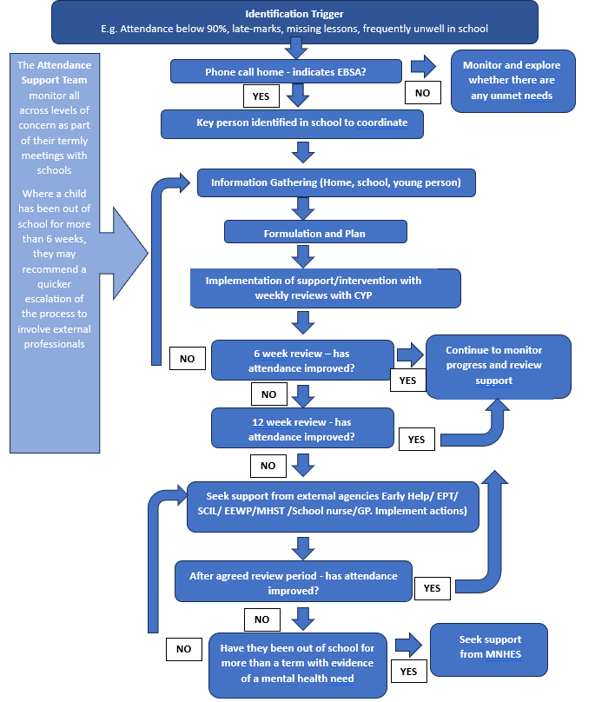

When considering implementation of provision, reference should also be made to [Bradford’s Matrix of Need](https://bso.bradford.gov.uk/userfiles/file/EPT/Bradford%20Matrix%20of%20Need%20v2_2%20RD260421.pdf).

## A message of hope: Success Stories

It is important to recognise even small steps of success.

Sometimes things may seem to take a step backwards, or a young person may have a difficult day. This is to be expected and it is important to maintain a sense of hope and optimism in what can appear like a very stuck situation.

We have some examples of success and hope from our local surveys and focus groups and hope to continue to add to this with your support.

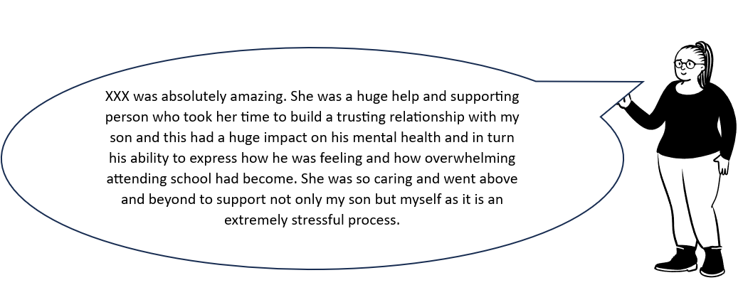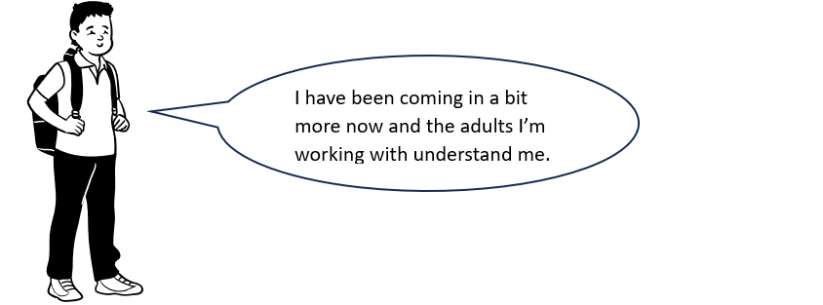

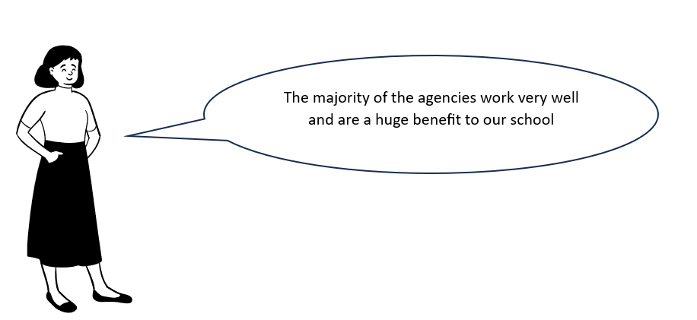

# Toolkit/Appendix

## Appendix 1: Whole School Approach

### Appendix 1.1 Whole School Audit Tool



### Appendix 1.2 Information for school staff



Useful Videos created by young people who have experienced EBSA

CYP Voice: School is not my enemy [video](https://vimeo.com/339941486)

CYP Voice: Walk in My Shoes [video](https://www.donaldsons.org.uk/walk-in-my-shoes/)

### Appendix 1.3 Information leaflet for families



### Appendix 1.4 Information leaflet for students (Primary)



### Appendix 1.5 (Information leaflet for students (Secondary)



### Appendix 1.6 Transition

[School Transition and Adjustment Research Study (STARS)](https://www.ucl.ac.uk/pals/research/clinical-educational-and-health-psychology/research-groups/school-transition-and-adjustment)

[Bradford’s Transition Booklets](https://bso.bradford.gov.uk/userfiles/file/Andrew/SCIL%20Autism/Transition%20to%20new%20class%20In%20school%20-%20Upper%20Primary.docx)

[Anna Freud Transition Resources](https://www.annafreud.org/schools-and-colleges/resources/moving-up-the-transition-to-secondary-school-animation-teacher-toolkit/%20)

[Young Minds Transition Resources](https://www.youngminds.org.uk/professional/resources/supporting-school-transitions/)

[School Concerns Questionnaire (UCL)](https://www.ucl.ac.uk/pals/sites/pals/files/school_concerns_questionnaire.pdf)

[What-if-cards.pdf (elsa-support.co.uk)](https://www.elsa-support.co.uk/wp-content/uploads/What-if-cards.pdf)

### 

### Appendix 1.7 EBSA and Autism

Awareness and Understanding of Autism:



<https://westsussex.local-offer.org/information_pages/460-emotionally-based-school-avoidance>

(Information for parents, West Sussex, 2022)

Bradford’s [Social Communication Interaction and Learning (SCIL) Team](https://bso.bradford.gov.uk/content/scil-team) can also support schools with developing their provision to meet the needs of young people with autism.

Working with parent/carers:

* Bradford-based support for parents/carers include [AWARE](https://aware-uk.org/) and [Cygnet (Barnardos)](https://www.barnardos.org.uk/get-support/services/bradford-parenting-cygnet-service)
* [Bradford Local Offer | Children's Community Support Team (C.C.S.T.)](https://localoffer.bradford.gov.uk/kb5/bradford/directory/service.page?id=bu4T90qt0nE&localofferchannel=153),
* [Emotionally Based School Avoidance (EBSA) and Autism - Information for parents and carers – West Sussex](https://schools.westsussex.gov.uk/Pages/Download/6ccfab16-b1b1-4ed0-ace0-269d19e60baf/PageSectionDocuments)
* Please see resource list for supporting families (Appendix 4.2)

## Appendix 2: Early Identification and Information Gathering

### Appendix 2.1 Gathering information from parents/carers



### Appendix 2.2 Round Robin



### Appendix 2.3 Risk and Resilience Scales and scoring from EdPsychEd

A video of how to use the profiles can be found here:

[EBSA | The EBSA Risk and Resilience Profiles (incl. scoring) | CYP (edpsyched.co.uk)](https://www.edpsyched.co.uk/risk-and-resilience-schools)



### Appendix 2.4 My School Timeline Activity



### Appendix 2.5 Example of ‘Zones’ and ‘Incredible 5-Point Scale’ Activities



[Incredible Five Point Scale](https://www.5pointscale.com/)

### Appendix 2.6 Pupil Voice activities



### Appendix 2.7 West Sussex activity booklet: Planning a return to school

** **

### Appendix 2.8 Card Sort Activity



### Appendix 2.9 Ideal School Activity

[The Ideal School Activity Pack Jericah Holder (EdPsychEd)](https://www.edpsyched.co.uk/ideal-school-resource-schools)

### Appendix 2.10 Bradford’s Formulation Proforma



## Appendix 3: Targeted Support

### Appendix 3.1 Support Plan Template

********

### Appendix 3.2 Psychoeducation / therapeutic resources

* Help! I’ve Got an Alarm Bell Going Off in My Head!: How Panic, Anxiety and Stress Affect Your Body (K L Aspden, 2015)
* Starving the Anxiety Gremlin (Kate Collins-Donnelly, 2013)
* Think Good, Feel Good (Paul Stallard, 2018)
* Your Life Your Way (Ciarrochi and Hayes, 2020)
* The Thriving Adolescent (Louise Hayes, 2015) book and [online resources](https://dnav.international/downloads/).
* [Promoting Emotional Resilience](https://hbtg.org.uk/wp-content/uploads/2015/06/KAN-Emotional-resilience-toolkit.pdf)
* The Worry Workbook: The Worry Warriors' Activity Book (Imogen Harrison, 2020)
* What to do when you worry too much: A kids guide to overcoming anxiety (Dawn Huebner, 2005).
* The Homunculi Approach to Social and Emotional Wellbeing: A Flexible CBY programme for Young People on the Autistic spectrum or with Emotional and Behavioural Difficulties (Anne Greig and Tommy MacKay, 2013).
* CYP Video: [Stress on the Brain](https://www.youtube.com/watch?v=fhI9KLwfpbM)
* [Anxiety Canada - My Anxiety Plan (MAP) for Children and Teens Link](https://maps.anxietycanada.com/courses/anxiety-plan-children-teens/)

Cognitive Behavioural Therapy (CBT)

Cognitive Behavioural Therapy (CBT) is a reflective and goal-oriented approach to help young people to manage their thoughts, emotions, and behaviours. It focuses on the idea that our thoughts can influence our feelings and actions. In education, CBT is often used to teach young people how to identify and challenge negative thought patterns, develop skills, and build resilience.

Cognitive Behavioural Therapy (CBT) can be a valuable tool for addressing Emotionally Based School Avoidance (EBSA) by helping young people to identify negative thoughts about school. CBT teaches practical skills to recognise emotions and develop strategies to help with school-related fears, which can be helpful when used alongside other adjustments to the environment or school situation.

CBT information and worksheets can be accessed for free at [CBT Worksheets | Therapist Aid](https://www.therapistaid.com/therapy-worksheets/cbt/none)

Acceptance and Commitment Therapy (ACT)

Acceptance and Commitment Therapy (ACT) is a practical approach that helps young people to manage difficult thoughts and emotions while staying committed to their values and goals. ACT encourages accepting feelings without judgment and guides young people to take actions that are aligned with their personal values, promoting emotional well-being and supporting a positive school experience despite the emotional challenges they may face.

The Thriving Adolescent (Louise Hayes) and the [DNA-V website](https://dnav.international/dna-v-for-youth/) offers helpful ideas and resources to support the implementation of Acceptance and Commitment Therapy in schools.

### 

### Appendix 3.3 Interventions to increase flexibility when considering change

Motivational Interviewing

Motivational Interviewing is a collaborative and non-judgmental approach to enable young people to talk about their goals. It helps them to explore their own reasons for positive change through supportive conversations with key adults. Motivational Interviewing can help young people to express their feelings and motivations surrounding school attendance, whilst allowing schools to understand the underlying reasons for school avoidance and collaboratively explore strategies for positive change. Through empathetic conversations, Motivational Interviewing focuses on building internal motivation to empower young people to overcome emotional challenges associated with attending school, ultimately promoting a more positive and constructive approach to school engagement.

The following resource is helpful when implementing Motivational Interviewing in an educational setting: Motivational Interviewing in Schools (Rollnick, Kaplan et al., 2016)

Solution-Focused Approaches

Solution-Focused approaches supports young people to identify their strengths and envision small, achievable steps towards success. Instead of adopting a problem-focused approach, a Solution-Focused approach concentrates on what is already working well, fostering a positive and forward-looking mindset and helping young people to feel confident in their ability to overcome obstacles. This approach can be supportive for addressing EBSA through shifting the focus towards practical solutions and positive outcomes, as well as identifying the young person’s unique strengths, setting achievable goals to promote school attendance and emphasising successes.

The NSPCC provides a helpful framework to support the implementation of Solution-Focused practice within schools: [Solution Focused Practice, NSPCC](https://learning.nspcc.org.uk/research-resources/2015/solution-focused-practice-toolkit).

**The ‘Miracle Question’**

Sometimes a ‘miracle question’ is used which asks young people to imagine their life without the current problem, helping them clarify their goals and envision positive change. In the context of school avoidance, it helps them to explore a future where challenges with attending school have been overcome. An example of this might be:

‘Imagine that you wake up one day and a miracle has happened overnight. All the worries or problems about going to school are gone and everything just feels better. What's the first thing you notice that tells you things have changed? How do you feel or act differently now that going to school is no longer a stress or worry for you? What will you see/hear? Who else will notice?’

### Appendix 3.4 Avoidance Hierarchy Template



### Appendix 3.5 Examples of a One Page Profile

[One Page Profile - National Development Team for Inclusion)](https://www.ndti.org.uk/assets/files/a.-one-page-profile-editable.pdf)

[One Page Profile - sheffkids.co.uk](https://sheffkids.co.uk/resources/)

### Appendix 3.6 Emotion Coaching

Emotion Coaching is a relational communication style which can develop emotional understanding and management of emotions. It seeks to respond to emotions in an attuned way, ‘connection first’ way by being curious and acknowledging emotions.

More information can be found here [Emotion Coaching](https://www.emotioncoachinguk.com/resources-for-professionals-parents-carers)

Training can be requested via the Educational Psychology Team or the [Virtual School](https://bso.bradford.gov.uk/Schools/CMSPage.aspx?mid=3447)

The following table can help with developing communication scripts:

|  |  |  |
| --- | --- | --- |
| Emotion Coaching Step | Description | Example |
| Step 1. Recognise feelings and empathise | Pay attention to the young person’s feelings and put yourself in their shoes. Consider a time when you may have experienced a similar emotion. | *I remember feeling incredibly anxious about giving a presentation at work and not wanting to go in that day…I wonder whether the young person feels that emotion every day they’re in school?* |
| Step 2. Label and validate the emotion | Help the young person to feel you understand and acknowledge their emotions. This includes labelling the feeling for the young person to provide them with the emotional vocabulary and help them to feel validated. | "I’m wondering whether going to Maths lessons might be making you feel anxious or worried. It's normal to have these feelings, and I want you to know that I'm here to understand and support you." |
| Step 3. Positive limit setting (if needed) | Limit setting involves establishing and communicating boundaries for behaviour while still acknowledging and validating the young person's emotions. This should be phrased in a positive way. | ‘It's okay to find certain subjects challenging. Attending Maths is important for helping to develop skills that will be important for your future, like managing money and budgeting, so we will work together to find ways to make it more manageable and enjoyable for you to attend lessons’ |
| Step 4. Problem-Solving | Engage the young person in finding solutions to address the specific challenges they face at school. Work together to develop strategies that make attending school more manageable and less emotionally overwhelming. | ‘Let's have a think about some strategies to make Maths lessons more enjoyable for you. Perhaps we can explore additional resources, consider extra help, or find ways to make the learning process more engaging. What do you think might help you feel better about attending your Maths lessons?’ |

## Appendix 4: Support Services

### Appendix 4.1: Local Support Services

The following websites provide useful information about local service offers:

|  |
| --- |
| **Family and Young Person’s Information Service** |
| <https://fyi.bradford.gov.uk> |
| A free impartial service offering advice, information and signposting to children, young people and families within the Bradford district. |

### 

|  |
| --- |
| **Healthy Minds: Support for Schools** |
| [Support for schools – Healthy Minds](https://www.healthyminds.services/support/schools) |
| Information, services and activities designed to help schools and teachers support their students' mental health and wellbeing |

The following services have kindly provided information about the support they offer in relation to EBSA and how this can be accessed:



### Appendix 4.2 Resource List for supporting Families

* Autism specific: Bradford-based support for parents/carers include [AWARE](https://aware-uk.org/) and [Cygnet (Barnardos)](https://www.barnardos.org.uk/get-support/services/bradford-parenting-cygnet-service)
* [Bradford Local Offer | Children's Community Support Team (C.C.S.T.)](https://localoffer.bradford.gov.uk/kb5/bradford/directory/service.page?id=bu4T90qt0nE&localofferchannel=153),
* [Square Peg](https://www.teamsquarepeg.org)
* [Not Fine in School](http://www.notfineinschool.co.uk)
* [Somerset Emotionally Based School Avoidance: Training for Parent/Carers](https://www.supportservicesforeducation.co.uk/Page/19956)
* [Plymouth City Council: Information for parents and carers to support children and young people experiencing Emotionally Based School Avoidance](https://www.plymouth.gov.uk/sites/default/files/publication_100_EBSA-Guidance-for-parents.pdf).
* [Five Tips for Emotionally Based School Avoidance | Suffolk County Council](https://www.suffolk.gov.uk/children-families-and-learning/pts/if/five-tips/)
* [The Invisible String By Patrice Karst](https://www.amazon.co.uk/Invisible-String-Patrice-Karst/dp/031648623X/ref=sr_1_1?dchild=1&keywords=Invisible+String+By+Patrice+Karst&qid=1625861242&s=books&sr=1-1)

# References

Bahali, K., Tahiroglu, AY., Avci A. and Seydaoglu, G. (2011). Parental psychological symptoms and familial risk factors of children and adolescents who exhibit school refusal. East Asian Arch Psychiatry, 21(4), 164-9.

Baker, M. and Bishop, F.L. (2015). Out of school: a phenomenological exploration of extended Non-attendance. Educational psychology in Practice, 31(4), pp.354-368.

Berg, I., Nichols, K. and Pritchard, C. (1969). School phobia--its classification and relationship to dependency. Journal of Child Psychology and Psychiatry, 10(2), 123-41.

DfE. (2014). Special educational needs and disability code of practice: 0 to 25 years. Department for Education. <https://www.gov.uk/government/publications/send-code-of-practice-0-to-25>

DfE. (2022). Working together to improve school attendance. Department for Education. <https://www.gov.uk/government/publications/working-together-to-improve-school-attendance>

Education Act. (1996). Available at [https://www.legislation.gov.uk/ukpga/1996/56/contents tion.gov.uk)](https://www.legislation.gov.uk/ukpga/1996/56/contents%20tion.gov.uk)).

Elliott, J. G. (1999). Practitioner Review: School Refusal: Issues of Conceptualisation, Assessment, and Treatment. J. Child Psychology & Psychiatry, 40 (7), pp. 1001-1012.

Finning K. et al. (2019). Emotional disorder and absence from school: findings from the 2004 British Child and Adolescent Mental Health Survey. European Child & Adolescent Psychiatry, 29(2), 187-198.

Gaus, V. L. (2011). Cognitive behavioural therapy for adults with autism spectrum disorder. Advances in Mental Health and Intellectual Disabilities, 5(5), 15-25.

Gee, K. A. (2018). Minding the Gaps in Absenteeism: Disparities in Absenteeism by Race/Ethnicity, Poverty and Disability. Journal of Education for Students Placed at Risk (JESPAR), 23, 1–2.

Gregory, I.R. and Purcell, A. (2014). Extended school non-attenders’ views: Developing best practice. Educational Psychology in Practice, 30(1), pp.37-50.

Gulliford, A. and Miller, A. (2015). Coping with life by coping with school? School refusal in young people. In *Educational Psychology Ed*. Hove: Routledge.

Heyne, D., & Brouwer-Borghuis, M. (2022). Signposts for school refusal interventions, based on the views of stakeholders. Continuity in Education, 3, 25-40.

Heyne, D., Gentle-Genitty, C.S., M., Melvin, G.A., Keppens, G., O’Toole,C., & McKay-Brown, L. (2024). Embracing change: From recalibration to radical overhaul for the field of school attendance. Frontiers in Education 8, Article 1251223. <https://doi.org/10.3389/feduc.2023.1251223>

Higgins, M. (2022*).*[The Ideal School: Exploring the perceptions of autistic students experiencing Emotionally Based School Non-Attendance (EBSNA).](https://repository.essex.ac.uk/33345/)  Other thesis, University of Essex & Tavistock and Portman NHS Foundation Trust.

Holder, J. (2022). EBSA Horizons. Ed Psych Ed. Accessible at: <https://www.edpsyched.co.uk/ebsa-horizons>

Ingles, C. J., Gonzalvez, C., Garcia-Frenandez, J. and Juan, M. V. (2015). Current status of research on school refusal. European Journal of Psychology of Education, 8(1), 37-52.

Kearney, C. A. (2002). Identifying the function of school refusal behavior: A revision of the School Refusal Assessment Scale. Journal of Psychopathology and Behavioral Assessment, 24(4), 235–245.

Kearney, C. A. (2008). School absenteeism and school refusal behaviour in youth: A contemporary review. Clinical psychology review, 28(3), pp.451-471.

Kearney, C. A. and Silverman, W. K. (1990). A preliminary analysis of a functional model of assessment and treatment for school refusal behavior. Behavior Modification, 14(3), 340–366.

Kearney, C. A., Benoit, L., Gonzálvez, C., and Keppens, G. (2022). School attendance and school absenteeism: a primer for the past, present, and theory of change for the future. Front. Educ. 7:1044608.

King, N. J. and Bernstein, G. A. (2001). School refusal in children and adolescents: a review of the past 10 years. Journal of the American Academy of Child & Adolescent Psychiatry, 40(2), 197-205.

Lancashire County Council. (2022). Emotionally Based School Avoidance Guidance. Lancashire Educational Psychology Service EBSA Working Group. Available at: [lancashire-ebsa-guidance-strategy-toolkit-2023-update.pdf](https://www.lancashire.gov.uk/media/930428/lancashire-ebsa-guidance-strategy-toolkit-2023-update.pdf)

Marschall, A, (2022) What is masking in mental health. Verywellmind.com, <https://www.verywellmind.com/what-is-masking-in-mental-health-6944532>

Maynard, B. R., Brendel, K. E., Bulanda, J. J., Heyne, D., Thomspon, A. and Pigott, T. D. (2015). Psychosocial interventions for school refusal with primary and secondary students: A systematic review. Campbell Systematic Reviews, 11, 1-76.

McLeod, B.D., Wood, J.J. and Klebanoff, S. (2015). Advances in evidence-based intervention and assessment practices for youth with an autism spectrum disorder. Behavior Therapy, 46, 1-6.

McNaughton, D. and Vostal, B. R. (2010). Using Active Listening to Improve Collaboration With Parents: The LAFF Don’t CRY Strategy. Intervention in School and Clinic, 45(4), 251-256.

Moran, H. (2001). Who do you think you are? Drawing the Ideal Self: A technique to explore a child's sense of self. Clinical Psychology and Psychiatry, 6, 599-604.

Munkhaugen, E. K., Gjevik, E., Pripp, A. H., Sponheim, E. and Diseth, T.H. (2017). School refusal behaviour: Are children and adolescents with autism spectrum disorder at a higher risk? Research in Autistic Spectrum Disorders, (41-42), pp.31-38.

NICE. (2013). Autism spectrum disorder in under 19s: support and management. Clinical Guidance. Available at: [Autism spectrum disorder in under 19s: support and management (nice.org.uk)](https://www.nice.org.uk/guidance/cg170/resources/autism-spectrum-disorder-in-under-19s-support-and-management-pdf-35109745515205)

Office for Statistics Regulation. (2023). Pupil absence in schools in England: autumn and spring terms 2022/23. Available at: <https://explore-education-statistics.service.gov.uk/find-statistics/pupil-absence-in-schools-in-england#explore-data-and-files>

O’Hagan, S., Bond, C., & Hebron, J. (2021). What do we know about home education and autism? A systematic review. Research in Autism Spectrum Disorders. 80.

Ozsivadjian, A. and Knott, F. (2016) Anxiety problems in young people with autism spectrum disorder: a case series. Clinical Child Psychology and Psychiatry, 16(2), 203-14.

Pellegrini, D. (2007). School non-attendance: definitions, meanings, responses, interventions. Educational Psychology in Practice, 23(1), 63-77.

Public Health England working with the Department for Education. (2021). Promoting children and young people’s mental health and wellbeing A whole school or college approach. Available at: <https://assets.publishing.service.gov.uk/media/614cc965d3bf7f718518029c/Promoting_children_and_young_people_s_mental_health_and_wellbeing.pdf>

Reaven, J., Blakeley-Smith, A., Culhane-Shelburne, K. and Hepburn, S. (2012), Group cognitive behavior therapy for children with high-functioning autism spectrum disorders and anxiety: a randomized trial. Journal of Child Psychology and Psychiatry, 53, 410–419.

Rice, F., Frederickson, N., Shelton, K., McManus, C., Riglin, L. and Ng-Knight, T. (2015). Identifying factors that predict successful and difficult transitions to secondary school. The Nuffield Foundation. Available at: <http://nuffieldfoundation.org/sites/default/files/files/STARS_report.pdf>

Sawyer, R. and Collingwood, N. (2023). SPIRAL: parents’ experiences of emotionally-based school non-attendance (EBSNA) informing a framework for successful reintegration. Educational Psychology in Practice, DOI: [10.1080/02667363.2023.2285457](https://doi.org/10.1080/02667363.2023.2285457)

Sheffield Educational Psychology Service. (2020). Emotionally Based School Avoidance Guidance for professionals working with families and young people. Available at: <https://www.sheffielddirectory.org.uk/media/w0hbiriz/ebsa-guidance-sheffield-eps-final.pdf>

Steensel, F. J. A., Zegers, V. M. and Bögels, S. M. (2017) Predictors of Treatment Effectiveness for Youth with ASD and Comorbid Anxiety Disorders: It all Depends on the Family. Journal of Autism and Developmental Disorders, 47, 636.

Thambirajah, M. S., Grandison, K.J. and De-Hayes, L. (2008). *Understanding school refusal: A handbook for* *professionals in education, health and social care* London: Jessica Kingsley.

Ting, V. and Weiss, J.A. (2017). Emotion Regulation and Parent Co-Regulation in Children with Autism Spectrum Disorder. Journal of Autism and Developmental Disorders, 47, 680-68.

Van Steensel, F. J., Bögels, S. M. and Perrin, S. (2011). Anxiety disorders in children and adolescents with autistic spectrum disorders: a meta-analysis. Clinical Child and Family Psychology Review, 14(3), 302-17.

West Sussex. (2022). Emotionally Based School Avoidance: Good practice guidance for schools and support agencies. West Sussex County Council. Available at: <https://schools.westsussex.gov.uk/Pages/Download/c5b4a7c0-81b1-4d5e-a3ae-aa0ebe689b05/PageSectionDocuments>

Williams, J. and Hanke, D. (2007). 'Do you want to know what sort of school I want?': optimum features of school provision for pupils with autistic spectrum disorder. Good Autism Practice, 8(2), 51-63.

Wolpe, J. (1958). *Psychotherapy by reciprocal inhibition*. Stanford, CA: Stanford University Press.