Soldiers of the Empire

A project to commemorate the centenary of end of First World War
And remembering the forgotten soldiers from Undivided India who fought for Britain

Dear Teacher,

Our project “Soldiers of the Empire” is about the contribution made by soldiers from Undivided India who supported the British Empire during World War I.

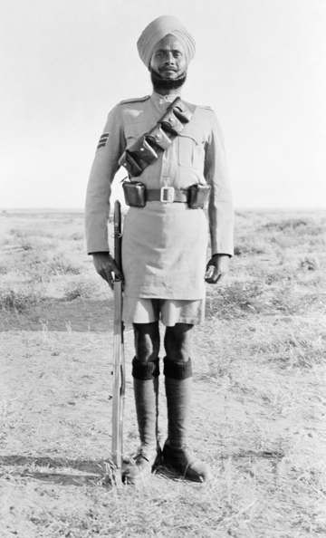
During our visit to your school we talk about these forgotten soldiers, touching upon the historic positive relationship between Great Britain and the Indian sub–continent.

In this workshop we will also share a beautiful Indian dance for world peace and harmony and teach children the many hand gestures and rhythms of dance .

Please find enclosed a more detailed information pack about our research on this subject for your interest.
Available week beginning 5th of November .
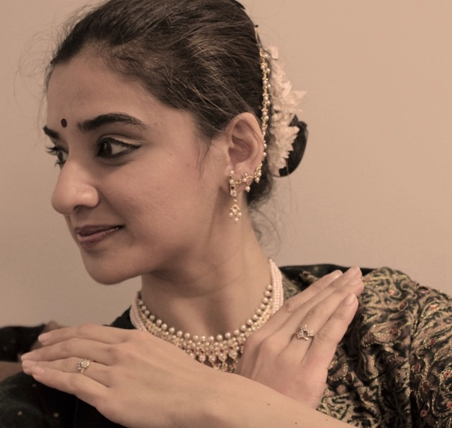
Cost for the morning or afternoon session lasting approximately an hour is only £80.00 (schools outside Halifax Travel costs upto £10.00 apply)

For more information Please contact us on :
info@annapurnadance.com
www.annapurnadance.com

Mob: 07737759783
Landline: 01422 209906

