Bradford’s Language for Learning Strategy
are once again proud to present:

The Talking School Conference 2015

Talk for deepening learning: strategies for raising standards

This conference for headteachers and senior managers will provide national and local key messages and inspirational training on successful whole school development of talk and communication.

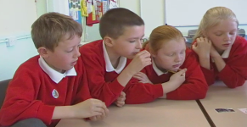
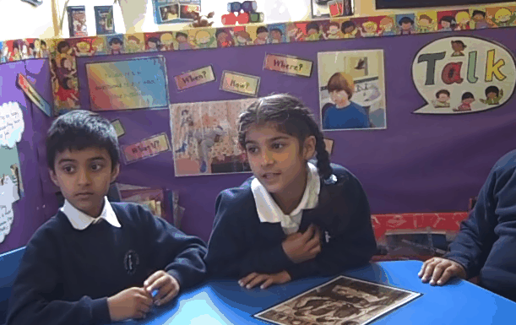


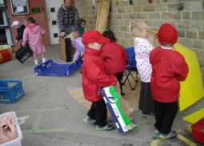
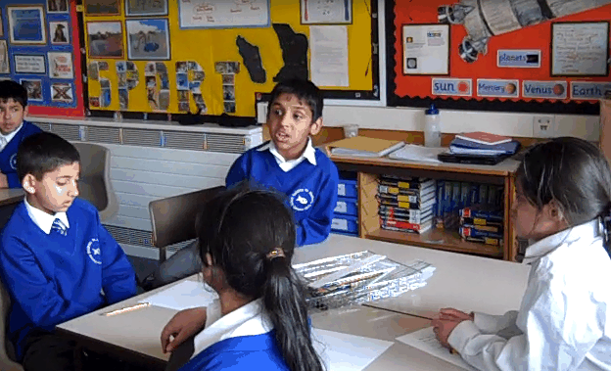
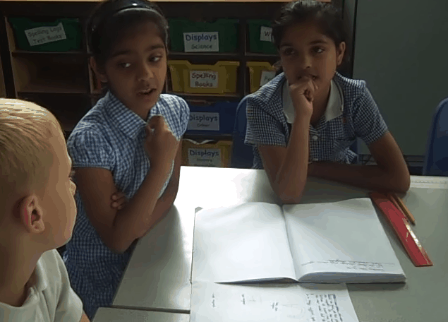


Language for Learning

Neil Mercer: Enabling learning and raising standards through talk
Neil Mercer is Professor of Education at the University of Cambridge. One of the country’s leading researchers into talk in the primary classroom and joint creator of Thinking Together, his most recent books are Exploring Talk in School, Dialogue and the Development of Children’s Thinking and Interthinking: putting talk to work.

Sue Palmer: Talk for Learning, for Literacy, and for Life!
Sue Palmer, a former primary headteacher, is an independent writer and consultant on literacy and child development. Her book Toxic Childhood: how modern life is damaging our children… and what we can do about it helped spark a debate throughout the UK about the nature of modern childhood.

Plus a range of exciting workshops [national and local workshop leaders]
  - Speaking Scientifically - Claire Holt
  - Developing Language in My Classroom - Clare Reed and Catherine Pass
  - Get the Picture: using visual materials to provoke talk in History and Geography –
Julia Tanner
  - Developing comprehension through talk - Malcolm Kerridge
  - Developing a love of stories - why working with all parents matters - Sarah Gordon and Ermina Kesedzic
  - Get the point? A debating society in your school - The Woolsack Debating Society

Audience: Headteachers, Deputy Headteachers, Subject Leaders
Date: Tuesday 14th April
Venue: The Midland Hotel, Bradford
Time: 9.00 – 3.45 [registration from 8.15]
Cost: £105

Book early to avoid disappointment – last year’s conference sold out very quickly!

Language for Leaning
The Talking School Conference 2015 Booking Form

School Name
and Address:

1: Name:

Email address:

Position in
school:

Special
requirements:
e.g. access/dietary

2: Name:

Email address:

Position in
school:

Special
requirements:
e.g. access/dietary

Please return this completed booking form to:
Address: Tracey Parry, Green Lane Primary,
Green Lane, Bradford, BD8 8HT
Email: tracey.parry@greenlane.ngfl.ac.uk

All enquiries: tracey.parry@greenlane.ngfl.ac.uk

All applicants will receive confirmation of their booking by letter prior to the event. The full conference fee will be charged for cancellations unless the place is cancelled ten working days prior to the conference date.

PLEASE PHOTOCOPY AN ADDITONAL FORM IF YOU REQUIRE MORE THAN TWO PLACES

Your school will be sent an invoice in April

Purchase Order No

Name of payee for purchase order purposes: Green Lane Primary, Green Lane, BD88HT

