Information for Schools
Welcome to Walkshire, an exciting new web based initiative developed by the West Yorkshire Passenger Transport Executive (Metro) and the five district councils (Leeds, Bradford, Calderdale, Kirklees and Wakefield). The aim of Walkshire is to promote more congestion busting, healthy and environmentally friendly ways of travelling to school. The site is hosted by Metro at walkshire.generationm.co.uk.

How does it work?
Pupils are invited to help two characters called Footlings who are on a quest to save the land of Walkshire from an evil dragon called Fumes. In order to complete the quest, the Footlings must travel around Walkshire collecting pieces of treasure as they go. Throughout their journey they are pursued by Fumes who is trying to reach the treasure first. The Footlings journey is charted on an on-line map of Walkshire, an imaginary land based on the real district of West Yorkshire. The 3 pieces of treasure (bronze, silver and gold) are placed at intervals on the map and are collected along the journey. A congratulations message pops up each time a piece of treasure is acquired. The more of the three coins your school manages to collect, the more chances to win prizes your school will be entered for.
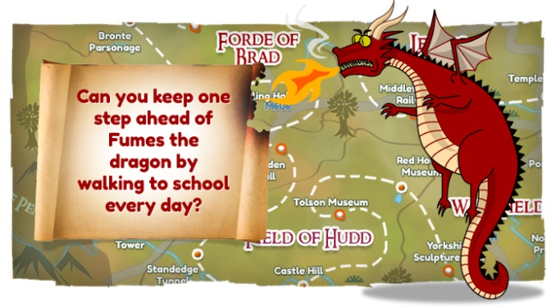
Walkshire is designed to be a challenge running over 6 weeks. To make the Footlings move around the map, schools must log in to the Walkshire website every week for the 6 weeks and enter data about how many pupils have walked, scooted or cycled to school. Pupil journeys are then converted to ‘miles’. These miles are not a real representation of the distance children are travelling to school, the key factor is how many children are walking, scooting and cycling to school, particularly those who weren’t doing so previously.
The challenge can only be completed if pupil’s sustainable travel journeys increase by 10% or more over a 6 week period. The 6 weeks do not have to run consecutively and can be separated, for example, by a half term break or due to a week of poor weather, however data can only be entered a maximum of 6 times.
The more pupils switch from travelling by car to walking, cycling or scooting, the quicker the Footlings will travel around the map, collect all three pieces of treasure and complete their quest. Schools may be able to complete the challenge in less than 6 weeks if they significantly increase the number of pupils who walk, scoot and cycle to school

When will it happen?
Schools taking part in the challenge in the 2013/14 school year will be able to start logging their miles on the Monday of any week from the week commencing the 28th of April (after Easter) through to the week commencing the 2nd of July 2014 (After Spring Break). You should consider that you may want to register your school and survey the number of pupils already walking, cycling and scooting to school before the first week of taking part in the scheme. Any later and the school will not be eligible for the prize draws detailed below. As stated above the 6 weeks do not have to run consecutively and can be separated, for example, by a half term break or due to a week of poor weather. However, schools should aim to enter a total of six weeks of data, on six occasions to be in with their best chance of winning prizes.

Prizes
Prizes for the Walkshire Challenge will be in the form of three prize draws which relate to the gold, silver and bronze coins. Schools that manage to collect the gold, silver and bronze coins in their journey around the challenge will be entered into all three prize draws. Those that get as far as the silver coin will entered into the silver and bronze draws. Those that get as far as the bronze will only be entered into the bronze draw. Thus the challenge will reward those schools where a greater percentage of children walk to school with more chances to win.

Details are being finalised as to what will go into each prize draw. The gold draw will be the biggest prize with silver and bronze proportionally smaller. The aim is that the prizes will be a combination of items to be enjoyed by both the whole school (e.g. sports equipment vouchers) and by individual pupils (e.g. free passes / discounts) to maximise the motivation to take part. All schools that take part in the challenge will be informed of the final contents of the prize draws at the earliest opportunity.

Schools will be informed whether they have won one of the prize draws in the week commencing the 14th of July. Schools should be aware that some prizes may be for individual children but not available in large enough numbers to go to every child at the school. As such schools should be prepared to arrange their own internal prize draws or other system to see which individuals, classes or year groups should receive such prizes.

The system will ask schools if they wish to run the challenge again at the end of the six weeks. Schools are free to do so but the above prize draw entries will only relate to their first six week run partaking in the challenge (at least in the 2013/14 school year, arrangements are not in place for 2014/15 as yet).

Class Resources
As the Footlings move around the map, chapters of a story are unlocked telling the tale of their adventures. The chapters can be downloaded along with fun facts about the real West Yorkshire landmarks the Footlings have passed on the journey. The fact sheets can be used as class resources and include; road safety advice, jokes, recipes, and information about the geography and history of West Yorkshire and some of its famous characters.

School Challenge
The Walkshire initiative is not designed to be a competition between schools. It is intended as a challenge for individual schools to try to increase the number of pupils walking, cycling and scooting to school by 10% over a maximum period of 6 weeks. However, schools can view the results table and compare their progress with other schools if they wish.

The Walkshire initiative is designed to be a whole school based challenge. In some cases it might be possible for individual classes and year groups to take part but please contact your local authority to find out more (contacts under the ‘About Walkshire’ tab)

There will be no ‘bonus miles’. A previous similar challenge was able to accommodate the award of additional miles for special additional efforts such as fancy dress walk to school days or the establishment of walking buses. With regret the new system cannot fairly accommodate such a bonus. Of course schools should continue to make such efforts as they will get more children walking and increase the chance of winning a prize draw.

How does my school take part?
- Conduct surveys of the children in your school/class to find out how many currently walk, scoot or cycle to school. Children who are driven to school but park 500 metres or more from the entrance and walk the rest of the journey can be classed as walkers.
- Register your school by clicking on the “sign up now” button on the Walkshire home page at www.generationm.co.uk and complete the registration information as follows:
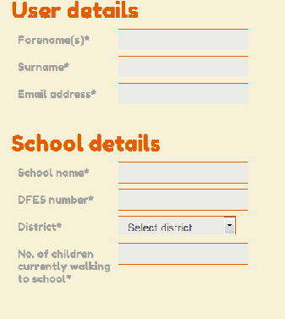

Add the name and email address of the person who will be entering pupil travel data

Add the full name of the school
Add your seven digit DFES number
Select the district in which your school is located

Enter the number of pupils who currently walk, cycle or scoot to school. Pupils who park 500m or more from school and walk the rest of the journey can be counted as walkers

- Promote the initiative to pupils, parent/carers and staff through letters and assemblies. An information sheet for parents/carers can be downloaded from the Resources tab.
(It is worth considering that steps 1 to 3 should happen before the week commencing the 2nd of July in order to start and therefore complete the challenge in time to enter a prize draw).
- Survey your pupils every week for a maximum of 6 weeks in order to find out how they travel to school.
- Log in to the Walkshire pages at walkshire.generationm.co.uk every week for a maximum of 6 weeks using your registered email address and your 7 digit DfES number.
- Submit the total number of pupils who have walked, cycled or scooted to school each week by clicking the Map tab and completing the data entry box. Children who are driven to school but park more than 500m from the entrance and walk the rest of the journey can be classed as walkers.
- Note that data can only be entered a maximum of 6 times however the 6 weeks do not have to run consecutively
Note that where the whole school or year is taking part individual classes must not submit the numbers as in step 6. This should be handled by school administration. Classes will still be able to check on the Footlings progress around the map if they have the schools sign in details.
- Click on the Map tab at any time to look at your school’s progress.
- Go to the Results tab to see how many coins your school has collected and how you are progressing compared to other schools.
- Download chapters of the story and fun fact sheets by clicking on the Resources tab.
- Contact your local authority when you have completed the quest to claim your certificate or to see if you are eligible for a prize. Click on the Prize tab for local authority contact details.
- Repeat the challenge at any time. Walkshire will be available at walkshire.generationm.co.uk for the foreseeable future. If you would like to have another go, first contact your local authority so that they can reset your registration information. (please note the earlier relevant point regarding prizes).

