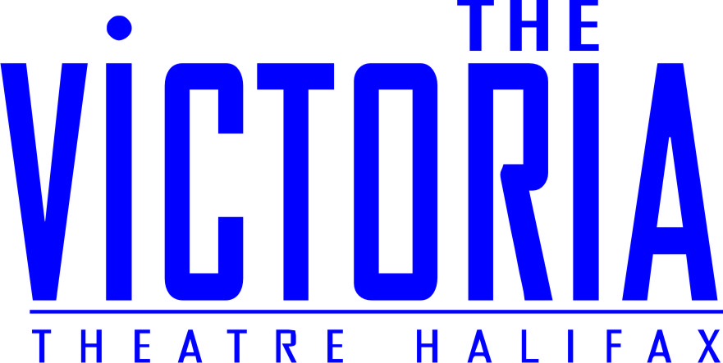

Special Offer: An Evening with Steven Berkoff for just £7.50
Sunday 28 September, 7.30pm at the Victoria Theatre, Halifax

If you’ve ever wondered what it’s like to play Hollywood baddies in classics such as A Clockwork Orange, Rambo and Girl With a Dragon Tattoo, now is your chance to find out. Berkoff will be lifting the lid on his colourful life and career as not only an actor, but an award-winning writer and director.
Berkoff is best known to the public as one of Hollywood’s favourite baddies, having starred in movies such as A Clockwork Orange, Octopussy, Beverley Hills Cop, Rambo and more recently The Girl With The Dragon Tattoo.
When not playing a baddie, Berkoff works as a playwright, author and director. His plays and adaptations have been performed all over the world; they include Kafka’s Metamorphosis and The Trial, Agamemneon after Aeschylus, and Poe’s The Fall of the House of Usher and The Tell Tale Heart. He has also directed and toured productions of Hamlet, Macbeth and Oscar Wilde’s Salome.
Berkoff has also published collections of short stories, production journals, travel writing, poetry and his autobiography, Free Association. Born in London in 1937, he studied Drama in London and Paris and performed with repertory companies before forming the London Theatre Group in 1968.
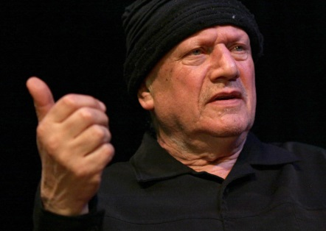Give your students a unique An Audience with Steven Berkoff on Wednesday 15 October, 7.30pm.
We’re offering you the special price of £7.50 per ticket (including a £1 Theatre Support Fee). Book online or by calling the box office on 01422 351158. Or if you’re in the area, why not drop by in person? Our friendly box office team is happy to help.
We hope you can join us for this exciting event!

