Special Schools Offer: Phoenix Dance Theatre for just £7.50

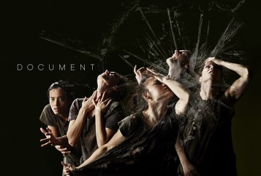This autumn the Victoria Theatre is thrilled to be hosting one of the country’s most acclaimed contemporary dance companies – Phoenix Dance Theatre, who will present their scintillating 2014 Mixed Programme on 22 October. With a free after-show Q & A from the company, this would be a great educational opportunity for your students, which is why we’re offering the special price of just £7.50 per student ticket.

As well as presenting two world premieres, the programme features a fresh chance to experience a company classic. The evening is essential viewing for lovers of dance, sizzling physical theatrics or quite simply a jaw dropping night of entertainment.

The triple bill includes Document by the exciting European choreographic duo Ivgi &Greben. Powerful and brooding, the piece takes five dancers through a relentless and hard-hitting struggle with the darkest of human emotions. Didy Veldman’s See Blue Through plunges the stage into a fascinating, mysterious undersea world. Featuring sensuous, elastic choreography and costumes and an atmospheric Alfred Schnittke score, this audience favourite was first performed by the company in 2005. Darshan Buller’s Mapping encapsulates the innovative and dynamic choreography. Inspired by his father’s journey from East to West, the former Phoenix Artistic Director looks down on the world from above, resulting in a thrillingly inventive new performance.

“Phoenix Dance Theatre is on a high… The 10-strong ensemble is ready to take on the world” Observer, May 2013

Don’t miss Phoenix Dance Theatre at The Victoria Theatre on Wednesday 22 October. Student tickets are only £7.50 (with one free teacher ticket per 10 students). Please book by calling the Box Office on 01422 351158 or online at www.victoriatheatre.co.uk. Don’t forget, this includes entry to the after-show discussion!

I look forward to seeing you there.

Clare Fisher
Marketing Officer,
Victoria Theatre, Halifax

