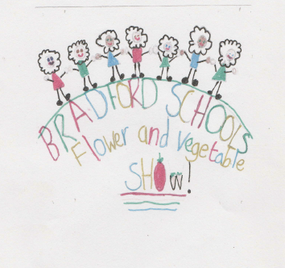
Bradford Schools Flower & Vegetable Show 2016
Sponsored by Steve Thorpe & Son Gardening Ltd
To be held at Haworth Primary School on Friday 16th September, 2016
All Bradford Primary Schools are invited to exhibit in ANY or ALL of the following categories –
- Best Basket of Vegetables
- Best Group of Potatoes
- Best Potted Plant
- Best Flower Arrangement
- Longest Runner Bean
- Best Vegetable in Show
- Strangest & Wackiest Vegetable
- Longest Carrot
- Tallest Sunflower grown at exhibiting School (to be measured by individual school & photograph brought to the show)
10. Heaviest Tomato

We are looking forward to a fun day, celebrating all the brilliant growing that is happening in Bradford Schools

Timetable

Friday 16th September, 2016

9.30am to 11.30am
Arrive at Haworth Primary School and set out your exhibits

11.30am to 12.15pm
Gardening activities

12.15pm to 1.00pm
Lunch

1.00pm to 1.30pm
Viewing entries and results

1.30pm
Presentation of prizes

2.15pm
Event finishes

Please complete the form opposite if you would like to be part of this special event.
Participating schools will be contacted directly regarding children’s activities and lunch arrangements.

Bradford Schools Flower & Vegetable Show 2016

Friday 16th September, 2016

Please complete and return to Haworth Primary School by Friday 8th July, 2016

We would like to exhibit in the show

Name of School......................................................

Contact Person.........................................................

Telephone.................................................................

E Mail......................................................................
Categories we would like to exhibit in -

- Best Basket of Vegetables
- Best Group of Potatoes
- Best Potted Plant
- Best Flower Arrangement
- Longest Runner Bean
- Best Vegetable in Show
- Strangest & Wackiest Vegetable
- Longest Carrot
- Tallest Sunflower grown at exhibiting School (to be measured by individual school & photograph brought to the show)
10. Heaviest Tomato in Show

