
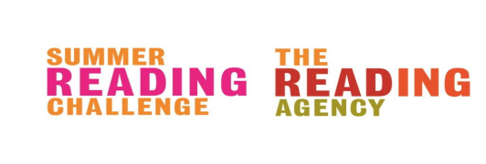

Summer Reading Challenge Young Ambassador Role Description

As a Summer Reading Challenge Young Ambassador you will be involved in the following:-

- Working with library staff to help out at events and activities.

- Helping to register children onto the summer reading challenge; giving out incentives; recording information, and taking part in the evaluation.

- Talking to children about which books they’ve been reading and helping them to choose new books.

- Reading stories to children and listening to them read to you.

- Helping to create in-house library displays related to the summer reading challenge.

- Working co-operatively with other young ambassadors.

