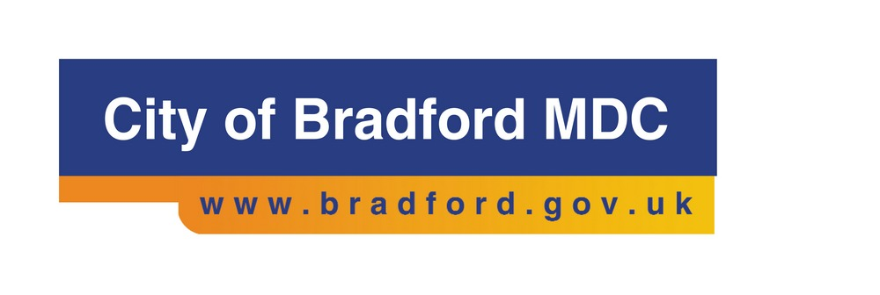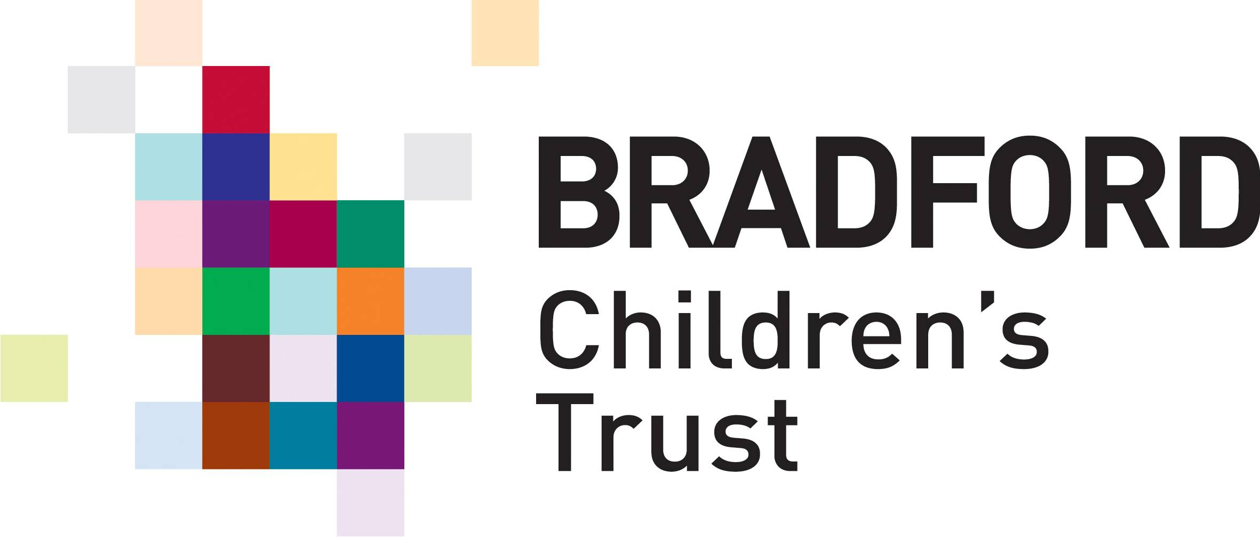

Journey to Excellence: thriving children – strong families

December 2015

What is the Journey to Excellence?
Children’s Services is transforming our approach to family support and the provision of care for children and young people within the Bradford District.

This is an exciting and ambitious programme. We will make sure we have excellent and effective support and care for children and young people across our District.

Journey to Excellence goes alongside our other local priorities to improve health and education outcomes and increase employment and skills.

We will focus on four main areas:

- Developing our integrated Early Help offer across all key agencies:
  - Early Help gateway for the public and staff
  - Whole family approach
  - Getting it right first time to reduce repeat referrals
  - Focus on reducing the demand on Children’s specialist services

- Refocusing children’s placement provision within the Bradford District:
  - smaller children’s homes
  - more foster carers for teenagers
  - a shared model of care across placements, health, education and other key services

- Better response to young people in crisis:
  - Young people in crisis will receive a rapid and supportive response
  - More joint working across social care and health key teams
  - More safe spaces for young people when they are in crisis

- Develop an integrated service across children’s, adult’s and health services for young people aged 14-25 years with complex health and/or disabilities:
  - Timely plans which prepare young people for adulthood
  - Adult Services within the Council will lead
  - More young people and families to direct their own support through Direct Payments
Clearly, Children’s Services and the Council cannot make these changes alone. We are working closely with partners, young people and carers to deliver these changes. We are drawing on some of the excellent work and partnerships already in place.

Signs of Safety
We are working with partners to develop a plan to use Signs of Safety to cut across the programme. We want a shared approach to working with children and families where the family takes the lead for their children’s safety and well-being.

Signs of Safety provides a consistent way of working that all practitioners can use in their work with children and families. From Early Help through to how we manage child protection plans, Signs of Safety can bring about more consistency in our work together.

Why Signs of Safety?
We want all practice to be child-centred and solution focused. We need the support with families, whether early help or with a looked-after child, to lead to lasting change.

Signs of Safety always puts a child’s safety first.

The approach supports more direct work with children and families. It draws on people’s strengths and natural networks of support. Families lead the plans and practitioners support them to keep children safe and well.

The model grew out of what practitioners and families reported to be effective. It leads to plans with families that include a robust analysis of strengths and risks. Plans will include specific actions that families must take. The emerging research highlights that family members say they are clear about what is expected from them. Families report that they feel their views and strengths have been acknowledged as well as their weaknesses understood.
Signs of Safety is now used in many countries around the world. Longitudinal studies in Australia and America are consistent in demonstrating the positive impact of this approach. Over 30 local authorities in England are using the approach. Prof Eileen Munro is leading an Innovation Project with 10 local authorities implementing this approach. The approach is being used in Wakefield, Calderdale, North Yorkshire and Doncaster.

How will we roll out Signs of Safety?
We are in discussions with both local partners and the network of accredited Signs of Safety Consultants and Trainers. We plan to hold multi-agency briefings in January 2016.
A multi-agency Working Group is now in place and we are working with key partnerships across the District, for example the Children’s Trust Board and the Bradford District Children’s Safeguarding Board.

How will we know anyone is better off?

Other areas have found a reduction in the numbers of children who need to have child protection plans or come into care. Emerging research states this is because of:
  - The way the approach focuses on strengths
  - The shared ownership of plans between family members and different professionals
  - More clarity about what needs to happen to make the child safe.

We would need to analyse the feedback we get from families and practitioners. Our expectation is that feedback will demonstrate more effective work with families and better outcomes which are reached in a more timely way.

Want to know more about Signs of Safety?

1.5 hour briefing sessions will take place on the 27 & 28 January 2016. The briefings will also provide an update on Early Help developments.

These are open to agencies across the district who work directly with children, young people and families. To book a place on one of these sessions please go to:

http://www.bradford.gov.uk/bmdc/education_and_skills/training_and_development/workforce_training_and_development/atoz/Signs+of+Safety+-+Briefing+Sessions

A summary of the approach can be found on the Council’s website

The main website for Signs of Safety is: www.signsofsafety.net

Any questions can be sent to: journeytoexcellence@bradford.gov.uk

