Specialist Inclusion Project
Information Pack 2016

The Specialist Inclusion Project runs short breaks leisure and recreational activities for children and young people with a diagnosed disability aged 8 to 18.

Workshops
The team are running new exciting workshops that will change every few months, this is to give young people the opportunity to try new activities that have a main focus, such as dance, drama or Minecraft instead of just elements of these in a club. We recently finished a 10 week programme in partnership with Mind The Gap, England’s largest learning-disabled theatre company. This workshop focused on Dance and Drama and with the help of Mind The Gap the young people were able to try their hand at thinking of, creating and performing a dance or drama production for their parents and peers.
We are also currently half way through our LEGO/Minecraft group on a Friday Evening in Bradford and the young people have been very creative in transforming their LEGO structures into Minecraft.

Our upcoming workshops include;
Name of workshop | Dates to and from | Venue
LEGO/Minecraft  A workshop focusing on the use of using LEGO and Minecraft to support a young persons imagination and building. | June til August  Exact dates will be given to those interested. | Keighley tbc  Exact venue details will be given to those interested.
Duke of Edinburgh Bronze Award  SIP will now be offering young people with disabilities the opportunity to gain the Duke of Edinburgh Bronze Award whilst being supported by our staff team. This will include learning new skills, being part of a group and mostly enjoying the outdoors. | June til June  Exact dates will be given to those interested. The programme may last anywhere from 6 months to 12 months and will finish with an expedition (camping). | Bradford tbc  There will be a weekly session in Bradford to look at planning and the skills needed to go on expedition. The expedition will end the workshop and will likely be either in Nidderdale and Harewood.
11^{3/4} group  The group will focus on 8-12 year olds who have an interest in the outdoors and want to build some skills and may be interested in D of E when they are old enough. | June til August  Exact dates will be given to those interested | Various  We will be using outdoor venues but based at Nellbank

We also now have access to a newly refurbished swimming pool in Eccleshill which we will soon be running sessions from.

If your young person would like a specific activity that could be transformed into a workshop then please contact us on the details below.

If you are interested in any of these workshops please contact The Specialist Inclusion Project on
01274 438744 or 07582 101393 or register your interest through our Local Offer page or through email at s.i.p@bradford.gov.uk

Summer Camp 2016

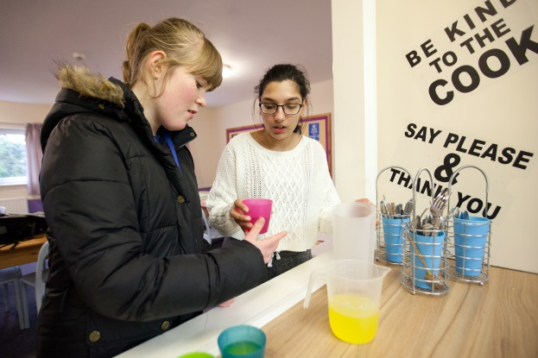This year SIP will be approaching Summer in a whole new and exciting way. We will be running a Summer Camp held at the William Henry Smith School in Brighouse. There is access to fantastic facilities including individual bedrooms, lounge areas with TV’s and pool tables, a huge sports hall, cinema room as well as outdoor facilities which include an adventure playground, go karting track and a mini farm. Staff will be on site 24 hours a day to ensure all young people are supported and we have experience in a variety of personal care needs and medication needs. This will be a perfect time for your young person to gain new skills, meet new people and have their own holiday during the Summer holidays. The venue of Brighouse also allows us to be closer to Bradford and Keighley than previous residentials we have run at Buckden and Ingleborough and also offers more indoor facilities.

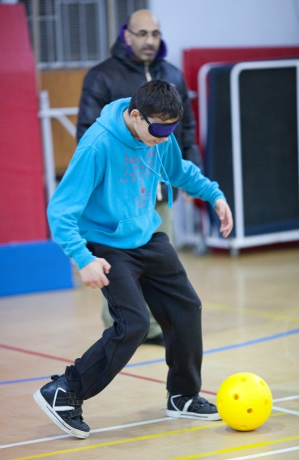We also have a new online booking and payment system which gives parents the control of payments and offers flexibility. This system allows parents to pay in instalments of their choice and they can make payments whenever they would like. We have also made payments available until February 2017 to give parents the option of spreading the cost out over 10 months.

The cost of the Summer Camp is £300 for the week for a space. This is for a young person on a 1:3 staffing ratio (1 staff member to 3 young people) for most of the day although they may require closer supervision or support during personal care or bedroom routines.
The cost of the Summer Camp is priced alongside mainstream Summer Camps however we offer a higher staffing ratio who are all highly trained and experienced.

The Summer Camp will run over 3 weeks and young people are able to sign up for 1 of the 3 weeks (4 nights/5 days) although more weeks can be discussed.

Week 1: 8 August – 12 August 2016
Week 2: 15 August – 19 August 2016
Week 3: 22 August – 26 August 2016

Venue address:
William Henry Smith School
Boothroyd Farm
Booth Royd Ln
Brighouse
HD6 3JW

The Specialist Inclusion Project is for children and young people with a diagnosed disability aged 8 to 18.
To find out more please contact The Specialist Inclusion Project.
01274 438744 or 07582 101393 or register your interest through our Local Offer page or through email at s.i.p@bradford.gov.uk

Nell Bank Family Fun Days
Book now for a fun packed day! Activities include the adventure playground, habitat trail, pond dipping, water play, den building and the FISICAL coaches will be there to run football, cricket, rounder’s and tennis.

We ask parents to bring their own picnics to eat in the grounds of Nell Bank. The fun days are free for families from the Bradford District and £5 for families outside.
The details are;
Dates: 31st May 2016
26th July 2016
13th August 2016
25th October 2016

Time: 11am – 3pm

Booking is essential!
To reserve tickets please contact Nicola Norris using the details below.

  Nell Bank, Denton Road, Ilkley LS29 0DE
  nicola.norris@bradford.gov.uk
  07582 101307

Booking will be confirmed with an information pack containing everything you need to know about the day.

Link Work
The Specialist Inclusion Project also have a new role known as Link Work for short breaks which will run alongside our short breaks services we offer. The role of the team as Link Workers is to work alongside the Family Information Service which will take referrals for the service. The Link Work service will visit the family and speak to the parent/carer and young person to find a short break service from a range of providers based on what the young person wants to do or try, this can include clubs, groups, supported places and much more.
The Link Work pathway was created following the Short Breaks statement which provides all parents of young people with disabilities information on Bradford Short Breaks. This can be found on the Local Offer website and through the following link;

https://localoffer.bradford.gov.uk/Content.aspx?mid=202

Frequently Asked Questions
Workshops:
- How much are the workshops?
Each workshop will have its own cost and you will be informed of the cost when registering your interest over the phone or through email. The costs are usually between £5-£10 for a 2 hour session. Duke of Edinburgh will have its own structure of payment, if you are interested in Duke of Edinburgh a member of the team will discuss this with you.

- Are there any workshops near me?
At SIP we work District wide, from Ilkley to Bradford. If you want to know what we have to offer in your local area feel free to contact us. If you would like us to consider a workshop close to you let us know!

- Why don’t the workshops run continually? My child really enjoyed the session.
At SIP we want to offer young people with disabilities different opportunities. We looked at being able to provide workshops with a sole focus (e.g dance, film making) helps young people focus on the activity. The workshops are time limited so we can offer a variety of activities over the year that young people can try new things and not get bored. If you have any feedback or have an idea for a new activity please feel free to contact us.

Summer Camp:
- Why the change to Summer?
SIP had been running activities for children and young people with disabilities for over 15 years. We had also run Summer Schemes for 15 years and the format of these days hadn’t changed too much over this time and the Summer Scheme format has been replicated by other services. To look at the options we did 2 consultations with young people, one during last Summer and one at Nell Bank and 2 of the top choices were residential and days out. We combined these to create the idea of a Summer Camp.

- The cost is too high for us, how can I pay?
Our Summer Camps are priced alongside mainstream Summer Camps, however we provide the extra support, training and experience needed to work with our young people. We have a new online payment system in place which enables parents to pay for the Summer Camp in flexible instalments until 2017 to spread the cost out.
Payments can also be supported by Direct Payments packages.

- Why have you chosen Brighouse for a venue?
At the end of one of our recent residentials at Ingleborough we did a consultation and feedback session with our young people. Young people mentioned that they would like somewhere a little closer to home and one with more indoor facilities in case of bad weather. We took this on board and through a lot of searching found the William Henry Smith School in Brighouse. The venue has fantastic facilities as mentioned above and ticks a lot of boxes with it being less than 25 miles from most Bradford, Keighley and Ilkley postcodes as well as being 10 minutes from Brighouse centre.

- What if my child struggles to stay away for so long or gets homesick?
We understand that many young people with or without disabilities may not have stayed away for 5 days before. We want to support young people to try new things and overcome hurdles. We believe with the correct amount of support, free time, space and good communication we can limit homesickness. We want young people to feel like they are on holiday when they come to us but safe with the knowledge they are supported.
We will also keep an open communication with parents which can involve daily updates, phone calls home in an evening and personal diaries.

- What if my child needs a higher level of support than 1:3 (1 staff to 3 young people)?
As a short break provider we staff on levels of 1 staff member to 3 young people during most of the day and extra assistance can be given with personal care. If you feel your young person requires a higher level of support than this throughout the day please contact us to discuss this.

- How do I sign my child/young person up?
Please contact The Specialist Inclusion Project on the details below or register your interest through our Local Offer page or through email at s.i.p@bradford.gov.uk. Alternatively Google “Specialist Inclusion Project Bradford” and click on the top link.

Contacts
Our contact details are;

Emails: s.i.p@bradford.gov.uk
specialist.inclusion.project@bradford.gov.uk

Telephone: 01274 438744
01274 435251
01274 435032

Website: http://www.bradford.gov.uk/bmdc/health_wellbeing_and_care/disability/specialist_inclusion_project

Office address: Specialist Inclusion Project
Room 20
Bingley Town Hall
Myrtle Grove
Bingley
BD16 2LQ

