The 8-3-7-2 Tournament: remembering srebrenica through football

"The Srebrenica genocide was the worst war crime in Europe since the Second World War. It happened 20 years ago this July in my home country of Bosnia-Herzegovina. I'm proud to support Remembering Srebrenica's 8-3-7-2 Tournament which brings young people together through football to remember the victims and survivors. It's a really powerful way to help the next generation to learn about the importance of tackling hatred and intolerance. This will help us to build a stronger society around the world." Asmir Begovic

An invitation for your school to take part in a football tournament to support the 20th Anniversary commemorations of the Srebrenica genocide:

- 8372 young people
- 380 schools
- 380 matches/1 day
- Remember the Srebrenica Genocide

- Friday 5 June 2015
- Chance to meet Asmir Begovic, Bosnian international
- 15 teams invited to attend the national memorial service at Westminster Abbey on Monday 6 July.

What is the 8-3-7-2 Tournament?
The 8-3-7-2 Tournament is a powerful campaign run by the British charity Remembering Srebrenica, which aims to encourage pupils to learn lessons from the Srebrenica genocide.
The tournament brings together 8372 young people to play football on the same day- Friday 5th June. The figure 8372 represents the number of individuals who lost their lives during the genocide at Srebrenica in eastern Bosnia-Herzegovina in July 1995. The memorial match will commemorate the twentieth anniversary year of this most recent of European tragedies.
We invite your school to participate in this flagship event by holding a football game of 11 vs 11 on Friday 5th June. The match should take place internally between two teams from your own school.
Every match should be preceded by a one minute silence to remember the victims and survivors of the genocide and reflect on lessons to be learned for the importance of tolerance and understanding here in the UK. Where possible, organising teachers might also read a short piece of scene setting text supplied by Remembering Srebrenica prior to tournament day.
Beyond this broad framework individual schools are free to tailor the event to their requirements; for example, feel free to decide who will take part (year group/gender), at what time kick-off should take place, and how long the match should last.
Remembering Srebrenica will provide resources such as assembly aids prior to the tournament, stickers for every player and a certificate of participation for every school.

Meeting Asmir Begovic

Two winning teams will be given the opportunity to meet with The 8-3-7-2 Tournament ambassador, Stoke City and Bosnia-Herzegovina goalkeeper Asmir Begovic, who was himself forced to leave Bosnia as a child during the 1992-1995 conflict.
Following the match day please notify Remembering Srebrenica of the winning team of eleven players who will then be placed into a draw. Please label teams with your school name followed by Side A or Side B to assist in ease of organisation.

Attending the UK’s national Srebrenica memorial: Westminster Abbey

A further 15 winning teams will be invited to participate in our national Srebrenica memorial event at Westminster Abbey at 12 noon on Monday 6th July.

This is a fantastic opportunity for pupils to represent their schools at a commemorative service which will also be attended by key political, faith and community leaders from across the UK and Europe, as well as genocide survivors and relatives of survivors from Srebrenica itself.
The teams to attend will be chosen in a fair and random selection process from among the pool of winning teams.

Why get involved?
By remembering and honouring the victims and survivors of the Srebrenica genocide we bring people in the UK together to genuinely learn from the past.
The next generation of young people are key to this project. By working with them to promote the importance of tolerance, respect for other cultures and the rule of law, we help to strengthen modern British society.
Benefits for your school:
· Participation in the UK’s national 20th Anniversary commemorations of the worst war crime in Europe since the Second World War
· Powerful opportunity for young people to come together through sport to consider the possible outcomes of racism, intolerance and division
- Active participation in a project designed to illustrate the importance of living in a diverse and cohesive modern British society
· Opportunities for pupils to participate in high-profile national and regional memorial events
What happened at Srebrenica?
In 1991 the six republics that made up Yugoslavia descended into civil war. The conflict that followed lasted until 1995 and saw casualties and atrocities on all sides. In Bosnia-Herzegovina, Bosnian Serb nationalists led a campaign for a ‘Greater Serbia’ which drove processes of ethnic cleansing in areas inhabited by Bosniak (Bosnian Muslims) and Bosnian Croat communities.
In 1993 the eastern Bosnian town of Srebrenica was declared a UN Safe Area under the flag of a United Nations Protection Force (UNPROFOR). The town was filled with refugees, including many children, who had fled fighting and acts of ethnic cleansing in their home towns and villages.

In July 1995, Bosnian-Serb nationalist forces under General Ratko Mladić’ overran and captured the town, despite its designation as an area “free from any armed attack or any other hostile act”.

In the days following Srebrenica’s fall, 8372 Bosniak (Bosnian Muslim) men and boys were systematically massacred and buried in mass graves. It was the greatest atrocity on European soil since the Second World War. Many of those killed were of school-age at the time.

The International Court of Justice (ICJ) and the International Criminal Tribunal for the Former Yugoslavia (ICTY) ruled that the mass execution of Bosniak men and boys in Srebrenica constituted genocide.

What is Remembering Srebrenica?

Supported by the Department for Communities and Local Government Remembering Srebrenica is a British charity that commemorates the anniversary of the Srebrenica genocide in Bosnia-Herzegovina in 1995. It aims to learn lessons from the past to inform our understanding of the present and the future.
Remembering Srebrenica is the organiser of the UK events for the EU-designated Srebrenica Memorial Day, which takes place annually on 11 July. It also runs a tailored education programme called Lessons from Srebrenica, which sees UK citizens visit Bosnia-Herzegovina.
Alongside this, the charity conducts awareness raising campaigns aimed at countering discrimination and building stronger community relations here in the UK. We also work with experts in education, such as the PSHE Association, to produce educational resources for schools.
While recognising that we have achieved a lot in terms of building a cohesive society here in the UK, discrimination and exclusion persist. We believe that our young people are the key to making our communities stronger and by bringing thousands of pupils together to remember and honour the victims, we can help to educate them in ‘Living the Lessons From Srebrenica’ to build stronger, safer communities for the future. In this way we can leave a lasting and fitting legacy to mark the 20th Anniversary of the Srebrenica genocide.
Join the team
Join us in honoring the victims and survivors in this 20th Anniversary year of the Srebrenica genocide. By bringing 8,372 young people together on the same day we can show the world that the UK is serious about teaching our young people to understand the possible consequences of hatred and division.
Sign up your 22 players, our next generation, to stand alongside us in uniting against hatred. Help them to remember Srebrenica through football and make ‘Never Again’ a reality.
To apply to join the 8-3-7-2 Tournament simply return this slip to Remembering Srebrenica
137-139 Hagley Road, Birmingham, B16 8UA by Friday 1st May.

School contact details (tear off slip…..)
School:
Local Authority Area:
Address to deliver materials:
Contact information:
Contact individual

Alternatively sign up by email by sending the above details to: aidan.stonehouse@srebrenica.org.uk
To enquire further about the project please don’t hesitate to contact us on +44 (0)121 454 3343

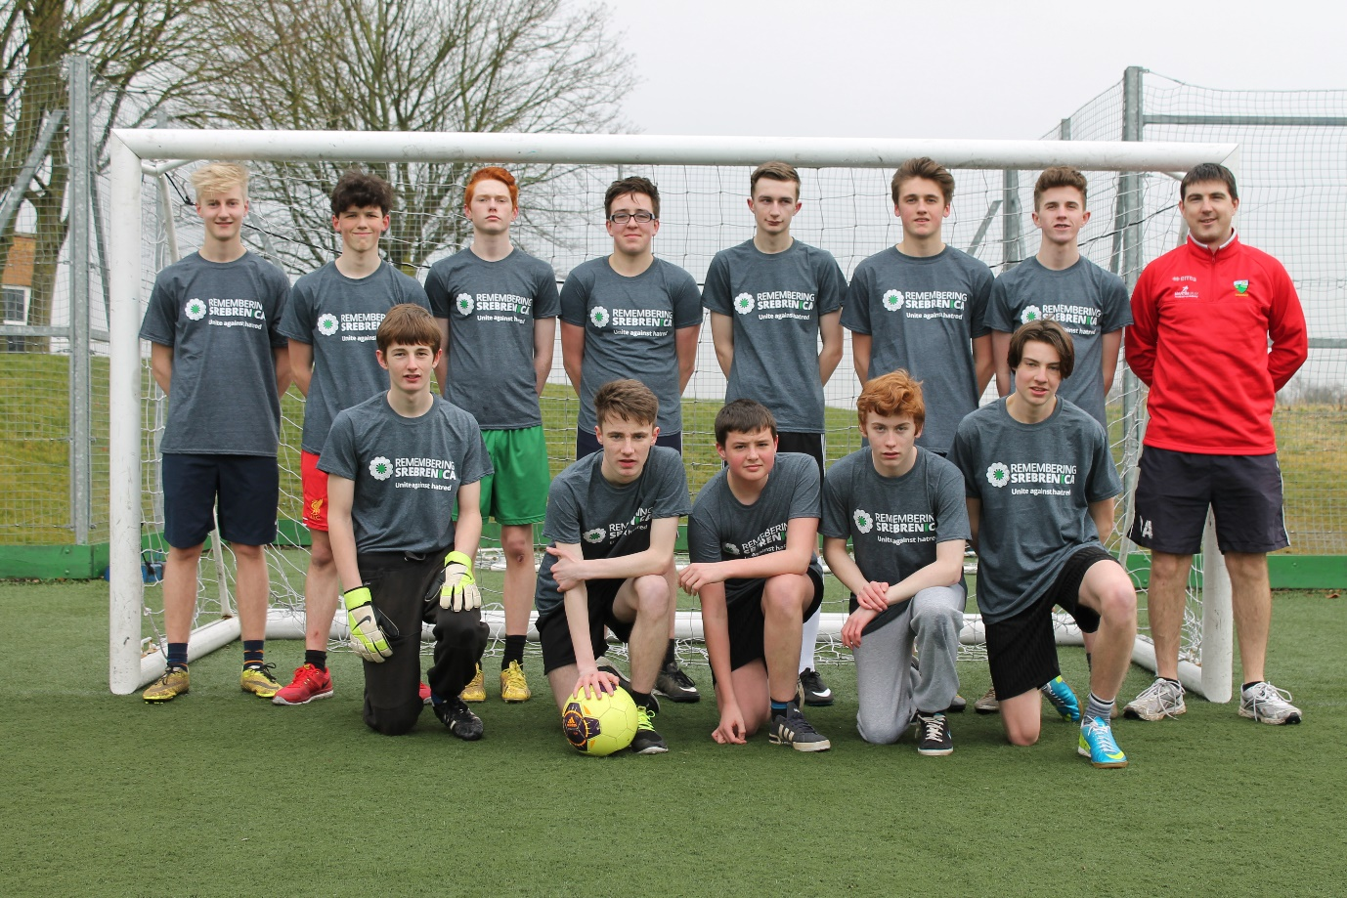
Greenfield Community College, County Durham, is ready for The 8-3-7-2 Tournament

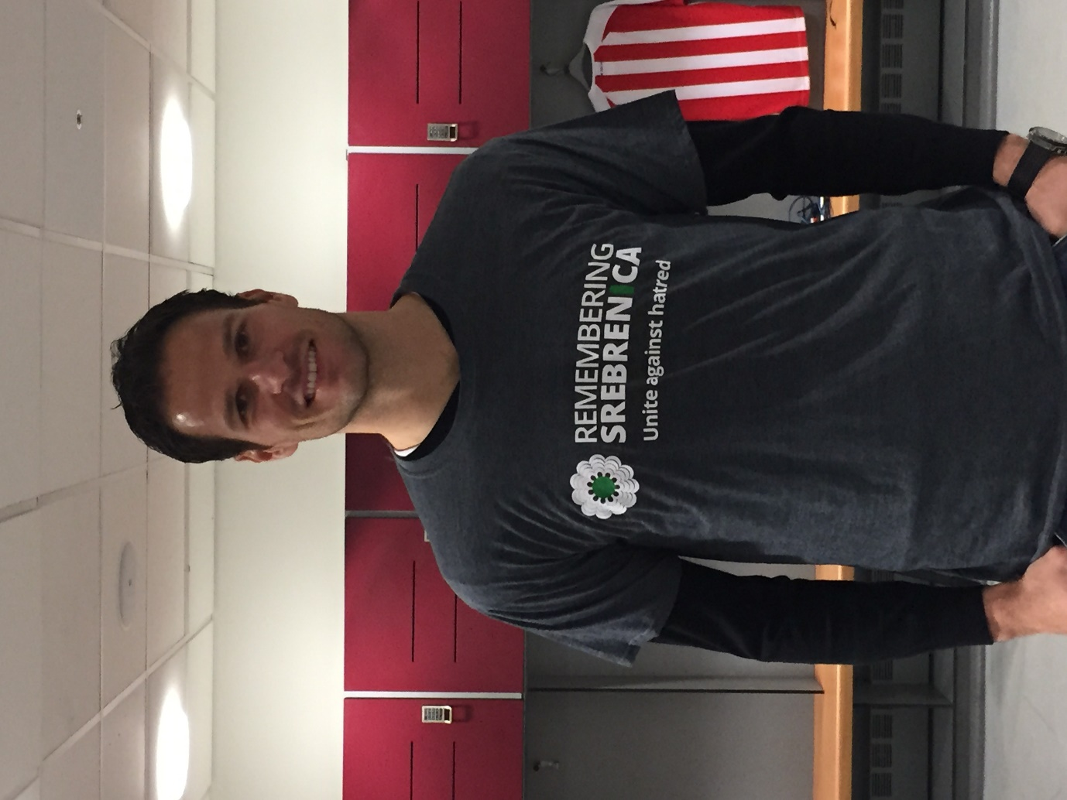
Asmir Begovic, Goalkeeper, Bosnia-Herzegovina and Stoke City FC

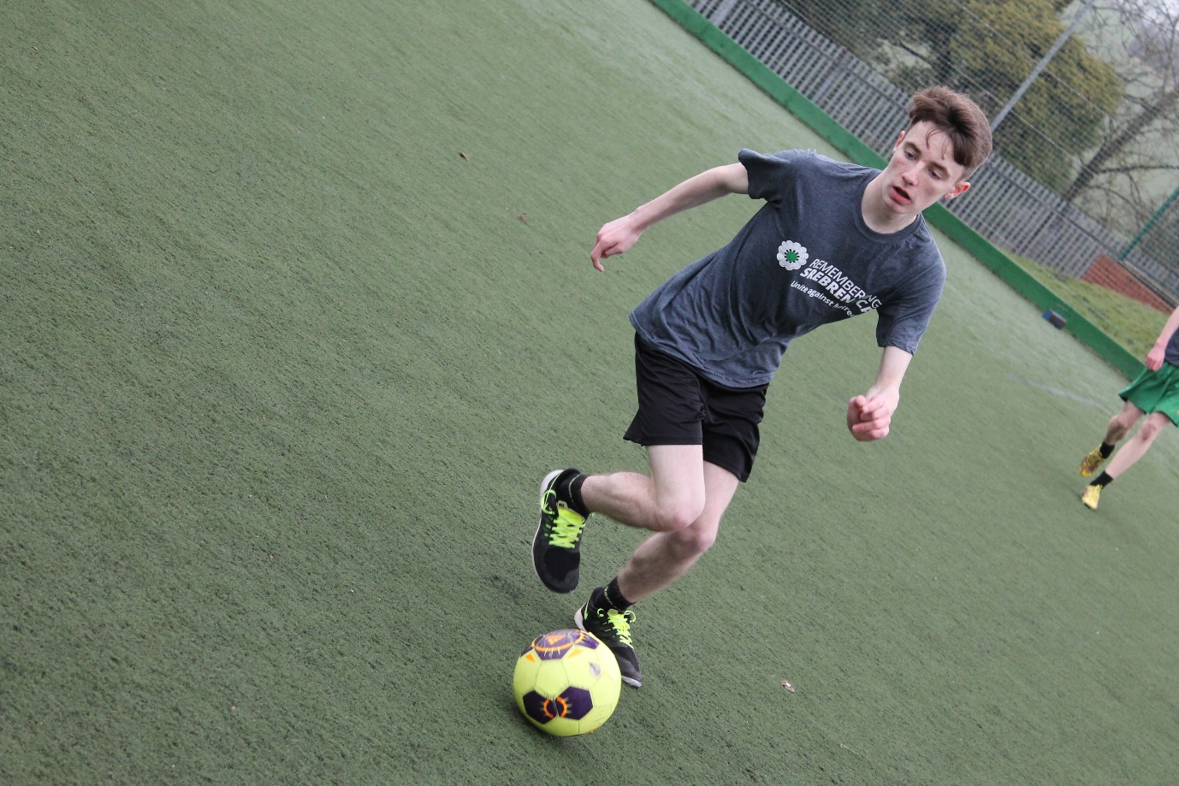
Playing football for Srebrenica at Greenfield Community College, Newton Aycliffe, County Durham

