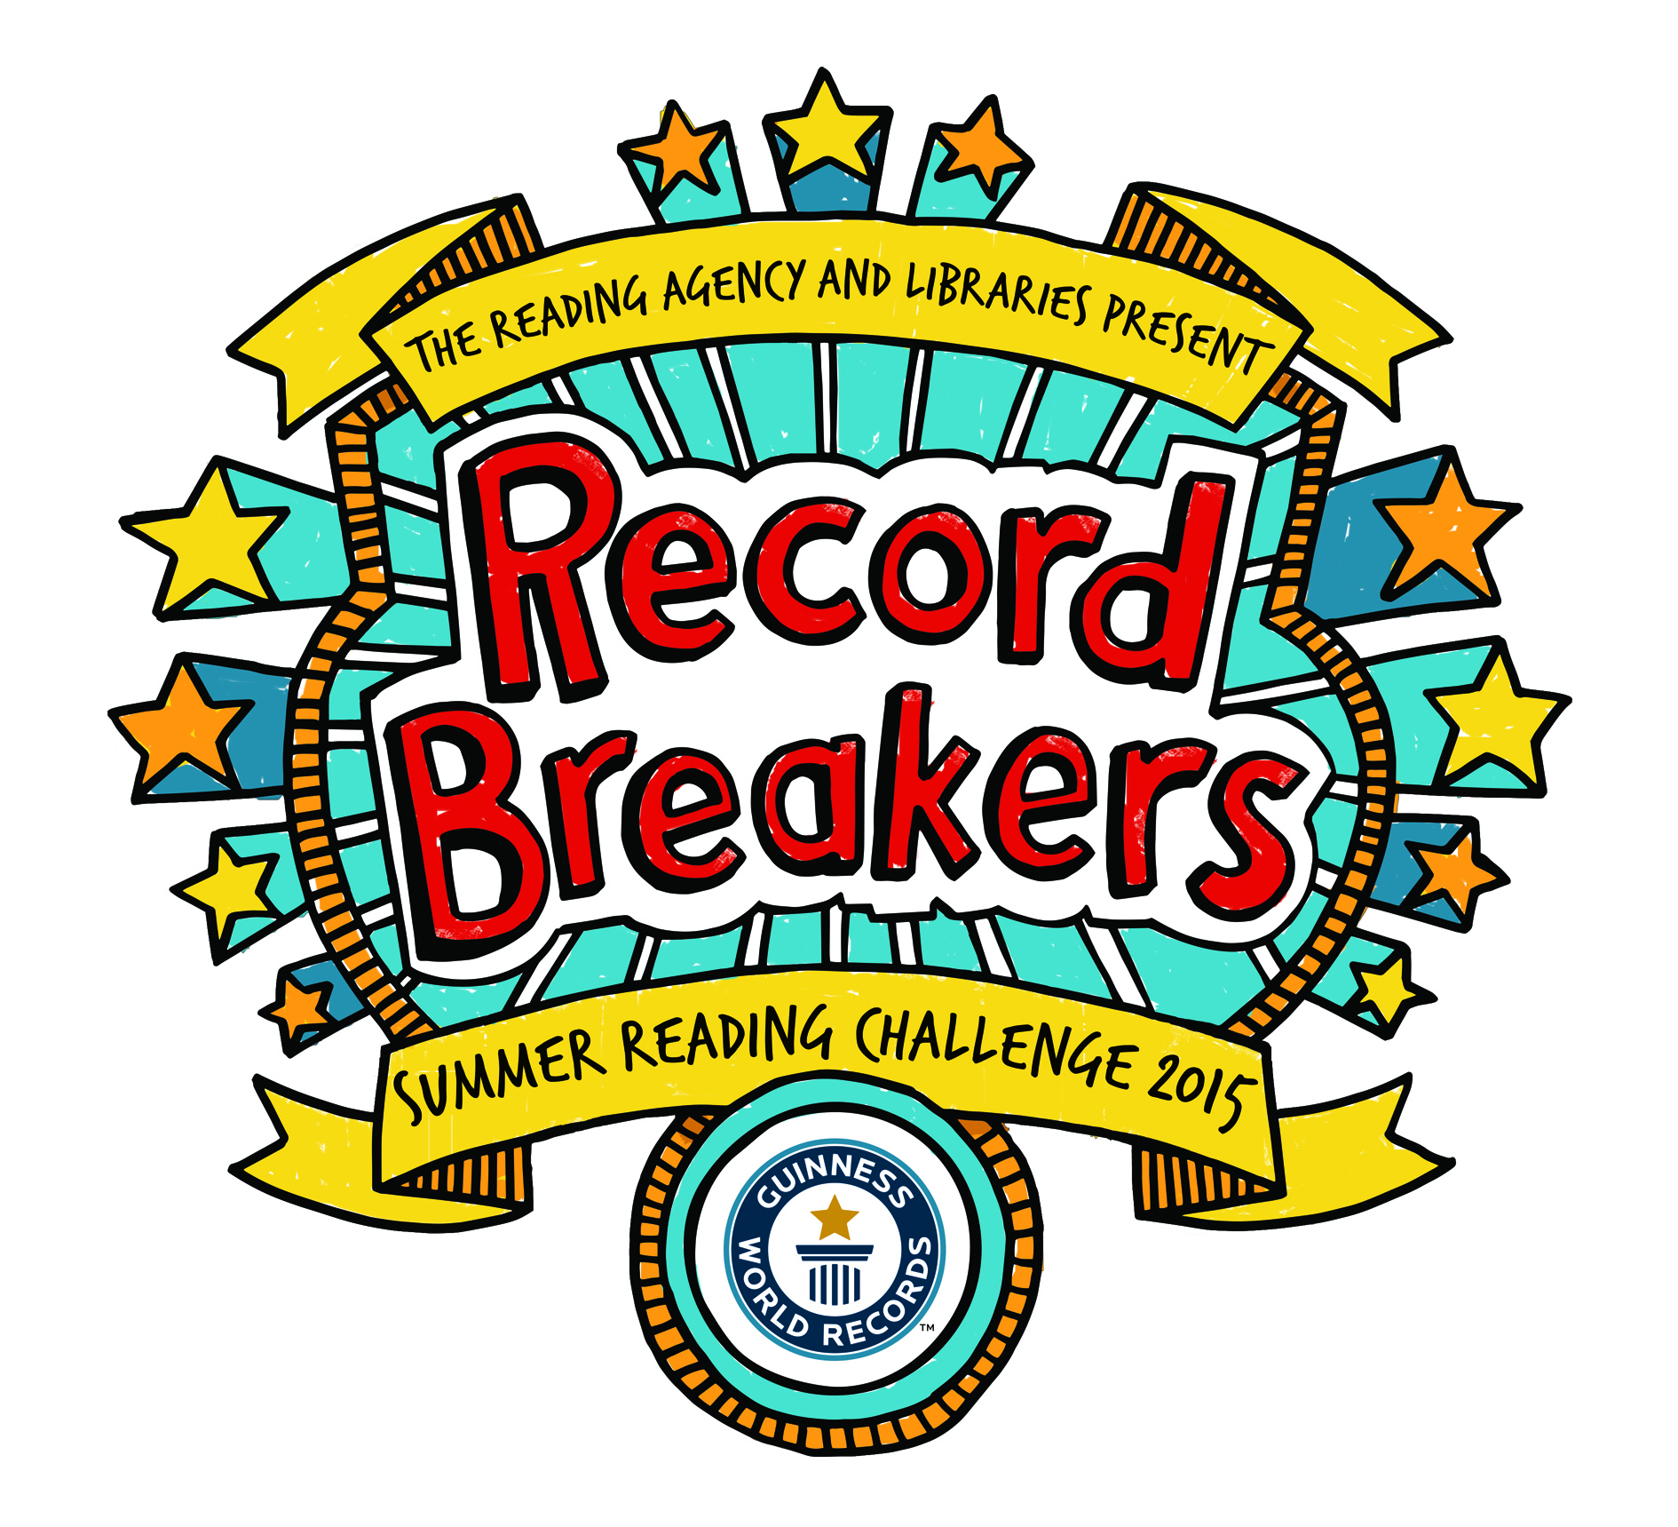
Ilkley Library
Station Road
Ilkley
LS29 8HA
13th May 2015

Dear Literacy Coordinator

2015 is a RECORD BREAKING year for your school to take part in the Summer Reading Challenge. Not only can you join us for the Record Breakers launch but you have the chance to win a free author event at your school later in the year.

Join us for the launch of
Record Breakers Summer Reading Challenge 2015
with
Word Wizard, Andrew Newbound, and his humorous & energetic “Word Records” show.
on
Friday 10th July
at
City Library @ 10am
and
Keighley Library @ 1.15pm

The event is open to classes from Y3, Y4 and Y5. Children will also get the opportunity to be amongst the first to join the summer reading challenge. We have 3 class places available for each library. We will offer one class (max 30) per school. This is a free event.
If you are interested please return the form below. Closing date for applications is Friday 5th June 2015
In addition, this year the Summer Reading Challenge will be offering author events to the two Bradford schools with the highest percentage of children participating in the challenge and the highest percentage of children who complete the challenge i.e. read six books. Record Breakers Summer Reading Challenge information packs will be arriving shortly, please look out for them and use the material included to promote the challenge in your school. Last year Bradford increased participation in the Summer Reading Challenge by 10% ahead of the 2.2% national average. Your pupils could be missing out on this important and enjoyable way to maintain or improve reading levels throughout the summer.

If you require further information about any of the above or the Summer Reading Challenge please contact Christinea Donnelly Development Officer for Young People christinea.donnelly@bradford.gov.uk

Yours Faithfully

Christinea Donnelly
Development Officer for Young People: Bradford Libraries

I am interested in the Word Records Summer Reading Challenge 2015 Launch Event. Please tick one option.

@ City Library Friday 10th July 10am – 11.30am.

@ Keighley Library Friday 10th July 1.15pm – 2.45pm

Contact Name: _____________________________________

School: ____________________________________________

Contact Tel Number: ________________________________

Contact Email: _____________________________________

Class Yr: _________ No. of Pupils: __________________

Return this form to: - Christinea Donnelly Development Officer for Young People Bradford Libraries, Ilkley Library, Station Road, Ilkley, LS29 8HA
Closing date for applications is Tuesday 5th June 2015

