Department of Children’s Services
National Literacy Trust Hub Bradford
2nd Floor Margaret McMillan Tower
Princes Way
Bradford
BD1 1NN

Tel: (01274) 439246 / 07736280323
Email: imran.hafeez@literacytrust.org.uk

Date: 25/11/2017
Bradford Schools Literacy Pledge

Dear Headteacher/Literacy Lead,

I hope your term is going well. I would like to take this opportunity to invite you to attend a breakfast meeting to mark the launch of the Bradford Schools Literacy Pledge on the 12th January 2018 at City Hall (Banqueting Suite) from 8:30 – 10:30. This will be an opportunity to learn more about the Pledge and discover different ways the National Literacy Trust Hub and its partners in Bradford can support your school.

The idea for a Schools Pledge has come out of a series of consultations held with school leaders, the library service and the council. We aim to be able to identify, share and celebrate good practice across Bradford schools, as well as support schools in areas which they have prioritised as needing development.

We are inviting every school in Bradford to sign the pledge and to undertake a range of actions which will help to put literacy at the heart of school strategy, community engagement and in the classroom.

The National Literacy Trust Hub in Bradford has recently received some funding from the Morrisons Foundation to help us build individual partnerships with schools and look at how best we can support you in your journey to success. The Literacy campaign is being rebranded as Bradford Stories, celebrating the rich heritage of Bradford and highlighting the importance of families, young people and different communities in the city sharing stories. As part of the new funding every school in Bradford is registered automatically as a National Literacy Trust member, giving you access to resources, audit tools and other benefits.

We look forward to welcoming you at the breakfast to find out more about the pledge. Please confirm your school’s attendance to imran.hafeez@literacytrust.org.uk no later than 8th January 2018. I look forward to your engagement in this campaign and do feel free to get in touch with any further questions.

Yours sincerely,
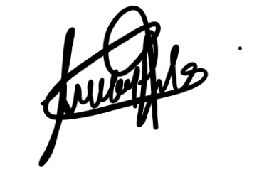
Imran Hafeez (Bradford Hub Manager)

