Our ref:  Your ref: | Department of  Children’s Services  – Aiming High for Children  Music & Arts Service  Fairfax Learning & Development Centre, Flockton Road, Bradford, BD4 7RY  Tel: 01274 434 970  Fax: 01274 408 335  Email: schoolsmusicandarts@bradford.gov.uk
The Headteacher/
Music Co-ordinator or Head of Music
ALL BRADFORD MDC SCHOOLS
27 June 2017

Dear Headteacher/Music Co-Ordinator or Head of Music

MUSIC RETURN – ACADEMIC YEAR 2016-2017

Annually we are asked to collate information across the Bradford MDC to return to the Arts Council, all information is then fed through ton the DfE in order that a picture can be formed of music across the country.

Please find attached a data form which I would be grateful if you would complete as fully as possible.

Please note any ensembles/groups which you have booked directly with the Music & Arts Service do not need including as we already hold this information.

Would you also complete the pupil level information if known for your pupils including those who play but may not be in one of your ensembles.

Please also note that the information is required for the academic year 2016-17.

In the unlikely event it is a “nil” return for your school please indicate this also on the form.

Please return the completed forms no later than the 14 July 2017 for inclusion in the 2016-17 data collection for Bradford MDC.

MUSIC EVALUATION – ACADEMIC YEAR 2016-17

Attached is the evaluation form for completion for the academic year 2016-17. PLEASE RETURN THIS EVALUATION FORM NOT LATER THAN FRIDAY, 14 JULY 2017.

MUSIC AUDIT

As part of our continued commitment to support music in schools we hope to visit all schools each year to ensure the correct musical support can be offered. We have simplified last year’s Music Audit Form and this will be sent out in due course. However, if you would like an early visit please get in touch.

Yours sincerely
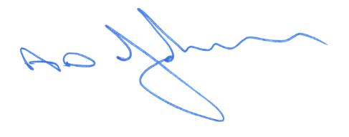
Tony Johnson
Head of Music & Arts Service

Enc.

