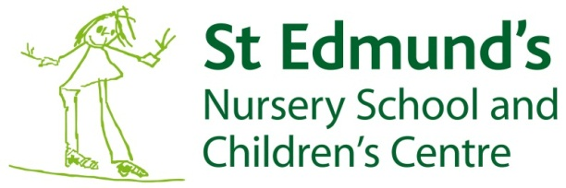

Training by Practitioners, for Practitioners
What a Quality Environment for 2 Year Olds Looks Like
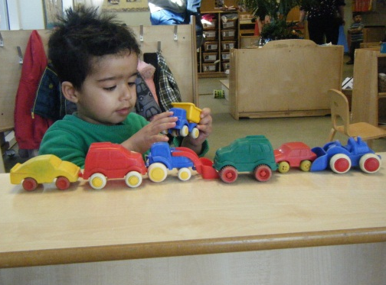
Wednesday 9th April 9.30 - 11.30am (tour of the centre at 9.00am)

OR Thursday 8th May 4.00 - 6.00pm (tour of the centre at 3.30pm)
Venue: St Edmund’s Nursery School and Children’s Centre, Washington Street, Girlington, Bradford BD8 9QW.
Cost: £50 per participant

This course focusses specifically on the needs of 2 year olds, and will cover:
- Adult/child interactions
- Creativity
- Language development
- Characteristics of effective learning
- Outdoor and indoor play and learning
- Resources

Anne-Marie Merifield, Executive Headteacher at St Edmund’s and National Leader in Education, will be delivering the course, alongside Lindsay Mihailovic, Deputy Headteacher at St Edmund’s and Specialist Leader in Education.
The course is ideal for any practitioner working with children aged 2 years, particularly those new to this age group. If you would like to have a look around St Edmund’s, please arrive at 9.00am (9th April) or at 3.30pm (8th May).

For further information please contact Sue Easterbrook at sue.easterbrook@stedmundsnscc.com or call 01274 543282.

To book a place, please return the course booking form to:
St Edmund’s Nursery School and Children’s Centre,
Washington Street,
Girlington,
Bradford BD8 9QW

teachingschool@stedmundsnscc.com
COURSE BOOKING FORM
Course details
Course title: | What a Quality Environment for 2 Year Olds Looks Like
Please indicate which date you would like:
Wednesday 9th April 9.30 - 11.00am
Thursday 8th May 4.00 - 6.00pm

Applicant details
Name:
Job title:
Organisation:
Contact address and postcode:

Contact phone number:
Contact email:
Dietary requirements:
Any other requirements:
How did you find out about this training?

Payment details
Payment can be made by cheque or invoice.
Cancellations made later than 2 weeks before the start of a course will be non-refundable.
Cancellations made later than 4 weeks before the start of a course will be subject to a 50% charge of the total cost of your booking.
I enclose a cheque for the cost of the training made payable to St Edmund’s Nursery School and Children’s Centre (£50)
Please send an invoice for the cost of training (£50)

Purchase order number:

Invoice address:

Please return as soon as possible to secure your place to:
St Edmund’s Nursery School and Children’s Centre,
Washington Street,
Girlington
Bradford BD8 9QW
Telephone: 01274 543282 Email teachingschool@stedmundsnscc.com

