Department of Children’s Services
Aiming High for Children
SEND & Behaviour Services
5th Floor
Margaret McMillan Tower
Bradford, BD1 1NN

Tel: 01274 439610

Email: Angela.Spencer-Brooke@bradford.gov.uk

Date: 15 May 2017

PRIVATE & CONFIDENTIAL

Dear Colleague
Thank you for submitting your request for an Educational Health and Care Needs Assessment.
We have already begun piloting a way forward whereby funding is available to schools earlier to manage children with SEND at School Support level through My Support Plan. My Support Plan aims to ensure that children and young people’s needs are met in a timely way and outcomes improve for this group of students.
My Support Plan leads to the production of a clear plan of what needs to happen to improve outcomes for the young person and allows school to access additional funding in order to put in place additional provision.
We have decided to extend this pilot and would like to offer you the opportunity to make a request for additional funding via My Support Plan, rather than submitting a request for an EHCA. In this way, following submission of the paperwork, you should receive any agreed funding within 4 weeks.
If you would like to take up this opportunity you will need to do the following:
- Ensure that the child / young person is Range 4 of the Bradford Range Guidance;
- Seek agreement from parents to request a My Support Plan (letter enclosed);
- Complete the draft “My Support Plan” template (enclosed / on BSOL) providing information on needs, outcomes and provision;
- Complete the “SEND Accountability Framework” template to demonstrate how the “notional SEND funding” of up to 10K has been spent in attempting to meet the young person’s needs and the impact of this.

If you wish to proceed with this, please return the MSP paperwork to the SEN Assessment Team, who will moderate the request and allocate up to £3000 (Band 4b) funding in order to put in place provision to meet the agreed outcomes.
The MSP extended pilot will become live on 15th May 2017 and the first panel to agree requests will meet during the week of 22nd May 2017. Any funding agreed should be with you shortly after this.
Funding will be allocated for 20 weeks and the My Support Plan should be reviewed in school at least termly, to monitor progress against the agreed outcomes. At this point a decision should be made as to whether to request a continuation of the funded MSP (maximum 2 cycles), to request an EHCA or to revert back to school based provision. This decision should be based on what progress the young person has made and the next steps for the indivIdual concerned.
Please inform us if you do not wish to take part in this pilot, in which case we will progress the EHCA request.
Full details of the MSP funded pilot including the dates of panel and required paperwork will be made available on BSOL. Further training will be available in September 2017 to ensure that schools are able to make best use of this development.
Thank you for your support with this pilot.
Yours sincerely
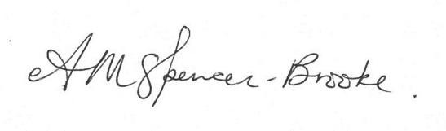
Angela M Spencer-Brooke
SEND and Behaviour Strategic Manager
Education, Employment and Skills

