Centre of Good Practice for New Arrivals

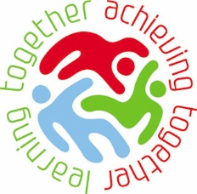

Bowling Park Primary School

Welcome to Bowling Park Primary School.
We believe that we are a unique school. We are a 3 form entry primary, with just under 700 pupils, situated on 2 sites that are approximately one mile apart! We have a fantastically varied school population who come from many different backgrounds, cultures and faiths. We are very proud of this and constantly strive to celebrate and develop our school as a happy, nurturing and respectful place for children to learn. We think it is important that every child, no matter what their starting point or background is, makes very good progress and enjoys learning.
Before I was appointed as Principal in September 2008, our two sites were totally separate schools and were both very different to how they are today. Many visitors now comment on our special ethos, noting how the school feels full of energy and joy. Over the last few years, we have worked relentlessly and have overcome many challenges, such as the ever changing demographic and population of BD5, to ensure that children, families and staff feel valued and part of school.
We strongly believe that children come to school to help prepare them for adult life. This is why our vision for school is that children become successful learners, confident individuals and responsible citizens. This is achieved by encouraging all children to ‘Go the Extra Mile’. Children at Bowling Park understand that school helps them to take positive steps towards their futures, and improves their life chances.
Our New to English and EAL provision has grown from strength to strength in recent years. Our new arrivals make excellent progress and feel settled, happy and confident to try to new things. In 2015, this was confirmed by a Local Authority BPIP Review, which noted that our New to English provision is a key strength of the school. They said “Provision for pupils new to learning English is excellent since the school effectively deploys skilled adults. Senior leaders regularly monitor progress and pupils consistently make accelerated progress”. We are very proud of what we have achieved and look forward to sharing our experience and knowledge with you.
Stuart Herrington
Principal.

Get in touch!
Bowling Park Primary School offers support to schools with new arrivals. This support includes visits to our Centre of Good Practice for New Arrivals, sharing planning and other key documents, and workshops. In addition, we can offer personalised school to school support in your own setting.
If you would like more information about the services we can provide or further information about the Centre of Good Practice for New Arrivals, we would love to hear from you. You can also take a look at our school blog http://bowlingparkprimary.net/ or follow us on Twitter @BowlingParkPS.
Point of contact for bookings and information:
Mrs. Gill Camm
01274 770270
Office.bowlingpark@gmail.com

Mrs. Sadie Cordingley – Centre of Good Practice Leader
01274 723255
Sadie.cordingley.bp@gmail.com – Sadie is currently away from school, please contact gill.camm.bp@gmail.com

Harriet Crossley
New to English Teacher

Teaching and Learning Strategies

Module 1
Experiential learning, experiences and visual, hands-on learning for brand new to English learners.

Module 2
Planning for New to English children in class, with a specific focus on guided reading and topic lessons. Advice on adapting planning to suit New to English needs.

All workshops include a tour of school, shared work samples and electronic materials

All support packages can be tailored to your needs.

Our support packages:

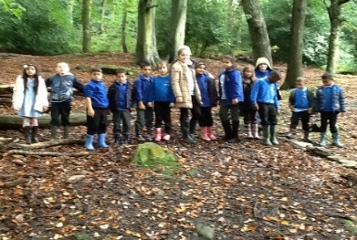
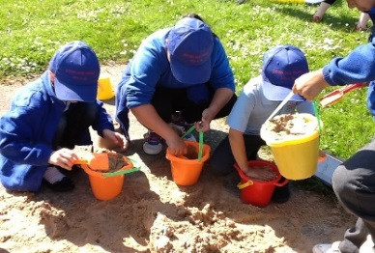
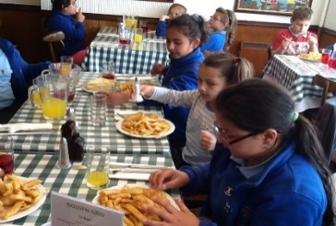
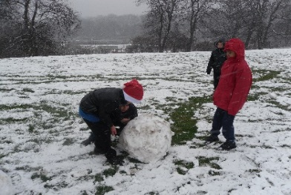

Teaching and Learning Strategies

Module 3
Specific New to English interventions, with a specific focus on English planning, grammar and writing outcomes.

Module 4
Clicker training – an English based computer programme that helps learners develop basic word and sentence skills. Clicker is particularly useful for New to English children because it helps to develop vocabulary in order to use the English language in a meaningful way.

All workshops include a tour of school, shared work samples and electronic materials

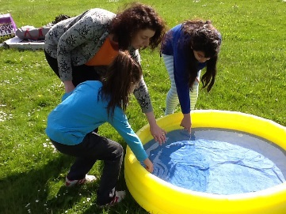
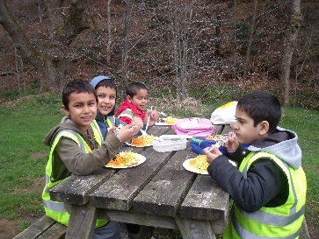
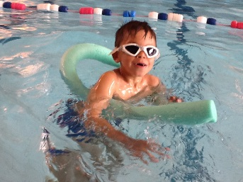
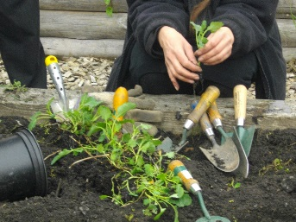

Parental Involvement and Attendance

Our support package:

Focus on getting parents ‘on-side’ and supporting them so they feel part of school.
Specific focus on improving Roma attendance
Advice and information about encouraging families to subscribe as Roma.

All workshops include a tour of school, shared work samples and electronic materials

All support packages can be tailored to your needs.

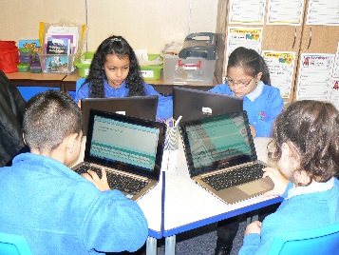
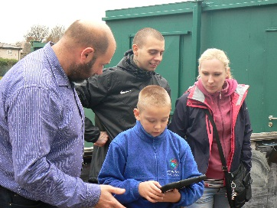
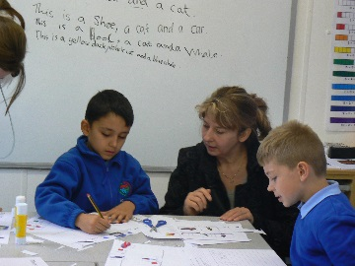
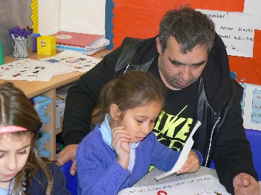

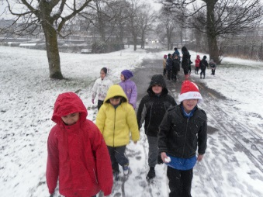
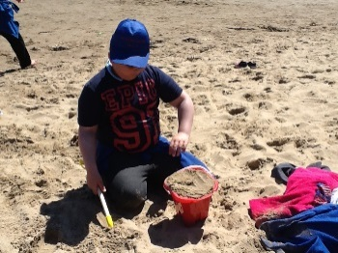
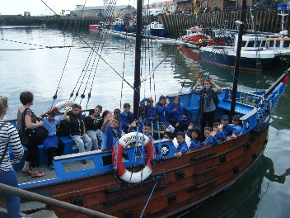
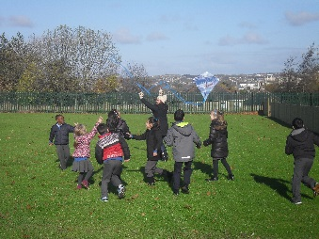
All support packages can be tailored to your needs.

Phased Approach to teaching New to English

Our support package:

Information about our phased approach to teaching New to English children. Look at the logistics of setting up the approach, our model and the outcomes.
Phase 1 – children who are brand new to English attend Phase 1 to learn basic skills for developing early speaking, reading and writing skills.
Phase 2 – Children in phase 2 further develop their speaking, reading and writing skills in more complex grammar structures.

All workshops include a tour of school, shared work samples and electronic materials. This is all free of charge!

