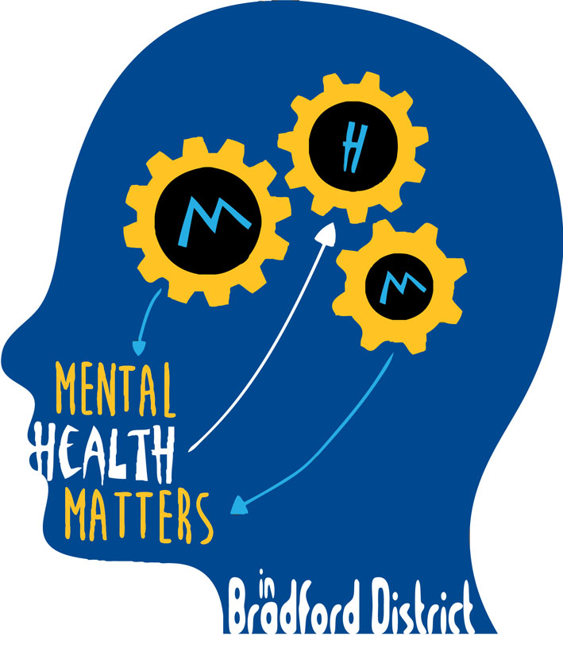
Bradford Children’s Services
This protocol was commissioned by the Mental Health in Schools Strategy Group and should be used in conjunction with the Protocol For Responding to Self – Harm in Schools and existing safeguarding policies.
Self Harm Record

Biographical information
School ______________________________
Child’s name__________________________
Male/ Female Year group __________
Ethnicity______________________________
Is this the first incident for this student? Yes/ No
If so do you know how long the student has been self harming? _________________________

Assessing the student’s vulnerability
Do you feel you can address this student’s needs in school or do you feel you Is the student able to talk to you about the reasons for their self harming behaviour and what they hope will happen as a result of this self harming behaviour? Yes/ No
Were you able to explore some of the alternatives to self harm, as explored in the Young Minds leaflet? Yes/ No
Has the student talked of wanting to end their life? Yes/ No
If yes have you referred to the CAMHS helpline/ GP/ A&E

Seeking support for the student
Have you explored with the student ways of involving parents and carers to share concerns and plan support? Yes/ No
The student wants/ does not want me to contact parents/ carers
(if the latter you must discuss this with your named safeguarding lead or with…….)
Together with the student have you identified someone in school who will act as keyworker to offer emotional support to the student? Yes/ No
Name, and date of first support session ___________________________________________

Attending to the wound
Did the student require immediate first aid? Yes/ No
Did you need medical advice/ visit to A&E Yes/ No
Name of person completing form__________________________________________________
Date:________________________________________________________________________

Please keep a copy of this form in the child’s file and also keep a copy in the school self harm file.

