‘All to Play For’
Bradford District Network Event
3rd February 2015
Richard Dunn’s Sports Centre
Agenda

8.30 – 9.00 Registration and Refreshments
9.00 Welcome and Introduction by Cllr Swallow, Bradford’s Play Champion
9.10 Bradford District Play Strategy – Caleb Sutton
9.25 Presentations from Community Partners
9.45 The Play Forum Agenda – Janet Jewitt
10.00 Presentations from Community Partners
10.20 Impact and Quality Assessment – Debbie Jowett
10.30 Break
10.40 Round Table Discussions
-How does the Local Authority and voluntary and community sector enable children to play?
-What do children want and need?
-Play in the future
11.30 Feedback
11.45 A Closing presentation:- ‘The Social Necessity of Play’ – Senior Lecturer Mike Wragg, Leeds Beckett University
12.00 Lunch and Networking
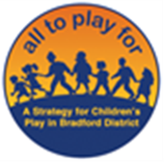
BMDC Play Team In Partnership with The Big Swing

