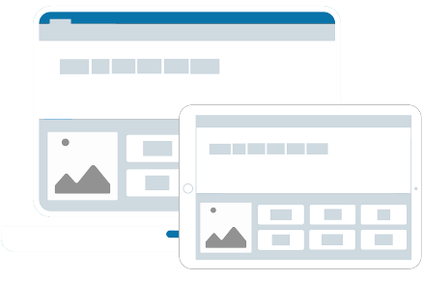

Bradford

Clicker Support Webinar

**Crick Software** and **Bradford’s Low Incidence, Physical and Medical Team**

would like to invite you to our Clicker Support Webinar

**Date:** Tuesday 5th October

**Time:** 2:45pm to 3:30pm

**Price:** Free



**Andrew Cumming**

Education Consultant

Email: [andrew.cumming@cricksoft.com](mailto:andrew.cumming@cricksoft.com)

Office: 01604 671691

Mobile: 07534 787127

Clicker is the complete writing solution for the primary classroom, providing every pupil with just the right level of support and challenge. Watch your pupils confidently tackle writing tasks with help from Clicker’s realistic speech feedback, audio note recorder and intelligent word prediction. The software includes access to a growing bank of topic-specific sentence building activities, word banks and writing frames, and it’s incredibly easy to create your own. The latest version, [Clicker 8](https://www.cricksoft.com/uk/clicker/8) combines proven literacy support tools teachers know and love with exciting new feature ideas from Clicker fans.

In this live QandA session, you will have the opportunity to:

* **Ask questions to develop your school’s implementation and understanding of Clicker**

We will also show you how you can:

* **Create a range of differentiated activities, to use throughout the classroom**
* **Save time by using our LearningGrids resources – Pre-made content developed by our Curriculum Team**

If you would like ideas on how to implement Clicker with a particular learner, or if you have any specific areas you would like to request support with - feel free to let us know via email.

[Join here](https://teams.microsoft.com/l/meetup-join/19%3ameeting_MTRmYmJiY2UtNWM0NS00YWE3LTg5NzctN2Q2ZDYwOWY2NTkz%40thread.v2/0?context=%7b%22Tid%22%3a%22a96b7c5d-7c50-45be-9a30-0a4143148d02%22%2c%22Oid%22%3a%2249448080-9e2e-4cd1-a007-90caa42263f4%22%2c%22IsBroadcastMeeting%22%3atrue%7d)

To join our webinar simply follow the link below