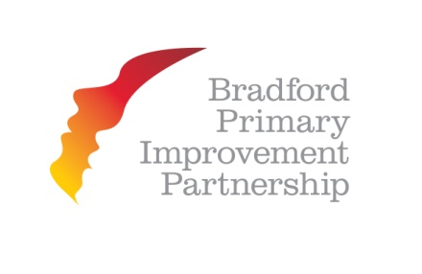
BOOKING FORM
BPIP New Leadership Demands Training

The Great Victoria Hotel, Bradford

Outline of Programme

Exclusive 3 day course for all senior leaders led by Professor John West-Burnham
A practical, school focused approach, rooted in the new world of school leadership
Dates:
Day 1 Knowing the challenges, 26th January 2015
Day 2 Finding the answers for you and your school, 12th February 2015
Day 3 Your School in the Community, 17th March 2015
__________________________________________________________________________________

Name
Role
School
School Address
Email Address
Telephone
Dietary requirements
BPIP member

You will be invoiced by Southmere Primary School

TO BE RETURNED A.S.A.P.

BPIP New Leadership Demands Training
FAO; HAYLEY MARSHALL
SOUTHMERE PRIMARY SCHOOL
EWART STREET
BRADFORD
BD7 3NR

FAX: 01274 504093
Cat.mccormack@southmere.bradford.sch.uk

