Primary SEAL
Theme: Relationships
Pupil Self-Assessment Booklet

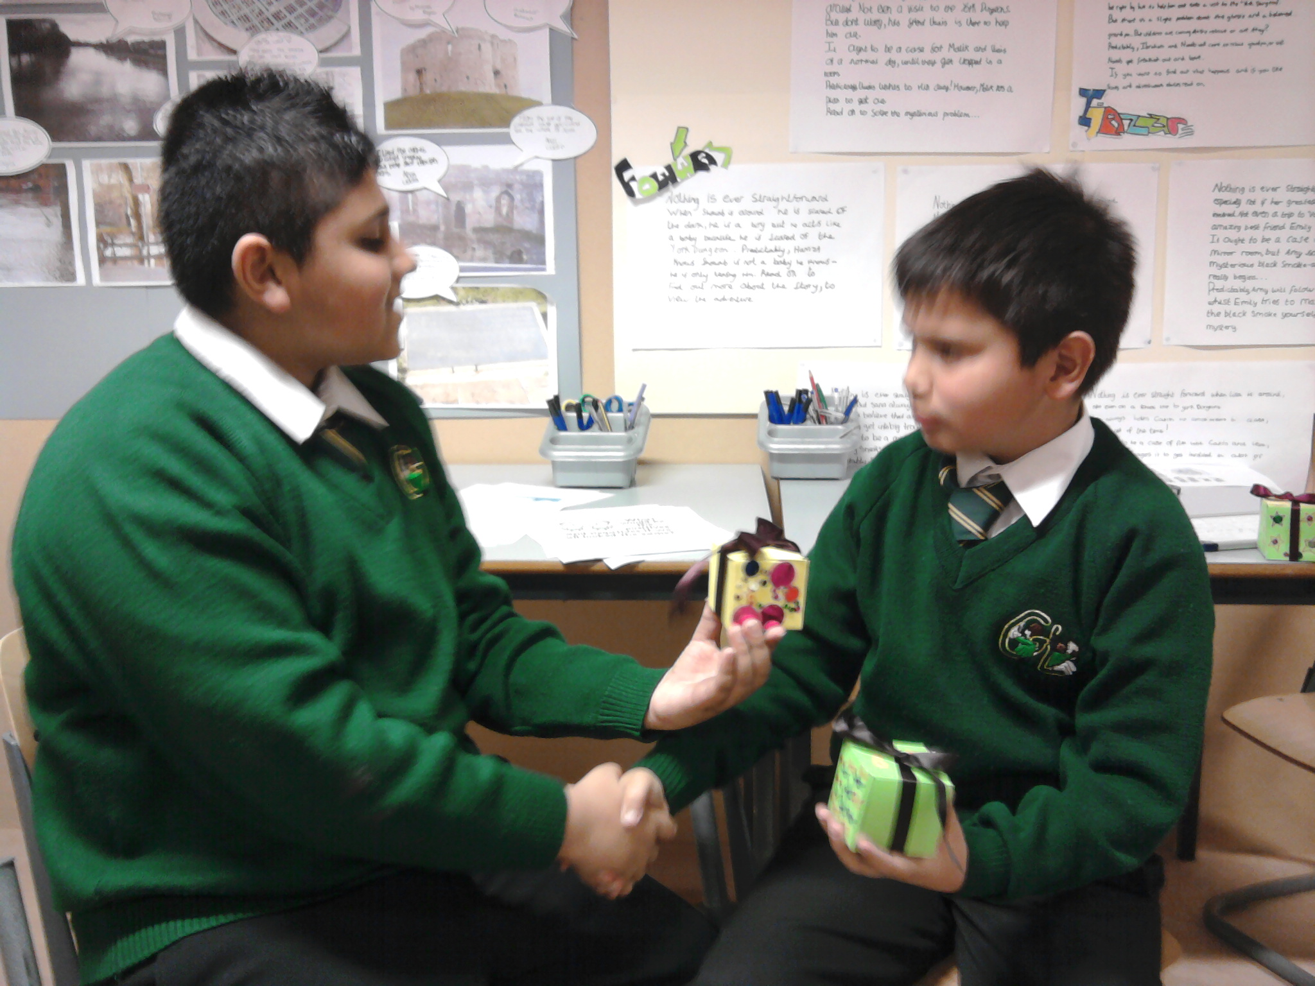

Relationships
Pupil self-assessment – Early Foundation

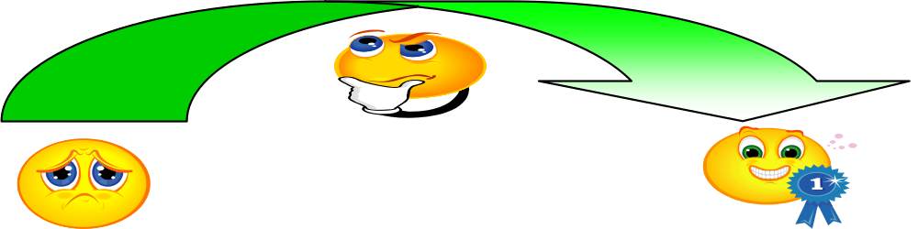

Name: Class: Date:

Understanding my feelings | How well did I do?
I can tell you how I feel if I am missing someone or have lost someone or something I care about. | 
I can tell when I am feeling sad or angry.
I can show someone when I am feeling sad, angry or happy.
Managing my feelings | How well did I do?
I am beginning to understand that if someone leaves me they can still love me.
I can remember someone I care about even if they are not there.
I can talk about how I can feel better when I am sad or am missing someone.
Understanding the feelings of others | How well did I do?
I can tell if someone is happy, sad or angry.

I enjoyed learning about…

I will try to…

Relationships
Pupil self-assessment – Later Foundation

Name: Class: Date:

Understanding my feelings | Can explain this on  my own
I can tell you how I feel if I am missing someone or have lost someone or something I care about. | 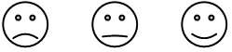
I can tell when I am feeling sad or angry.
I can show someone when I am feeling sad, angry or happy.
I can tell you how it feels when things are unfair.
Managing my feelings | Can explain this on  my own
I am beginning to understand that if someone leaves me they can still love me.
I can remember someone I care about even if they are not there.
I can talk about how I can feel better when I am sad or am missing someone.
Understanding the feelings of others | Can explain this on  my own
I can tell if someone is happy, sad or angry.
Making choices | Can explain this on  my own
I can tell you what is fair and unfair.
I can tell you when I think things are fair or unfair.
I know some ways I can make things fair

I enjoyed learning about…

I will try to…

Relationships
Pupil self-assessment - Year 1

Name: Class: Date:

Knowing myself | How well did I do?
I know the people who are important to me

Understanding my feelings | How well did I do?
I can tell you something that has made me jealous.
I can tell when I am proud or jealous.
I understand that being unkind and hurting someone doesn’t make me feel better.

Managing the feelings | How well did I do?
I can feel proud on behalf of my friends when they have done something well.
I can think of ways to make me feel better when I feel hurt.
I can make myself feel better without hurting others.

I enjoyed learning about…

I will try to…

Relationships
Pupil self-assessment - Year 2

Name: Class: Date:

Knowing myself | How well did I do?
I can tell when I feel cared for.
I can tell when I love or care for someone.
Understanding my feelings | How well did I do?
I can tell you how I feel when I lose someone or something I care about.

Managing the feelings | How well did I do?
I can share people I care about.
I can talk about my feelings when I am alone or when I have to share someone or something that is important to me.

Understanding the feelings of others | How well did I do?
I understand that if someone leaves me they might still love me
I understand that people have to make hard choices and sometimes they have had no choice.

I enjoyed learning about…

I will try to…

Relationships
Pupil self-assessment - Year 3

Name: Class: Date:

Knowing myself | How well did I do?
I can tell when something is my fault and when something is not my fault.
I can tell you the things that hurt my feelings.
Understanding my feelings | How well did I do?
I can express feelings of guilt
I can say when I might feel guilty
I know when I will feel guilty and use this when I make a choice
Managing my feelings | How well did I do?
I can tell when I feel ashamed about something
I know when to tell someone about it
I know some things to do when I feel guilty.
Social skills | How well did I do?
I can tell you how I can make someone who is important to me happy
I can tell you some ways of making amends if I have done something cruel or unkind

Making Choices | How well did I do?
I can take responsibility for what I choose to do

Understanding the feelings of others | How well did I do?
I can understand how I might hurt others

I will try to…
I enjoyed learning about…

Relationships
Pupil self-assessment - Year 4

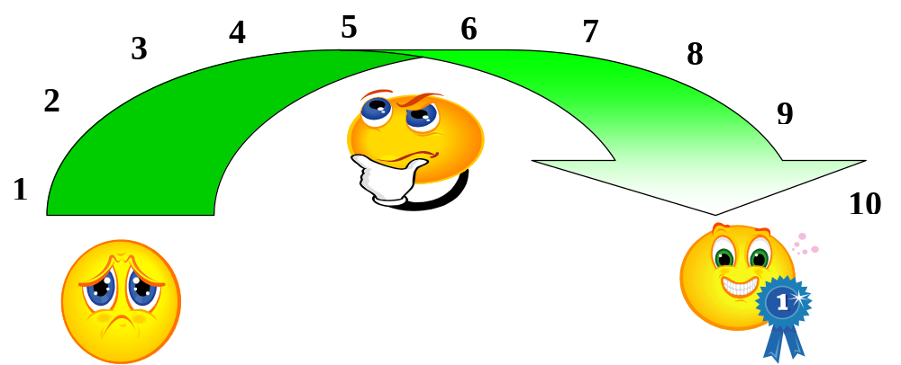

Name: Class: Date:

Social skills | How well did I do?
I can tell you how I feel about the important people or animals in my life, | 1-2-3-4-5-6-7-8-9-10
I know some ways to celebrate the life of someone I care about | 1-2-3-4-5-6-7-8-9-10
I can tell you about someone I know longer see | 1-2-3-4-5-6-7-8-9-10
I understand that we can remember people even if we no longer see them | 1-2-3-4-5-6-7-8-9-10

Understanding the feelings of others | How well did I do?
I know how most people feel when they lose something or someone the love | 1-2-3-4-5-6-7-8-9-10

I enjoyed learning about…

I would like to improve…

Relationships
Pupil self-assessment - Year 5

Name: Class: Date:
Knowing myself | How well did I do?
I can think about what embarrasses me and learn something about me that I didn’t know before | 1-2-3-4-5-6-7-8-9-10
Understanding my feelings | How well did I do?
I can tell you about a time that I felt embarrassed and what it felt like | 1-2-3-4-5-6-7-8-9-10
Managing my feelings | How well did I do?
I know some things to do when I feel embarrassed that will not make things worse | 1-2-3-4-5-6-7-8-9-10
Understanding the feelings of others | How well did I do?
I have helped someone who felt embarrassed | 1-2-3-4-5-6-7-8-9-10
I know how to make people feel good about themselves | 1-2-3-4-5-6-7-8-9-10
Social skills | How well did I do?
I can tell you about the people who are important to me | 1-2-3-4-5-6-7-8-9-10
I can give and receive a compliment | 1-2-3-4-5-6-7-8-9-10
I can recognise when I am using a put-down | 1-2-3-4-5-6-7-8-9-10
I can recognise stereotyping | 1-2-3-4-5-6-7-8-9-10
I can try to challenge stereotypes | 1-2-3-4-5-6-7-8-9-10
Making choices | How well did I do?
I can use a problem–solving approach to sorting out an embarrassing situation | 1-2-3-4-5-6-7-8-9-10

I enjoyed learning about…

I would like to improve…

Relationships
Pupil self-assessment - Year 6

Name: Class: Date:

Managing my feelings | How well did I do?
I can use some strategies to manage feelings associated with loss | 1-2-3-4-5-6-7-8-9-10
I can tell when I am hiding a feeling and then choose to share it with someone | 1-2-3-4-5-6-7-8-9-10
Understanding the feelings of others | How well did I do?
I know some of the feelings people have when someone close dies of leaves | 1-2-3-4-5-6-7-8-9-10
I understand that different people show their feelings in different ways | 1-2-3-4-5-6-7-8-9-10
I understand that there is not just one way to grieve | 1-2-3-4-5-6-7-8-9-10
Social skills | How well did I do?
I can tell you about the people who are important to me | 1-2-3-4-5-6-7-8-9-10
I can help support someone who is unhappy because they have lost someone or something | 1-2-3-4-5-6-7-8-9-10
I can break friends with someone without hurting their feelings | 1-2-3-4-5-6-7-8-9-10
I can think about when to forgive someone | 1-2-3-4-5-6-7-8-9-10
I can forgive someone | 1-2-3-4-5-6-7-8-9-10
Making Choices | How well did I do?
I understand when breaking friends might be the best thing do | 1-2-3-4-5-6-7-8-9-10

I enjoyed learning about…

I would like to improve…

