Primary SEAL
Theme: Relationships
Literacy Links Booklet
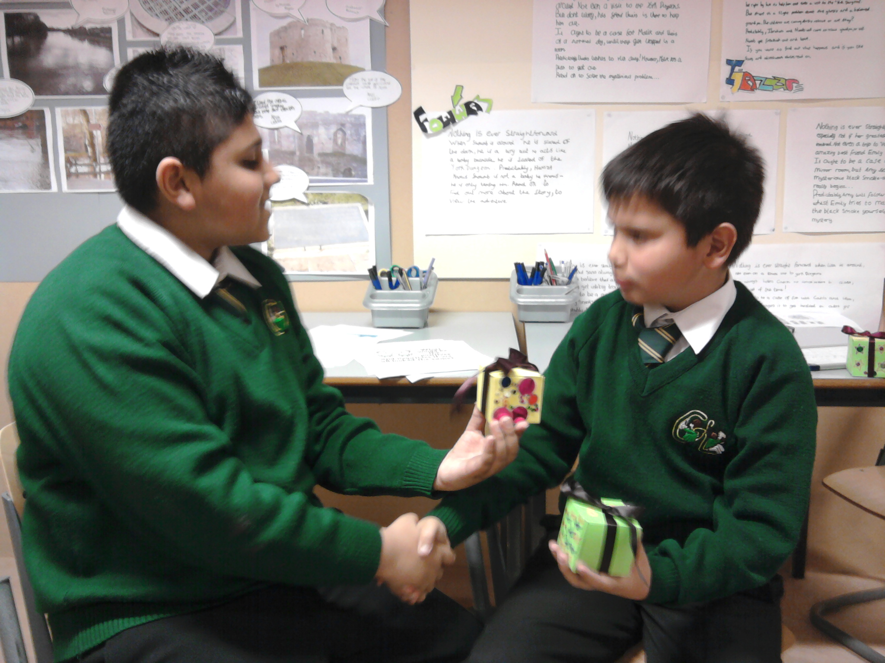

A sample of SEAL Literacy links

Covered by the

SEAL Curriculum Resource

Theme 6

Relationships

To be used alongside the Children’s Services medium-term planning documents.

Seal Literacy Links - Years 1 and 2

Relationships

SEAL Intended learning outcomes: (P.1. Blue Book)

Speaking and Listening links: group discussion and interaction (P.2. Blue Book)

Refer to medium term planning document.

 | Speaking and Listening Objectives | Literacy Objectives | Activity
1 |  | Literacy See exemplar lesson plans on jealousy and loss. | Use traditional tales, such as Cinderella, Sleeping Beauty and The Ugly Duckling, to look at jealousy, feeling left out, being pushed out and related uncomfortable feelings. Re-tell or write the stories from the viewpoint of one of the characters.  Share stories about the birth of a new baby, for example Katy Morag and the Tiresome Ted, by Mairi Hedderwick (Red Fox) ISBN 0099118815 and One round moon and a star for me, by Ingrid Mennen (Frances Lincoln) ISBN: 1 845 07025 9.  Discuss what it means when you have a new baby in the family, for example baby crying, Mum or Dad has less time for you. Does it feel as if your mum or dad doesn’t love you any more? Explore these feelings through texts such as  Not now Bernard, by David McKee (Addison-Wesley) ISBN: 0 050 04559 8,  The very worst monster, by Pat Hutchins (William Morrow) ISBN: 0 688 07816 8,  Love you forever, by Robert Munsch (Firefly Books) ISBN: 0 920 66836 4 (about the enduring nature of a parent’s love and how it crosses generations)  Gorilla, by Anthony Browne (Candlewick Press) ISBN: 0 763 61813 6 (about a girl whose father does not have time for her).  Talk about the jealousy or possessiveness of friends. Look at Dinosaur friends, by Paul Stickland (Ragged Bear US) ISBN: 1 929 92720 7 for discussion, then ask for writing about how it feels when a special friend plays with someone else.  Read the poem ‘Friends’, by Elizabeth Jennings in Poems for Thinking, by Robert Fisher (Nash Pollock Publishing) ISBN: 1 898 25515 6.  Get children to write their own poems about friends  When exploring loss, have the children write a letter to a special person who is no longer with them.
2 | Speaking and listening objectives  - • Y2: T2 S17 To tell real and imagined stories | Literacy objectives  - • Narrative 1 Y1 T3: T5, T13, Y2 T3: T4 | Speaking and listening  Act out stories, paying attention to facial expressions; use hot-seating to ask each character ‘How were you feeling then?’ ‘Why did you do that to Cinderella?’ Act out stories using a puppet theatre.  Exemplar Lesson 1  Discussing or writing about significant incidents or themes in stories  Text Dogger, by Shirley Hughes (Random House) ISBN: 0 099 92790 X  Text themes  A child’s sadness at losing a beloved toy. The understanding and thoughtfulness shown by the child’s sister who is prepared to forgo her own pleasure for her brother to be reunited with his special toy.  Possible focuses for response to this text: the teacher could pause in the story at the point where Dave has to go to sleep without Dogger. The children could be asked to talk about Dave’s feelings, and relate these to their own experiences, for example losing or forgetting a special toy when they stayed away from home.  The teacher could ask the children to consider how Dave’s family reacted to his news that he had lost Dogger. What did they each do? Try to draw out in the discussion that everyone took his feelings seriously, and no one told him it didn’t matter, or not to make a fuss. Although they could not find Dogger for Dave that night, how did the way they behaved help Dave to cope with his feelings?  The teacher could then read on to the incident where Dave spots Dogger on a stall at the fair, and pause again to discuss how Dave might have felt then. Help the children to see that he might have felt conflicting emotions, for example relief at finding Dogger, but worry that he wouldn’t be able to get him back.  The teacher could then read and discuss the end of the story, and ask the children to consider Bella’s actions, posing the question ‘Why was Bella being particularly kind?’ (Not only was she helping Dave to recover his toy, but she was giving up a special prize that she had won in order to do so.)  Dave is very grateful to Bella and remembers to thank her in words and with hugs. Why do the children think Bella tells Dave that she didn’t much like the new teddy anyway?  Suggested related activities  Many children will have experienced losing a precious toy at some point, or getting lost themselves in a crowd. They could be asked to tell or write about it.
3 | Speaking and listening objectives  - • Y 2: T2 L18 To respond to presentations by describing characters, repeating highlights and commenting constructively  • Y 2: T2 Dr24 To present part of a traditional tale | Literacy objectives  - • Narrative 1 (two weeks)T1, 2, 4, 6, 7, 12, 14 | Links to other curriculum areas - Art: work on portraits  Text Snow White – any illustrated version. Text themes Jealousy; good overcoming evil  It is expected that the book will have been read aloud in full to the children before or during this unit of work  Possible focuses after reading the story, the teacher could return to the part where, for the first time, the stepmother does not get the response she was expecting from the magic mirror. The children could be asked to identify the emotion that directs her subsequent actions, i.e. jealousy, and discuss with a talking partner other examples of characters being motivated by jealousy in stories or television programmes.  Children could be asked to look closely at illustrations of the stepmother’s face when she is feeling jealous and compare them to her earlier expression when the mirror gave her the answer she wanted. To extend their vocabulary, the children could be asked to find words to describe aspects of her face in detail – eyes and mouth especially – as preparation for writing a description. Words such as scowling, fierce, blazing, snarling could be introduced if need be.  The detailed description could become part of a ‘Wanted’ poster about the stepmother when she is disguised. This could also incorporate a warning about her ability to disguise her appearance, and descriptions of two of her known disguises to watch out for, based on illustrations and phrases from the text.  Suggested related activities - If you want to use your interactive whiteboard, there are interactive versions of many fairy tales, including Snow White or you might want to make your own stories using interactive multimedia software.  Children could use simple props (e.g. a silver paper mirror, an apple, a ribbon, a comb) to re-enact the story or parts of the story in groups.  In pairs or groups, children could act out ‘jealousy moments’, for example when Snow White’s stepmother is told by the mirror that Snow White is the fairest. This could be linked to acting out other jealousy moments in traditional stories, for example in Cinderella when her sisters are unpleasant to her.  The stepmother is presented in a very stereotypical way in this story. The teacher might want to explore a more realistic view of a stepmother or stepfather in children’s lives.  In order to help children understand the distinction between normal feelings of mild envy of their peers – I wish I had a new bike or a baby sister or a big piece of cake in my packed lunch like X has – and jealousy that leads to destructive behaviour, they could construct a chart with headings It’s OK to ... and But it’s not OK to ...

.

Seal Literacy Links - Years 3 and 4

Relationships

SEAL Intended learning outcomes: (P.1. Yellow Book)

Speaking and Listening links: group discussion and interaction (P.2. Yellow Book)

Literacy links/ exemplar lesson plans (P.25 – 34. Yellow Book)

Refer to medium term planning document.
 | Speaking and Listening Objectives | Literacy Objectives | Activity
1 |  | - • Y3 T3: T7, 15, 21  • Y4 T3: T4, 6, 9, 14, 15  Discussing and writing about issues or themes in poetry. A pet obituary. | Literacy See exemplar lesson plan for work on loss.  When working on guilt, read Get lost, Laura! by Jennifer Northway (Random House)  ISBN 0 30717520 0, in which children are nasty to a little sister and then she gets lost.
2 | - • Y3 T3: GD 35 To use the language of and reflect on feelings, behaviour or relationships  • Y3 T3: D36 To use some drama strategies to explore stories or issues  • Y4 T3: S44 To tell stories using voice effectively |  | Speaking and listening  Use the drama technique ‘conscience alley’, described in the leaflet Drama – making it work in the classroom, in QCA/Primary National Strategy guidance Speaking, Listening, Learning: working with children in Key Stages 1 and 2 (DfES 0623-2003).  The story Guilty!, in the resource sheets at the end of this section,  could be usefully explored in this way. Text Death of a cat by Anthony Thompson - see yellow booklet  Text themes Death of a loved pet  The teacher could read the poem to the class, then pose the following questions for consideration:  • What can we tell about the poet’s feeling for his cat from the first verse? The next four lines?  • Are there any clues about the cat’s feelings for the poet? (He opened his mouth as if to miaow; he lay quietly.)  • Why does the poet leave the room?  • Why is there no full-stop at the end of the poem?  • Why do you think the poet chose to tell readers the outcome in the title?  The children could be invited to talk about their own or others’ pets that have died, and how they came to terms with the loss. Those who do not have family pets may have watched television programmes like Animal Hospital that sometimes feature an animal’s death and the owner’s response.  Using teacher scribing, the children could be asked to help compose an imaginary obituary for the cat in the poem, inventing incidents from his life based on their own knowledge of cats.  The teacher may need to explain to the children that an obituary records memorable events from a life  Suggested related activities  In a drama session, the class could work in pairs to have a ‘telephone conversation’ between the poet and a good friend he rings to tell what has happened to his pet.  Alternative or additional texts with themes related to loss of a pet  Goodbye Mog, by Judith Kerr (Picture Lions) ISBN 0 007 14968 9  Fred, by Posy Simmonds (Red Fox) ISBN 0 099 26412 9  Lovely old Roly, by Michael Rosen (Frances Lincoln) ISBN 0 711 21488 3  Up in Heaven, by Emma Chichester Clark (Andersen) ISBN 1 842 70046 4  Badger’s parting gifts, by Susan Varley (Harper Trophy)  ISBN 0 688 11518 7  The tenth good thing about Barney, by Judith Viorst (Prentice Hall & IBD) ISBN 0 689 71203 0
Seal Literacy Links - Years 5 and 6

Relationships

SEAL Intended learning outcomes: (P.1. Green Book)

Speaking and Listening links: group discussion and interaction (P.2. Green Book)

Literacy links/ exemplar lesson plans (P.25 – 35. Green Book)

Refer to medium term planning document.

 | Speaking and Listening Objectives | Literacy Objectives | Activity
1 |  | Literacy See exemplar lesson plan on loss. | When working on embarrassment, explore some of these texts: Poetry: ‘My sister Jane’, by Ted Hughes and ‘Lorrie and Dorrie’, by Kit Wright, which lead to discussion about why adults embarrass children.  ‘Never ever tell’, by Michael Low, in A World of Poetry, ed. Michael Rosen (Kingfisher Books) ISBN: 1 856 97221 6, about a child painfully embarrassed about his eczema.  Love that dog, by Sharon Creech (HarperTrophy) ISBN: 0 064 40959 7, which is written in poem form and explores, among other themes, boys being embarrassed by praise and by poetry.  Face, by Benjamin Zephaniah (Bloomsbury USA) ISBN: 1 582 34774 3, about a teenager whose face is ruined and how he and his friends come to terms with it.  The terrible underpants, by Kaz Cooke (Hyperion Books) ISBN: 0 786 81924 3, a story for younger children which could lead to discussion and then children writing their own story for younger readers about having the wrong clothes and being embarrassed about it  Speaking and listening Role-play, act out or hot-seat from the point of view of different characters in texts relating to embarrassment.
2 |  | Literacy objectives T1, T2, T7, T8  Note: Links are made to text-level objectives in this suggested plan. Teachers will also need to link it to their word- and sentence-level objectives | Text ‘The long walk’, by George Layton in The Fib and other stories (Pan Macmillan) ISBN: 0 330 39795 8. This relates the final walk taken by a boy and his grandfather. The themes of close relationships, life and death are dealt with in a sensitive manner.  Narrative reading (two weeks)  This unit is exemplified in the NLS planning exemplification. For details see www.standards.dfes.gov.uk/literacy/ or the CD-ROM: Year 6 Planning Exemplification (2002–03), which was sent to all schools. The CD-ROM contains the full story text and all the teaching resources for the unit.
3 | - • Y6 T2 Dr64 Improvise … to explore themes such as hopes,  fears, desires  • Y6 T2 GD63 Consider examples of conflict and resolution, |  | Links to other curriculum areas The QCA History Unit 13 How has life in Britain changed since 1948? as there is textual evidence of change over time – clothing, transport, development of cities and so on, as the grandfather talks about his past life. The story would  provide some contextualising background information  Text themes The long walk presents a continuous narrative of a single event, which represents a number of previous similar encounters. This particular journey, however, is used by the grandfather to ‘close’ his life: he journeys through the stages of his life, finally taking his grandson to his grave plot. In retrospect, this makes complete sense to the grandchild, who is then perfectly prepared for the grandfather’s death.  There is no sense that the grandfather fears his death, rather that he is prepared for it and accepting of it.  The theme of change and continuity over time is explored – some things have altered, some have stayed the same. There is a sense of continuity between generations which helps place the grandfather’s death within a natural cycle.  Possible focuses for response to this text The annotated plan (in green booklet) shows how the existing unit of work could be amended to emphasise particular themes in the story.  Suggested related activities A linked guided reading session could also be included during days 1 and 2 to explore the issue further with selected children. The smaller group situation of a guided reading session could be supportive for some children in discussing uncomfortable feelings.  Having read and discussed The long walk in shared text work, introduce:  Grandpa, by John Burningham (Red Fox) ISBN: 0 099 43408 3 (or The grandad tree, by Trish Cooke (Walker Books) ISBN: 0 744 57875 2) in the guided session. These are picture books so will not present a reading challenge to Year 6 children and would therefore be a good text to use with a mixed reading ability group.  The challenge in the session would lie in comprehension, interpretation and discussion. Throughout the shared session, you could ask the children to compare the two texts. Both explore the close relationships between a child and a grandfather and they present the child’s reaction to the grandfather’s death.  The boy who suffers the loss of his grandfather in ‘The long walk’ has been prepared (along with the perceptive reader) for his grandfather’s death, which prevents a sense of shock  The girl in Grandpa is more apparently distressed, as she has fewer clues about her grandfather’s coming death, although the final picture suggests a natural circle of life continuing, into which she is drawn  After the discussion, children could write a reflective response in their reading journals or they could be asked to write a piece giving the girl’s memories of her grandfather  You might want to make electronic reflective journals, so that children can change and add to them at any time. It is often helpful to use a reflective journal, also called a process diary, in any piece of creative work, so that children can keep a record of ideas, sketches, notes, reviews and so on.  Alternative or additional texts  Poetry: ‘Grandad’, by Kit Wright and ‘Uncle’, by Brian Moses, in All in the family, with themes related to loss, a collection by John Foster (Oxford University Press) ISBN: 0 192 76119 6  Secret friends, by Elizabeth Laird (Hodder Children’s Books) ISBN: 0 340 66473 8  ‘The giant’s necklace’ and ‘Letter from Kalymnos’, by Michael Morpurgo, in Hereabout Hill (short stories) (Mammoth) ISBN: 0 749 72872 8  Eve and the man who helped God, by Michael Foreman (Andersen Press) ISBN: 1 84270219 X  Vicky Angel, by Jacqueline Wilson (Corgi) ISBN: 0 440 86415 1  My brother’s ghost, by Allan Ahlberg (Puffin) ISBN: 0 141 30618 1

