Primary SEAL
Theme: Going for Goals
Pupil Self-Assessment Booklet

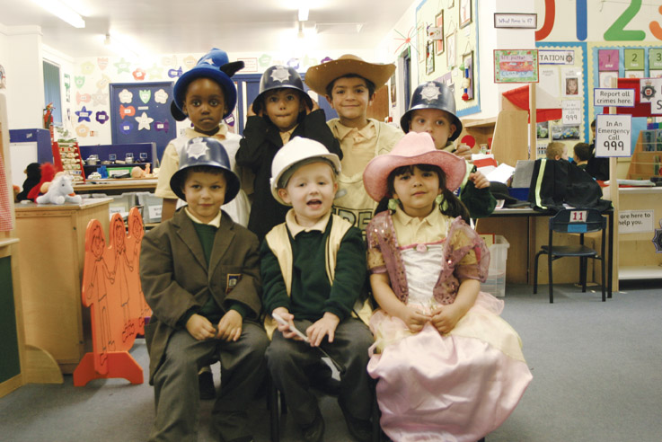

Going for Goals
Pupil self-assessment – Early Foundation

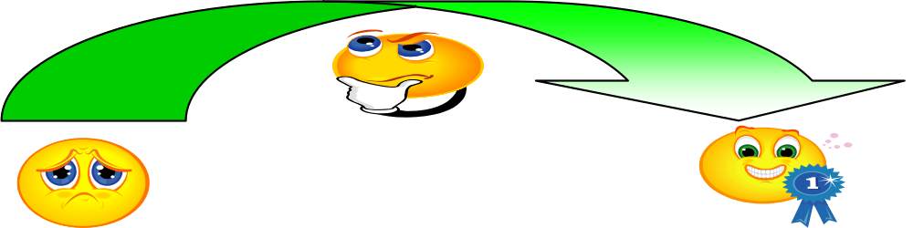

Name: Class: Date:

Knowing myself | How well did I do?
I know I can do more things now than I could when I was younger | 
I know when I am older I will be able to do more things
I know that we are all good at different things
Setting a realistic goal | How well did I do?
I can tell you what a goal is
I can work to try and reach my goal
I can set a goal for myself
I can try new things in my learning
Planning to reach a goal | How well did I do?
I can say what I am going to do next
I can work hard to achieve my goal
Evaluation and review | How well did I do?
I can set a goal for myself and a group

I will try to…
I enjoyed learning about…

Going for Goals
Pupil self-assessment – Later Foundation

Name: Class: Date:

Knowing myself | Can explain this on  my own
I know that we are all good at different things | 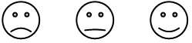
I can tell you what I like doing and learning
Setting a realistic goal | Can explain this on  my own
I can set a goal for myself
I can focus my attention and start a task
I can concentrate on what I am doing
I can tell you what I want to achieve and how I am going to do so
Planning to reach a goal | Can explain this on  my own
I can say what I am going to do next
I can know that working hard is important to reaching a goal
Evaluation and Review | Can explain this on  my own
I can set a goal for myself and for a group

I will try to…
I enjoyed learning about…
Going for Goals
Pupil self-assessment - Year 1

Name: Class: Date:

Knowing myself | How well did I do?
I know we learn in different ways
I can tell you some of my strengths as a learner
I can tell you how I work best

Setting a realistic goal | How well did I do?
I can choose a realistic goal and break it into small steps

Planning to reach a goal | How well did I do?
I can say what I want to happen when there is a problem
I can think of lots of different ideas or solutions
I can predict and understand the consequences of my solutions or ideas
Persistence | How well did I do?
I can break a goal down into small steps
I can recognise when I am becoming bored

I will try to…
I enjoyed learning about…

Going for Goals
Pupil self-assessment - Year 2

Name: Class: Date:

Knowing myself | How well did I do?
I can tell you how I learn best
I can learn from my successes

Setting a realistic goal | How well did I do?
I can say what I want to happen when there is a problem
I can break a goal down into small steps

Working together | How well did I do?
I can decide with my group about how well we have worked together.

Persistence | How well did I do?
I can recognise when I am becoming bored or frustrated

Evaluation and review | How well did I do?
I can tell you what I have learned
I enjoyed learning about…

I will try to…

Going for Goals
Pupil self-assessment - Year 3

Name: Class: Date:

Knowing myself | How well did I do?
I can tell you about myself as a learner
I know that I am responsible for my own learning and behaviour
I can foresee obstacles and plan to overcome them when I am setting goals
I know how to see things from someone else’s point of view.
Planning to reach a goal | How well did I do?
I can set success criteria so that I know whether I have reached my goal
I can break down a goal into a number of steps and wait for the result
I know how others can help me to achieve my goals and how I can help others
Making choices | How well did I do?
I can identify advantages and disadvantages of the goals I set
I can manage frustration by using a number of strategies
Evaluation and review | How well did I do?
I can recognise when I have reached my goal or been successful with my learning

I enjoyed learning about…

I will try to…

Going for Goals
Pupil self-assessment - Year 4

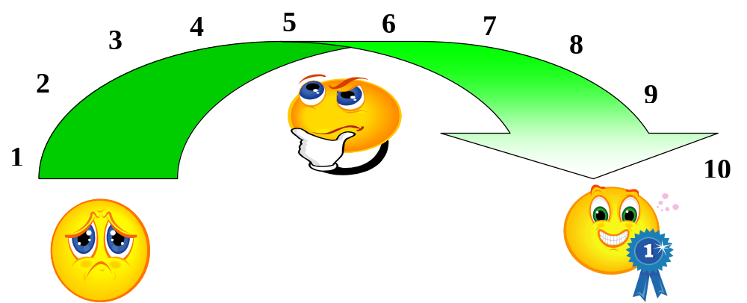

Name: Class: Date:

Knowing myself | How well did I do?
I know that I am responsible for my learning | 1-2-3-4-5-6-7-8-9-10

Setting a realistic goal | How well did I do?
I can foresee obstacles and plan to overcome them when I am setting goals | 1-2-3-4-5-6-7-8-9-10

Planning to reach a goal | How well did I do?
I can set success criteria so that I will know when I have reached my goal | 1-2-3-4-5-6-7-8-9-10
I can break a goal down into small steps and wait for the result | 1-2-3-4-5-6-7-8-9-10

Persistence | How well did I do?
I can identify some barriers to my learning | 1-2-3-4-5-6-7-8-9-10
I can tell you how I keep going even when the task is difficult or boring | 1-2-3-4-5-6-7-8-9-10
I can recognise when I find learning difficult and persevere when I need to | 1-2-3-4-5-6-7-8-9-10

Evaluation and review | How well did I do?
I can recognise when I have reached my goal or been successful | 1-2-3-4-5-6-7-8-9-10
I can tell you how I am going to apply what I have learned | 1-2-3-4-5-6-7-8-9-10
I would like to improve…
I enjoyed learning about…

Going for Goals
Pupil self-assessment - Year 5

Name: Class: Date:

Knowing myself | How well did I do?
I know the skills and attributes of an effective learner | 1-2-3-4-5-6-7-8-9-10
I can try to develop these skills | 1-2-3-4-5-6-7-8-9-10
I can recognise and celebrate my own achievements | 1-2-3-4-5-6-7-8-9-10
I know what some of the people in my class like or admire about me | 1-2-3-4-5-6-7-8-9-10

Setting a realistic goal | How well did I do?
I can set myself a goal or challenge | 1-2-3-4-5-6-7-8-9-10

Planning to reach a goal | How well did I do?
I can make small achievable goals | 1-2-3-4-5-6-7-8-9-10

Persistence | How well did I do?
I can try again even when I have been unsuccessful | 1-2-3-4-5-6-7-8-9-10
Evaluation and review | How well did I do?
I can be a critical friend to myself or others | 1-2-3-4-5-6-7-8-9-10
I can apply what I have learned | 1-2-3-4-5-6-7-8-9-10
I can tell you what I need to learn next | 1-2-3-4-5-6-7-8-9-10

I would like to improve…
I enjoyed learning about…

Going for Goals
Pupil self-assessment - Year 5

Name: Class: Date:

Knowing myself | How well did I do?
I know the skills and attributes of an effective learner | 1-2-3-4-5-6-7-8-9-10
I can try to develop these skills | 1-2-3-4-5-6-7-8-9-10
I can recognise and celebrate my own achievements | 1-2-3-4-5-6-7-8-9-10
I know what some of the people in my class like or admire about me | 1-2-3-4-5-6-7-8-9-10

Setting a realistic goal | How well did I do?
I can set myself a goal or challenge | 1-2-3-4-5-6-7-8-9-10

Planning to reach a goal | How well did I do?
I can make small achievable goals | 1-2-3-4-5-6-7-8-9-10

Persistence | How well did I do?
I can try again even when I have been unsuccessful | 1-2-3-4-5-6-7-8-9-10
Evaluation and review | How well did I do?
I can be a critical friend to myself or others | 1-2-3-4-5-6-7-8-9-10
I can apply what I have learned | 1-2-3-4-5-6-7-8-9-10
I can tell you what I need to learn next | 1-2-3-4-5-6-7-8-9-10

I would like to improve…
I enjoyed learning about…



1
2
3
4
5
6
7
8
9
10

Going for Goals
Pupil self-assessment - Year 6

Name: Class: Date:

Knowing myself | How well did I do?
I can recognise and celebrate my own achievements | 1-2-3-4-5-6-7-8-9-10
I can recognise when I am using an excuse instead of finding away around a problem | 1-2-3-4-5-6-7-8-9-10

Setting a realistic goal | How well did I do?
I can set myself a goal or challenge | 1-2-3-4-5-6-7-8-9-10
I know the skills and attributes of an effective learner | 1-2-3-4-5-6-7-8-9-10

Planning to reach a goal | How well did I do?
I know that its up to me to get things done by taking the first step | 1-2-3-4-5-6-7-8-9-10

Persistence | How well did I do?
I know that if at first I don’t succeed it is worth trying again | 1-2-3-4-5-6-7-8-9-10
I can try again even when I have been unsuccessful | 1-2-3-4-5-6-7-8-9-10

Making choices | How well did I do?
I can make a long term plan and break it down into smaller, achievable goals in my personal life or in my behaviour | 1-2-3-4-5-6-7-8-9-10
I know that it is up to me to get things done by taking the first step | 1-2-3-4-5-6-7-8-9-10

Evaluation and review | How well did I do?
I can apply what I have learned | 1-2-3-4-5-6-7-8-9-10
I can tell you what I need to learn next | 1-2-3-4-5-6-7-8-9-10
I would like to improve…
I enjoyed learning about…

