Primary SEAL
Theme: Relationships
Assessment Guidance Booklet
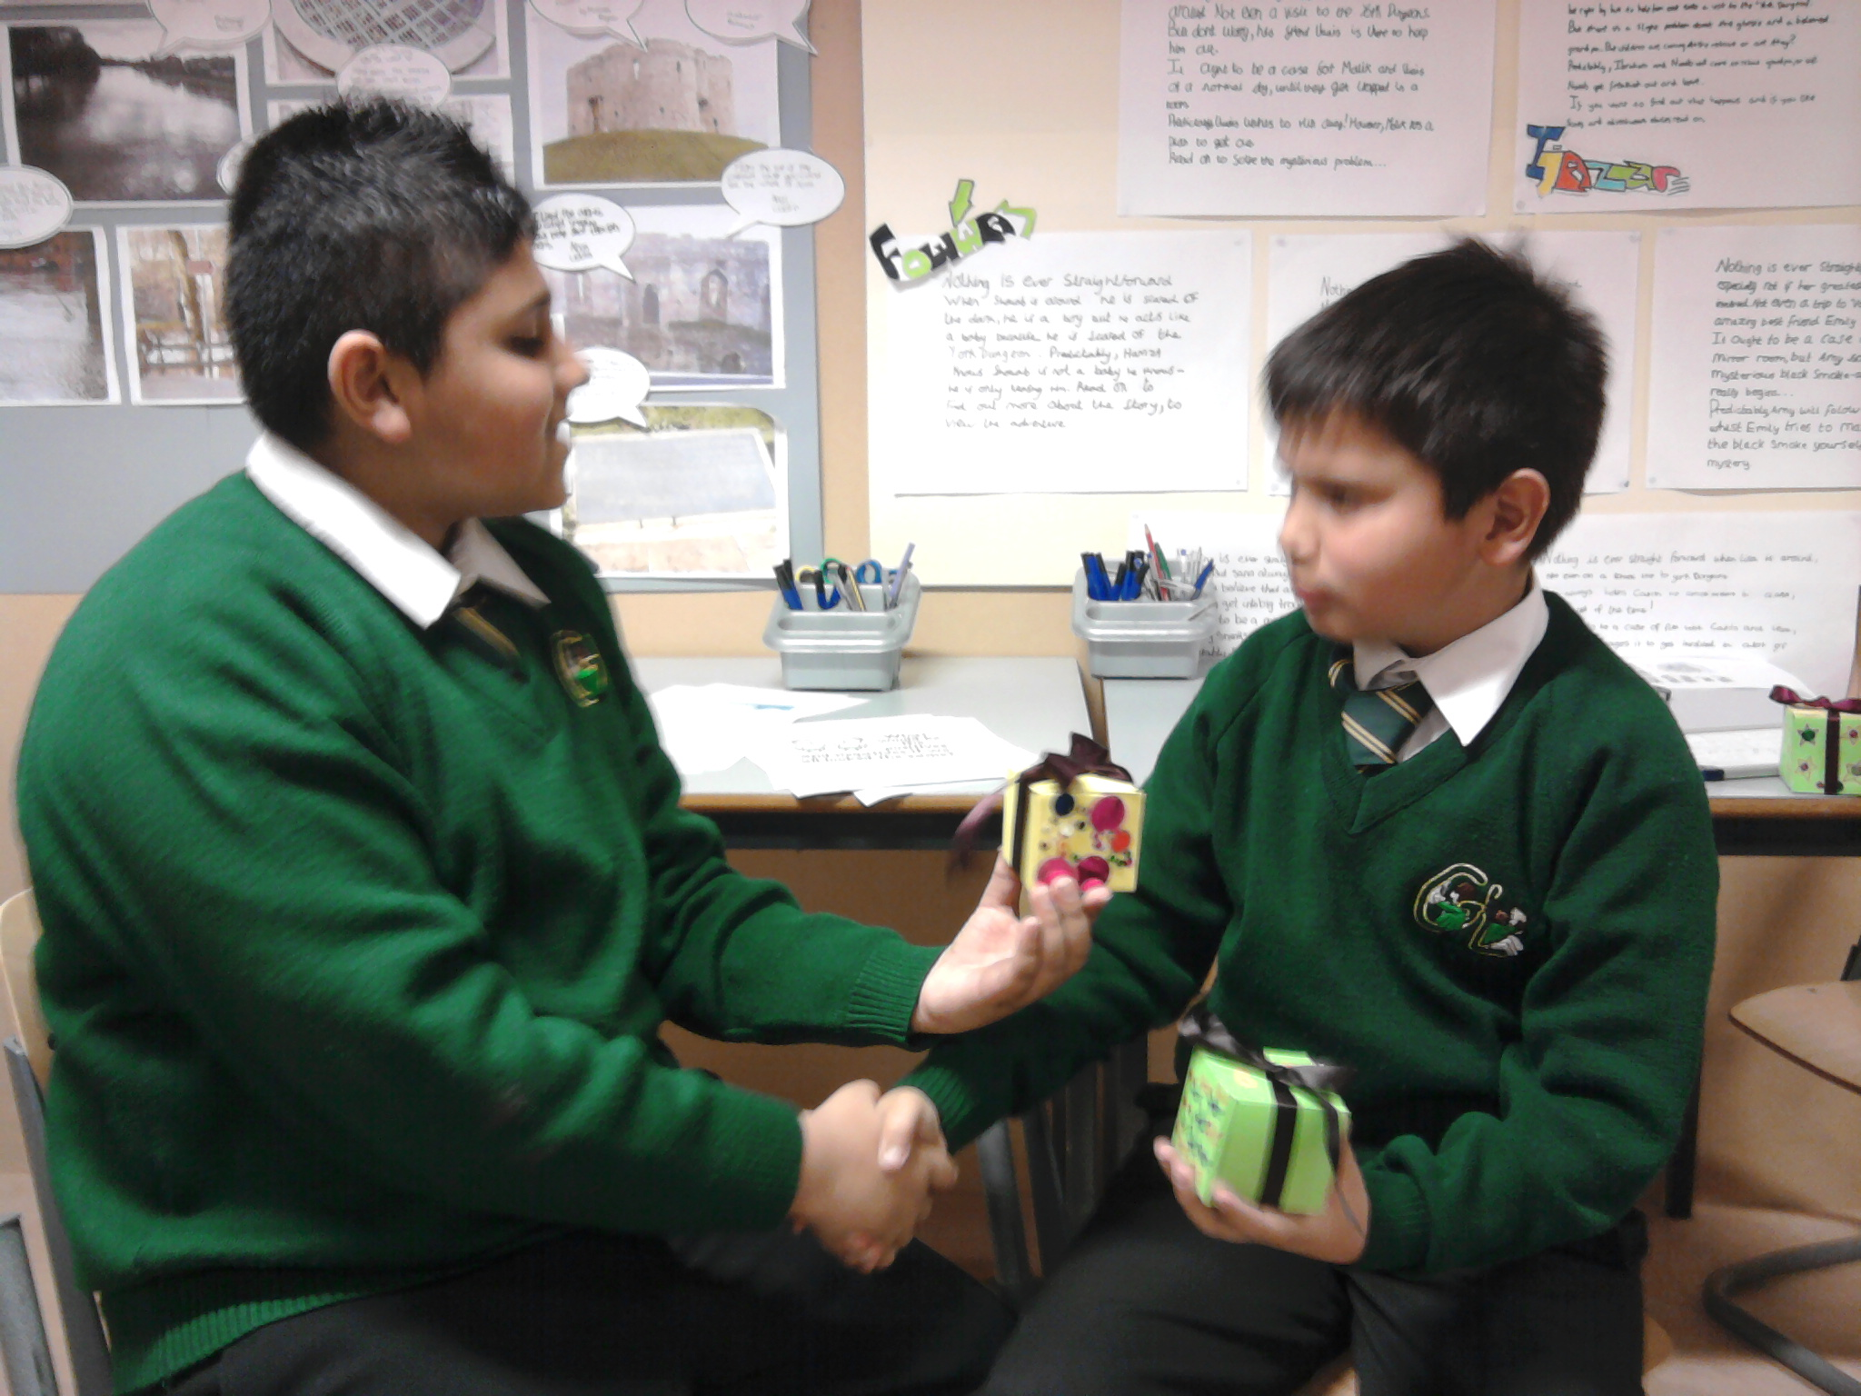

SEAL

Assessment and Monitoring Guidance

SEAL Assessment Guidance
Assessing children’s progress

The following information is taken directly from the SEAL Guidance booklet. (Page 36)

There are no formal arrangements for assessing individual children’s progress in developing social, emotional and behavioural skills included with this resource. Within each theme overview, however, there are descriptions for each age group of what children will know, understand and be able to do following the successful completion of work on the theme. For children in the early years these will contribute to assessments of progress towards the personal, social and emotional Early Learning Goals within the Foundation Stage Profile. For children in KS1 and 2, they will contribute to judgements teachers make about children’s progress within PSHCE and Citizenship, using the end of key stage summative statements available from the QCA website (www.qca.org.uk/pshe).

Teachers are encouraged to share clear intended learning outcomes and devise, with children, success criteria to test if these have been met at the beginning and plenary of each session. The assessment and monitoring of children’s learning is therefore continuous and formative. In this way children know that they are making progress in developing important skills. They and others learn to value and celebrate their achievements in this as well as more academic areas of work.

Clearly, where a child is having significant difficulty in making progress in their social and emotional learning, despite an appropriate environment and learning opportunities, the school or setting’s usual arrangements for identifying concerns would be used.

Assessment grids

The enclosed grids have been designed to be used to monitor the progress of classes throughout the school and to enable Teachers to identify pupils who would benefit from SEAL small group work.

This system has been designed so that the class teacher has very little extra work. (It should take about 1 minute at the end of every lesson)

This is meant to be a simple way of using Assessment for Learning and could be used as follows:
- The lesson objectives are shared with the children at the beginning of the lesson, along with the success criteria (these will need to be put into ‘child speak’ in many cases.)
- During the plenary at the end of the week/lesson, the teacher ascertains in the usual way (thumbs up/ traffic lights etc.) whether or not the children believe that they have met the success criteria.
- On the basis of this, the teacher highlights the ‘I can’ statements for the lesson, using a traffic light system.
- The children who do not meet the success criteria could be targeted for Small Group Activity work.
- There will be 7 sheets each year (one for each theme). These could be passed to the next teacher at the end of the academic year along with other records. The new teacher, at a glance, could identify children who have difficulties in certain areas of the SEAL curriculum.
- If some ‘I can statements’ have been highlighted in red, the new teacher will be aware of the areas that need further work.

In addition, the assessments could be used when the teacher is writing individual reports. Several of the statements could be used in the PSHCE part of the child’s report.

Similarly, it might be easier to see which of the end of Key Stage statements for PSHCE have been met if these assessments have been carried out.
SEAL Assessment
Relationships
Early Years Foundation Stage
Development Matters 30 – 50 months

Teacher: Class:

Key vocabulary ( to be introduced within the theme and across the curriculum)
comfortable | uncomfortable | missing | loss | angry
dead | unfair | fair | sad | happy
worried | alive | lonely

Understanding my feelings
- I can tell you how I feel if I am missing someone or have lost someone or something I care about
- I can tell when I am feeling sad or angry.
- I can show someone when I am feeling sad, angry or happy

Managing my feelings
- I am beginning to understand that if someone leaves me they can still love me.
- I can remember someone I care about even if they are not there.
- I can talk about how I can feel better when I am sad or am missing someone

Understanding the feelings of others
- I can tell if someone is happy, sad or angry

Links
Revised Early Years Foundation Stage version: Development Matters p.2 – 3
Red Book p. 2 – 4 Birth to three matters learning outcomes.

SEAL monitoring

Children whose achievement is secure | Children whose achievement is slightly insecure | Children whose achievement is significantly insecure | Comments

SEAL Assessment
Relationships
Early Years Foundation Stage
Development Matters 40-60+ months

Teacher: Class:

Key vocabulary ( to be introduced within the theme and across the curriculum)
comfortable | uncomfortable | missing | loss | angry
dead | unfair | fair | sad | happy
worried | alive | lonely

Understanding my feelings
- I can tell you how I feel if I am missing someone or have lost someone or something I care about
- I can tell when I am feeling sad or angry.
- I can show someone when I am feeling sad, angry or happy
- I can tell you how it feels when things are unfair.

Managing my feelings
- I am beginning to understand that if someone leaves me they can still love me.
- I can remember someone I care about even if they are not there.
- I can talk about how I can feel better when I am sad or am missing someone

Understanding the feelings of others
- I can tell if someone is happy, sad or angry

Making choices
- I can tell you what is fair and unfair.
- I can tell you when I think things are fair or unfair.
- I know some ways I can make things fair.

Links
Revised Early Years Foundation Stage version: Development Matters p.2 – 3
Red Book p. 2 – 4 Birth to three matters learning outcomes.

SEAL monitoring

Children whose achievement is secure | Children whose achievement is slightly insecure | Children whose achievement is significantly insecure | Comments

SEAL Assessment
Relationships
Year 1

Teacher Class:

Key vocabulary ( to be introduced within the theme and across the curriculum)
important people | love | unkind | loss | share
cared for | jealous | hurt | leave | proud
choice | lonely | miss | envy | envious

Knowing myself:
- I know the people who are important to me.

Understanding my feelings
- I can tell you something that has made me jealous.
- I can tell when I am proud or jealous.
- I understand that being unkind and hurting someone doesn’t make me feel better.

Managing the feelings:
- I can feel proud on behalf of my friends when they have done something well.
- I can think of ways to make me feel better when I feel hurt.
- I can make myself feel better without hurting others.

Links

P. 2 Blue book PSHCE/Citizenship links

Speaking and listening links: group discussion and interaction

SEAL monitoring

Children whose achievement is secure | Children whose achievement is slightly insecure | Children whose achievement is significantly insecure | Comments

SEAL Assessment
Relationships
Year 2

Teacher Class:

Key vocabulary ( to be introduced within the theme and across the curriculum)
important people | love | unkind | loss | share
cared for | jealous | hurt | leave | proud
choice | lonely | miss | envy | envious

Knowing myself:
- I can tell when I feel cared for
- I can tell when I love or care for someone

Understanding my feelings:
- I can tell you how I feel when I lose someone or something I care about.

Managing the feelings:
- I can share people I care about.
- I can talk about my feelings when I am alone or when I have to share someone or something that is important to me.

Understanding the feelings of others:
- I understand that if someone leaves me they might still love me.
- I understand that people have to make hard choices and sometimes they have had no choice.

Links

P. 2 Blue book PSHCE/Citizenship links

Speaking and listening links: group discussion and interaction

SEAL monitoring

Children whose achievement is secure | Children whose achievement is slightly insecure | Children whose achievement is significantly insecure | Comments

SEAL assessment
Relationships
Year 3

Teacher: Class:

Key vocabulary ( to be introduced within the theme and across the curriculum)
fault | blame | guilty | choice | love
proud | cruel | kind | ashamed | celebrate
funeral | amends | conscience | regret | remorse
apologise | death | miss | alone

Knowing myself:
- I can tell when something is my fault and when something is not my fault.
- I can tell you the things that hurt my feelings.
Understanding my feelings:
- I can express feelings of guilt.
- I can say when I might feel guilty.
- I know when I will feel guilty and use this when I make a choice.
Managing my feelings:
- I can tell when I feel ashamed about something.
- I know when to tell someone about it.
- I know some things to do when I feel guilty.
Social skills:
- I can tell you how I can make someone who is important to me happy.
- I can tell you some ways of making amends if I have done something cruel or unkind.
Making choices:
- I can take responsibility for what I choose to do.
Understanding the feelings of others.
- I can understand how I might hurt others.

Links

P.2 yellow book
PSHCE links

Speaking and listening links: group discussion and interaction

SEAL monitoring

Children whose achievement is secure | Children whose achievement is slightly insecure | Children whose achievement is significantly insecure | Comments

SEAL assessment
Relationships
Year 4

Teacher: Class:

Key vocabulary ( to be introduced within the theme and across the curriculum)
fault | blame | guilty | choice | love
proud | cruel | kind | ashamed | celebrate
funeral | amends | conscience | regret | remorse
apologise | death | miss | alone

Social skills:
- I can tell you how I feel about the important people or animals in my life.
- I know some ways to celebrate the life of someone I care about.
- I can tell you about someone I know longer see.
- I understand that we can remember people even if we no longer see them.

Understanding the feelings of others.
- I know how most people feel when they lose something or someone they love.

Links

P.2 yellow book
PSHCE links

Speaking and listening links: group discussion and interaction

SEAL monitoring

Children whose achievement is secure | Children whose achievement is slightly insecure | Children whose achievement is significantly insecure | Comments

SEAL assessment
Relationships
Year 5

Teacher: Class:

Key vocabulary ( to be introduced within the theme and across the curriculum)
embarrassed | humiliation | forgive | make amends | stereotype
breaking friends | grief | grieve | shock | denial
anger | disbelief | depression | despair | sadness
acceptance

Knowing myself:
- I can think about what embarrasses me and learn something about me that I didn’t know before.
Understanding my feelings:
- I can tell you about a time that I felt embarrassed and what it felt like.

Managing my feelings:
- I know some things to do when I feel embarrassed that will not make things worse.

Understanding the feelings of others:
- I have helped someone who felt embarrassed.
- I know how to make people feel good about themselves.

Social skills:
- I can tell you about the people who are important to me.
- I can give and receive a compliment.
- I can recognise when I am using a put – down.
- I can recognise stereotyping.
- I can try to challenge stereotypes.
Making choices:
- I can use a problem – solving approach to sorting out an embarrassing situation.

Links
P. 2-3 green book
PSHCE/Citizenship links
Speaking and listening links: group discussion and interaction

SEAL monitoring

Children whose achievement is secure | Children whose achievement is slightly insecure | Children whose achievement is significantly insecure | Comments

SEAL assessment
Relationships
Year 6

Teacher: Class:

Key vocabulary ( to be introduced within the theme and across the curriculum)
embarrassed | humiliation | forgive | make amends | stereotype
breaking friends | grief | grieve | shock | denial
anger | disbelief | depression | despair | sadness
acceptance

Managing my feelings:
- I can use some strategies to manage feelings associated with loss.
- I can tell when I am hiding a feeling and then choose to share it with someone.

Understanding the feelings of others:
- I know some of the feelings people have when someone close dies or leaves.
- I understand that different people sow their feelings in different ways.
- I understand that there is not just one way to grieve.

Social skills:
- I can tell you about the people who are important to me.
- I can help support someone who is unhappy because they have lost someone or something.
- I can break friends with someone without hurting their feelings.
- I can think about when to forgive someone.
- I can forgive someone.

Making choices:
- I understand when breaking friends might be the best thing to do.

Links
P. 2-3 green book
PSHCE/Citizenship links
Speaking and listening links: group discussion and interaction

SEAL monitoring

Children whose achievement is secure | Children whose achievement is slightly insecure | Children whose achievement is significantly insecure | Comments

SEAL Small Group Assessment & Monitoring

SEAL Assessment
Relatiionships
Small Group Work - Key Stage 1 Silver Strand – (Wave 2 Primary National Strategy Waves of Intervention)

Teacher/Support Group:

Key vocabulary to be introduced within the theme and across the curriculum)
Missing | Angry | Dead | Alive | Lonely
Worried | Comfortable | Uncomfortable | Important people | Cared for
Love | Unkind | Hurt | Loss | Share
Leave | Proud | Choice | Lonely | Miss
Envy/envious | Happy | Fair | Unfair

Core Activity 1 Key Vocabulary Happy Fair Unfair
- I know the people in the group
- I can make new friends
Core Activity 2 Key Vocabulary Fair Unfair Proud
- I can tell you what is fair and unfair
- I can tell you when I think things are fair or unfair
- I know some ways I can make things fair
Core Activity 3 Key Vocabulary Lonely Missing Happy Sad
- I can think of ways to make me feel better when I feel hurt
- I can make myself feel better without hurting others
Core Activity 4 Key Vocabulary Important people Cared for Love Lonely
- I know the people who are important to me
Core Activity 5 Key Vocabulary Angry Happy Sad Scared
- I can talk about my feelings when I feel alone or when I have to share someone or something that is important to me
Core Activity 6 Key Vocabulary Unkind Hurt Share Choice
- I understand that being unkind and hurting someone doesn’t make me feel better.
- I can make myself feel better without hurting others
Core Activity 7 Key Vocabulary Unkind Hurt Kind Love
- I can think of ways to make me feel better when I feel hurt
- I can make myself feel better without hurting others
Core Activity 8 Key Vocabulary Jealous Envy/envious
- I can tell you something that has made me jealous
- I can tell you when I feel jealous
- I can share people I care about
- I can name feelings that are often associated with relationships
Core Activity 9 Key Vocabulary See General Vocabulary Above
- I can tell you what I have learned
SEAL monitoring
Small Group Work – Key Stage 1 – Silver Set -

 | Children whose achievement is secure | Children whose achievement is slightly insecure | Children whose achievement is significantly insecure | Comments
Core Activity 1

Core Activity 2

Core Activity 3

Core Activity 4

Core Activity 5

Core Activity 6

Core Activity 7

Core Activity 8

Core Activity 9

