Our ref: BSS/JS/LW  Your ref: | Behaviour Support Service  Education Bradford  Future House  Bolling Road  Bradford  BD4 7EB  Telephone 01274 385617  Textphone 01274 385586  Fax 01274 385624  Website www.bradfordschools.net  E Jennie.Sadowskyj@educationbradford.com
To all Headteachers of Primary and Secondary Schools
To all Heads of Inclusion / SEN

Dear Headteacher

National Programme for Specialist Leaders in Behaviour and Attendance

I am writing to inform you of an exciting opportunity for aspiring middle leaders and other staff you may be looking to develop in the B&A area within your secondary school and staff employed in the primary sector, to take part in the National Programme for Specialist Leaders in Behaviour and Attendance (NPSLBA).

The programme is located within the DCSF National Strategies for B & A and consists of freely available national programme materials (downloaded from the Teachernet web-site). The nationally certificated course will be supported in 2009/10 by myself, Joanne Sykes, Helen Williams,(B & A Consultants) and Tim Stripe (Behaviour Manager, Beckfoot School).

Programme Aims – Why should your school be involved?

- The opportunity for colleagues in different schools to share good practice within and cross phase.
- The opportunity for colleagues to gain an understanding of how B&A is dealt with cross phase with a view to enhancing links and sharing good practice between primary, secondary and other settings.
- Helps build leadership capacity and offers supportive, distributive CPD.
- Supports and establishes clear links between leadership, standards, attendance, behaviour, SEAL etc.
- Supports your persistent absence (PA) agenda in school.

Structure of course

75% of the programme is employment-based learning, allowing participants to develop skills while improving behaviour and attendance in their workplace. Cluster group members may have their work accredited as a Vocationally Related Qualification (VRQ) or gain credits towards a Master’s level qualification.

- 3 Study days – Weds 7th Oct 2009, Tues 2nd Feb 2010, Thurs 10th June 2010
- 1 additional support day – Weds 23rd June
- 10 cluster sessions – Outside school hours, twilight sessions held in participants schools
- 3 work based activities

Each participant will complete a working folder and a portfolio. The latter will include a reflective log of the learning outcomes for submission at the end of the course. All participants attending the cluster sessions and study days will receive a National Certificate at the end of the programme.

NPSLBA study materials are written specifically for use by NPSLBA cluster groups. One member of the group takes the role of session leader and facilitates the session for the group as a whole. The session leader is not expected to act as an expert trainer and will be able to join the group in their learning together.
Cost
The cost per participant/releasing organisation is £200 which meets the costs associated with administration and study day venues. In addition there will be supply cover, downloading and copying materials and time provided for line management support.
Next steps
1. Further information about the programme can be found on the Teachernet website www.teachernet.gov.uk/npslba but Jo, Helen or I would be happy to answer any specific questions that you may have. Places are limited to 40 participants. (Contact e-mails: jennie.sadowskyj@educationbradford.com,joanne.sykes@educationbradford.com, helen.williams@educationbradford.com)
2. Please fill in the form below and e-mail or post back to Catherine Williams, Administrator, BSS, Future House, Bolling Road, Bradford BD4 7EB. catherine.williams@educationbradford.com. 01274 385913. Catherine will send you an application form and the process can begin.
3.A celebration for 2008/09 cohort and a launch for 2009/10 is scheduled to take place at Future House on 17 September 2009, commencing at 15.30pm . Prospective participants and their line-managers will be invited to attend this session which will see this year’s participants receive their certificates and provide an opportunity to find out more about this programme.

We look forward to supporting the staff in your school.

Yours sincerely

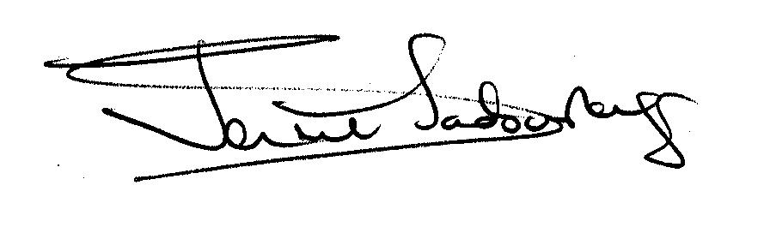

Jennie Sadowskyj
Behaviour Support Manager and NPSLBA Local Lead
Education Bradford


NPSL-BA Registration of Interest Form
School (Please print clearly)……………………………………………………….
Name: ……………………………………………………………………………….
Job Title: ……………………………………………………………………………
Please return to Catherine Williams, Administrator, BSS, Future House, Bolling Road, Bradford BD4 7EB catherine.williams@educationbradford.com 01274 385913

