GalaxKey for External Partners
Version 1.0

There are two ways to sign up to the GalaxKey Service, either you can go to www.galaxkey.com to sign up for an account prior to receiving an email from The Council, or you follow the instructions contained in the first secure email you receive from The Council.

Following sign-up you can access your secure emails either through a browser at manager.galaxkey.com or by downloading and installing the relevant application for your operating system from www.galaxkey.com.

Signing Up at www.galaxkey.com

- Use your browser to go to www.galaxkey.com and click “Sign Up”.
- Enter the email address which is used to communicate with the Council. It’s important to use the same email address at sign up that The Council will send secure emails to you on.
- Enter the Sign-Up symbols, and click “Sign Up”.

Signing Up via a Received Email

- If you have not pre-signed up for an account you will receive an invitation email from your contact in the Council at the point they send the first secure email to you. Depending on the browser or email client it will look like this:

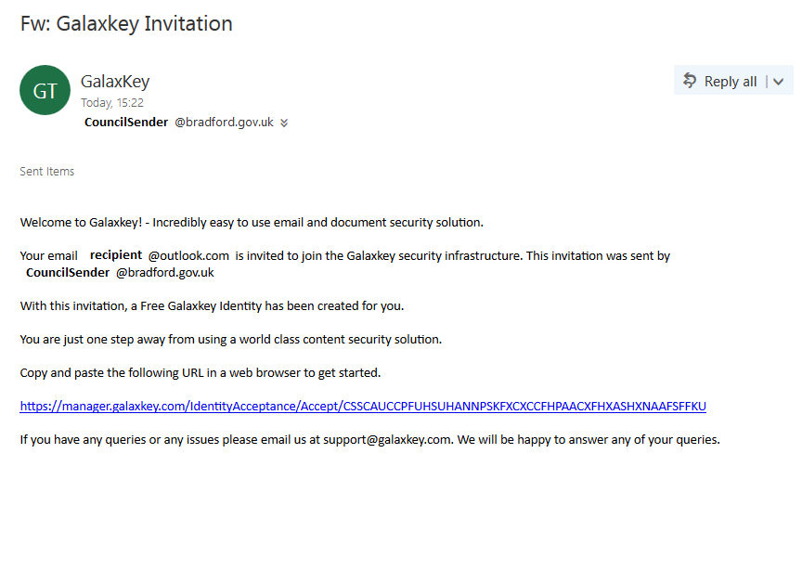

- Click on the link within the email, or copy and paste the link in to your browser. Enter the details requested to complete your registration. The ‘Login ID’ will be pre-populated and should relate to the email address that the secure email was received to.

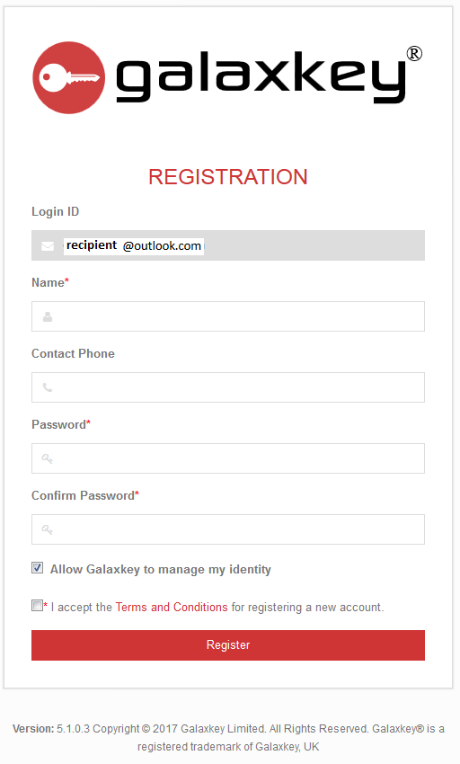

- Set a strong passphrase as your password and be sure to remember the password as this will be needed to access any future secure emails received. Click “Allow Galaxkey to manage my identity” and accept the Ts&Cs. Click “Register”.

- Registration is complete and you should see the email(s) received to date.

Opening a Secured Email

- When you receive a secured email from The Council, Click ‘View Message” and you will be asked to enter the details you previously entered to set up your GalaxKey account; this will unlock and allow you to access the secured email.

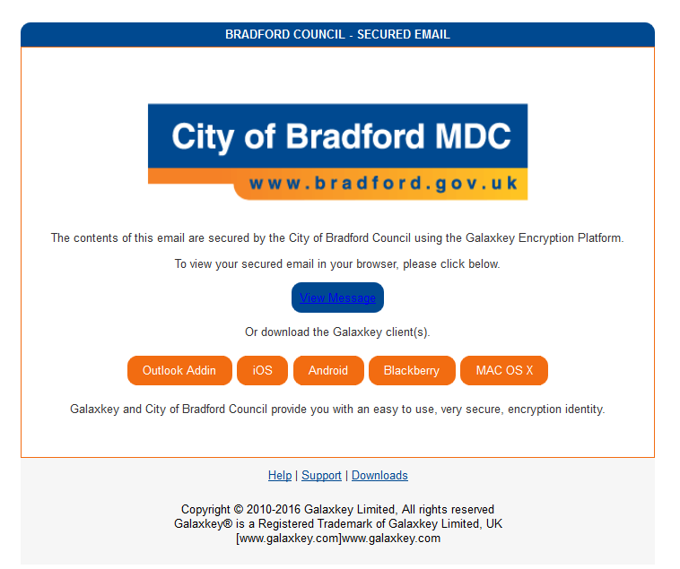

- Log in with the account you created previously.

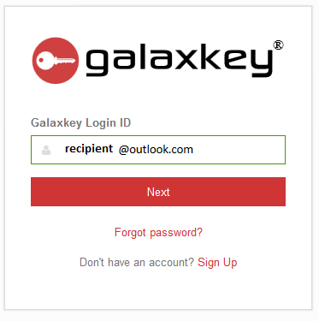

- Select the email to read from the inbox list.

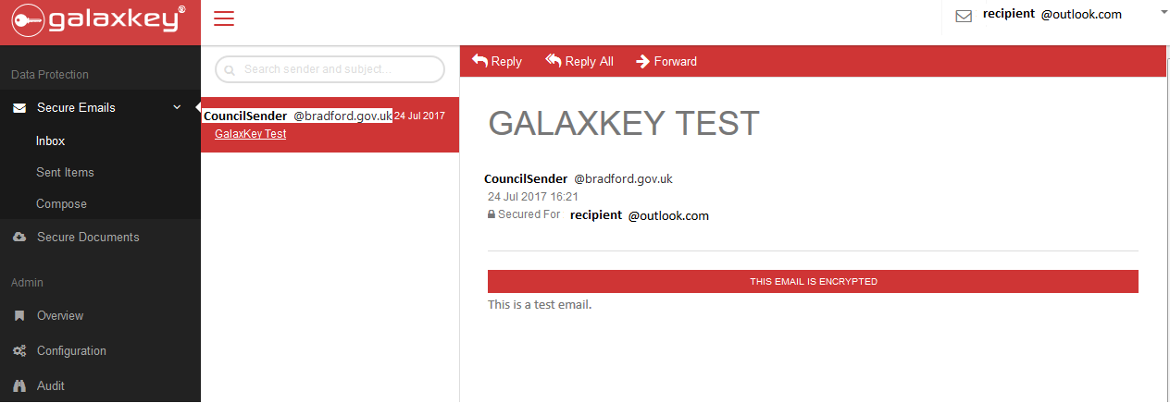

- If prompted with the below screenshot, it means the sender has requested a read receipt and you must click “Proceed” to access the email content. The send will then be notified that the secure email has been accessed.

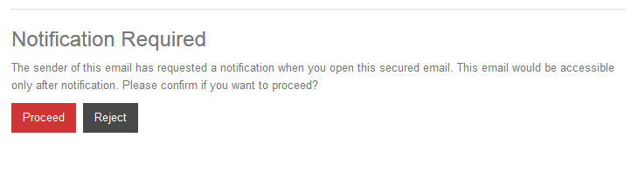
- To reply use the “Reply” button on the top bar. Before forwarding the secure email ensure the original sender is aware and approves this as the content may not be intended for further recipients.

Receiving a Read-Only Email (GeoFence)

You may receive an email from the Council which has been restricted to read only using GalaxKey’s GeoFence option.

In this case, to view the secure email click “View Message in Web Browser”.

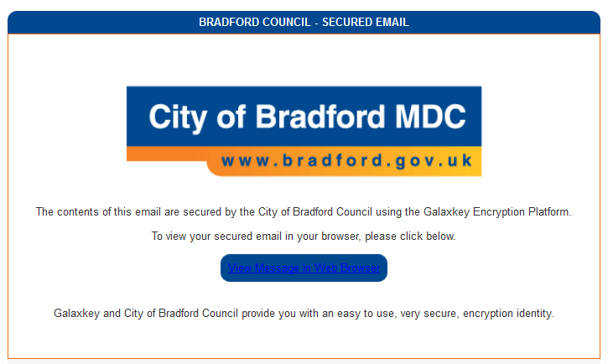

In this case the email cannot be forwarded and the email content and any attachments are not downloadable.

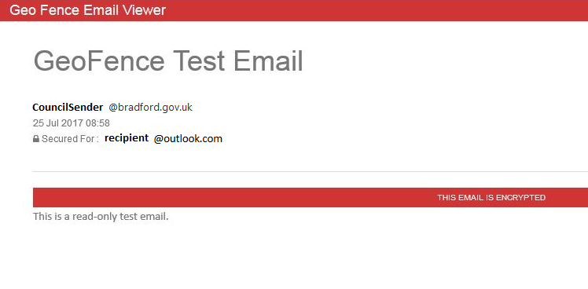

Changing your GalaxKey Passphrase

It is important to set a strong passphrase and change this periodically, at least every 90 days, to protect the data contained in your GalaxKey account.

- Log in to your GalaxKey account at manager.galaxkey.com.
- Select your account name drop down from the top right-hand corner of the browser.
- Click “My Profile” and then “Change Password”.
- Enter your current password once followed by your new password. Confirm your new password and click “Update”.

