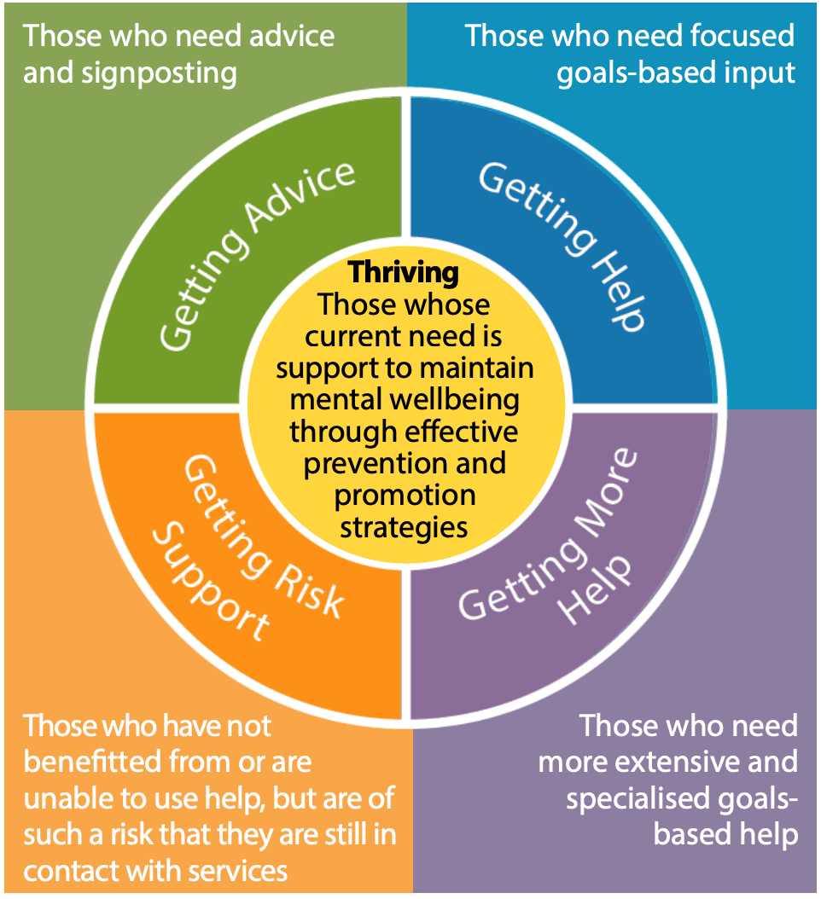
CAMHS Referral Guidance
Specialist CAMHS
Social Care
Bradford Rape Crisis
Children’s Trauma Therapy Service

Third sector organisations
School Nursing
Social Prescribing
Family Hubs
GP/ Practice Nurse
Online Services- Kooth
iThrive Framework

Counselling Provision 16+ Talking therapies
School MHST
Youth in Mind
Early Help
Sleep Tight

Acute Services- Ward
Specialist CAMHS
Safer Spaces (same day crisis support)
First Response
Inpatient A&E
Tier 4 Admission

Scan the below for more information about accessing mental health support.


CAMHS Referral Form
Once complete, please send the Referral to Fax-BDCT.CAMHS@bdct.nhs.uk
Please ensure this referral form is completed in full with all relevant information. Incomplete referrals forms will not be accepted.

*Before referring to CAMHS, have you considered other services as part of the iThrive Framework? | Y/N
*Services accessed already/currently involved? (Please provide details)
Delete as relevant
*Consent from CYP (please note this is required for all children over 14 y/o)? Yes / No *Consent from parent/person with PR? Yes / No
*Consent to discuss with other professionals if required? Yes / No
NHS No (if known)
*Preferred name
*Has the child been known by any other name?
*DOB
*Ethnicity
*Address
*Family Contact Number (please also add young person’s contact number where appropriate)
*Next of Kin / Carer
*Interpreter required (for parent or child?) or any other communication needs? | Y/N – if yes please state language/communication need:
Please list any other children in the household and any relevant information.
*Is the child Looked After by the Local Authority? | Please state which Local Authority  If yes, please ensure the child’s social worker has completed the additional information – LAAC Supporting Information LINK 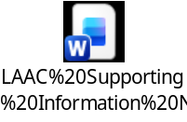
*Is the child a Young Carer?

*Referrer details, (including organisation if a professional)
*Referrer Contact details

*School / College
*Does the child have an EHCP? | Yes / No
Does the young person have any current diagnosis or health condition? (e.g. autism, ADHD, or a learning disability?)

Reason for referral
Please tell us about the reason for the referral in as much detail as possible.
- How long the difficulties have been occurring
- Where the difficulty is at present (e.g. home, school, college, all).
- How this is impacting the child’s day to day functioning
- Any previous interventions
- What helps and what doesn’t help?

What are the young persons/families expectations of CAMHS?

*Drug / Alcohol Use? Y/N
If yes, please provide details:

*Any current medication/dosage?

*Have physical conditions been considered? Y/N

Additional documentation / information relevant to this referral? Please list and attach.

For Neurodevelopmental assessments please ensure you submit the below forms with the referral:
Developmental History 
School Observation 
Parent SNAP 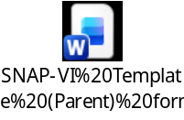
Teacher SNAP 

*Risks – if any immediate risks are identified please follow up with a call to First Response on 0800 952 1181
Has there been any historic or current self-harm (current is in the last two-weeks)? Y/N (if yes, please add details)
How often is/was the young persons self-harming? What is/was the young person using to self harm? Where on their person is the young person self-harming?

Historic or current thoughts of ending their life? Y/N (if yes please add details)

How frequently is/was the young person having these thoughts? Does the young person have a plan to end their life? Details of previous attempts of their life?

Historical or current harm to others (including thoughts of harm to others and actual harm to others)? Y/N (if yes, please add details including any support e.g. violence/aggression/bullying behaviour/coercive control).

Risk from others? (Y/N) (if yes, please add details including any support) e.g. physical, sexual, emotional abuse, neglect, exploitation/grooming, criminal involvement, online interactions, vulnerability?

*First Response telephone number provided? (111, option 2) Please indicate how and when? Y/N/NA
*Safeguarding concerns Y/N
If yes, please provide details including details of any current social care involvement. Please note it is the responsibility of the referrer to make a safeguarding referral if needed.

If making a referral for Eating Disorder Support:
Please complete the following additional information for referral ONLY required where there is concerns about an eating disorder.

We require information about weight, height and eating disordered behaviours to determine whether the young person meets our service criteria. Please find out this information before making the referral. Some information may need completing by a healthcare professional, we advise non-healthcare professionals to direct young people and families to their GP when making a referral for the eating disorders team.
Physical health
Physical Health
* Current weight: | * Height: No events found. | Weight for height No events found. %
* Has there been rapid weight loss (more than 500g/week for 2 consecutive weeks) |  | ☐ Yes ☐ No
* Has there been recurrent fainting or dizziness?  If yes, please indicate when/how often: |  | ☐ Yes ☐ No
Does the young person have any medical condition (including diabetes) or take any prescribed medication? |  | ☐ Yes ☐ No  If yes, please detail here:
History
* Deliberately attempting to lose weight? | ☐ Yes ☐ No
If yes, please indicate which compensatory behaviour is the young person using (e.g., vomiting, dietary restriction, purging or excessive exercise)
* Bingeing? (Eating a large amount of food in a short time with a feeling of loss of control) | ☐ Yes ☐ No
* Concerned about their weight and/or shape? If so, do they have a goal weight in mind? | ☐ Yes ☐ No  Goal weight:

How long have these problems been present? What was the child’s weight before the problem started?

Examinations and investigations
For healthcare referrers:
Pulse (sitting and standing):  O/E - pulse rate: beats/min | BP (lying): | BP (standing):
Please include recent blood results:

For non-healthcare referrers
I have directed the young person to their GP for a physical health check: |  |  | ☐ Yes ☐ No

