**Working together for successful outcomes for Bradford Students**

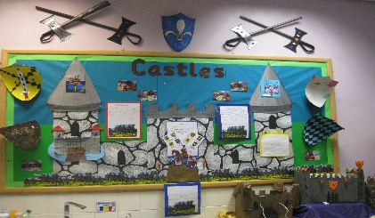**Offering positive experiences of learning in a nurturing environment to allow pupils to evolve into positive learners and schools to evolve their provision to meet assessed needs.**

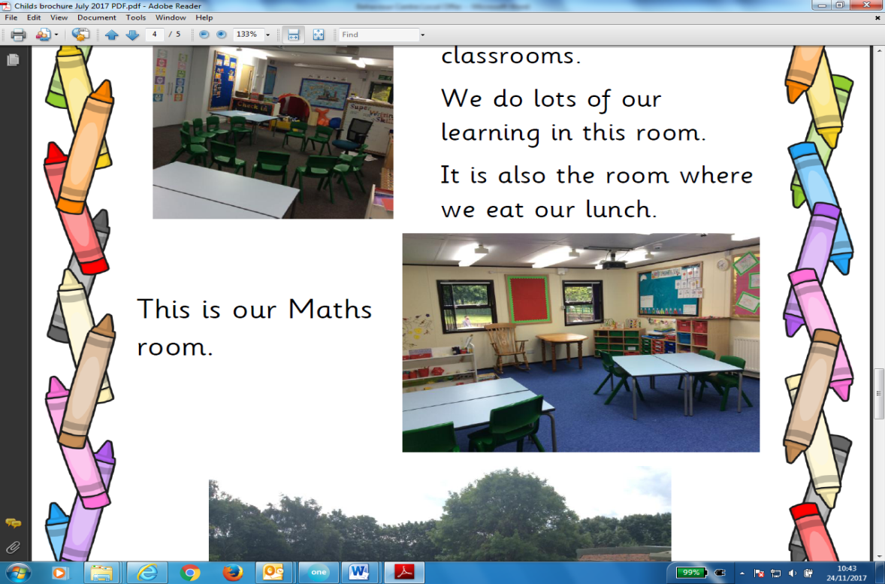

What have schools said?

Very helpful and supportive of EHCP application

Successful placement due to team around the child.



Positive and useful. Supported staff in roles, routines and strategies

What have parents said? What have students said?

I know breaks in my work help me at school

It’s a really happy place at the Hub

My child is simply happier

My child settled

quickly

It’s brilliant being back at school my relationships with friends are good.

My child now loves coming to school

**Bradford Behaviour Hub**

**Bradford Behaviur Hub (BBH) are a group of four primary phase settings providing off-site inclusion support to schools for students with Social, Emotional and Mental Health Special Educational Needs.**

These settings include:



**Phoenix**

**at Carrwood**



Long Lee

Each setting provides additional support and assessment to schools for primary phase students who are at range 3 of Bradford’s Social, Emotional and Mental Health (SEMH) Guidance through a referral process to Primary Panel.

The Offer

BBH focuses on partnership working which places meeting the needs of students at the centre of our work through nurturing approaches and principles.

Targeted support in key areas through individual or small group work focuses on specific areas to identify strategies that can be implemented in mainstream school. Identification of these areas of work is completed in planning meetings at the start of the placement and outcomes assessed at regular review meetings.

Students are encouraged and supported to build positive relationships through a nurturing approach which promotes and develops self-awareness and coping strategies. These trusting relationships enable self-exploration and problem solving skills to develop and allow students to take a risk in their learning journey.

We recognise that all pupils have their own individual styles of learning and different strengths and weaknesses that are drawn out to support improved access to learning and managing in the school environment. This is achieved by offering a broad and balanced curriculum and learning through a practical “hands-on” approach; this also aims to re-engage students who may be disaffected.

Play is an essential part of the provision we provide. It underpins learning and all aspects of a child’s development. Through play, children develop language skills, work through their emotions, are creative, develop social and intellectual skills. Providing high quality planned experiences for children is an important way for adults to support learning that is both enjoyable and challenging.

All pupils will be provided with detailed assessments which enable the team to develop individual provision maps or individual education plans. Following the placement an exit report is produced which schools can use for on-going support or to offer as evidence for any statutory special educational needs assessment being requested.

**BBH inclusion support provides the following:**

* Short-term part-time off-site provision with supported reintegration plans
* Behaviour management interventions and programmes
* In-school observation, support and advice
* Assessment of students’ special educational needs alongside our mainstream school and other agency partners
* Student and parent/carer voice embedded within the support
* Learning and development support through a range of interventions.

**The centre places are subsidised by the local authority through the high needs block at a cost of £10,000 per place per annum; From September 2018 schools can access a place from a cost of:**

|  |  |
| --- | --- |
| **Programme of support** | **Cost** |
| 12 week support place | £3,600 |
| 4 week extension request to placement for reintegration | £1, 200 |
| Additional 14 week assessment place | £4,200 |

**If you have a pupil who you would like support for please see Bradford Schools Online for our referral form and school agreement. Any questions or queries please contact Behaviour Support on 01274 439328 or email** [**bssadmin@bradford.gov.uk**](mailto:bssadmin@bradford.gov.uk)