

**FUNDED 30 HOUR CHECKER – USER GUIDANCE**

The Funded 30 hour Checker is a secure web service for early years funded providers to enable providers to verify a 30 hour HMRC eligibility code.

Parents receive a 30 hour eligbility code following an application to HMRC The Childcare Service. The code is an 11 digit number with the majority of codes beginning with 500. Some parents may be issued a temporary code beginning with 11.

Providers must check the codeis validbefore offering a parent any extended entitlement hours.

Bradford Council will carry out audits on all checked codes and any codes found not valid will not be funded, this includes codes that are checked after the child starts the place.

**The Funded 30 hour Checker is located in the secure area of Bradford Schools Online, you must be logged in to gain access.**

Link to the web page <https://bso.bradford.gov.uk/secure/eligibility/checker.aspx>

There is also a link on the Early Years Dashboard <https://bso.bradford.gov.uk/secure/EarlyYears/Menu.aspx>

and a link on the 30 hours Extended Entitlement page <https://bso.bradford.gov.uk/content/30-hours>

**Completing the online form**

By using the Funded 30 hour Checker providers are confirming that they have the parent’s consent to use their personal details. All parents must complete the Early Years Funded Place Parent Agreement to give their consent for the code to be checked.

To check a code providers must complete all four sections of the form and click on *Check HMRC Eligibility Code.*

An error message will occur if an invalid National Insurance Number or eligibility code is entered.

Providers should print the check and save a copy as this may be required for Bradford Council audit purposes if there is an issue with the funding claim.

Screenshot of the Funded 30 Hours checker online form

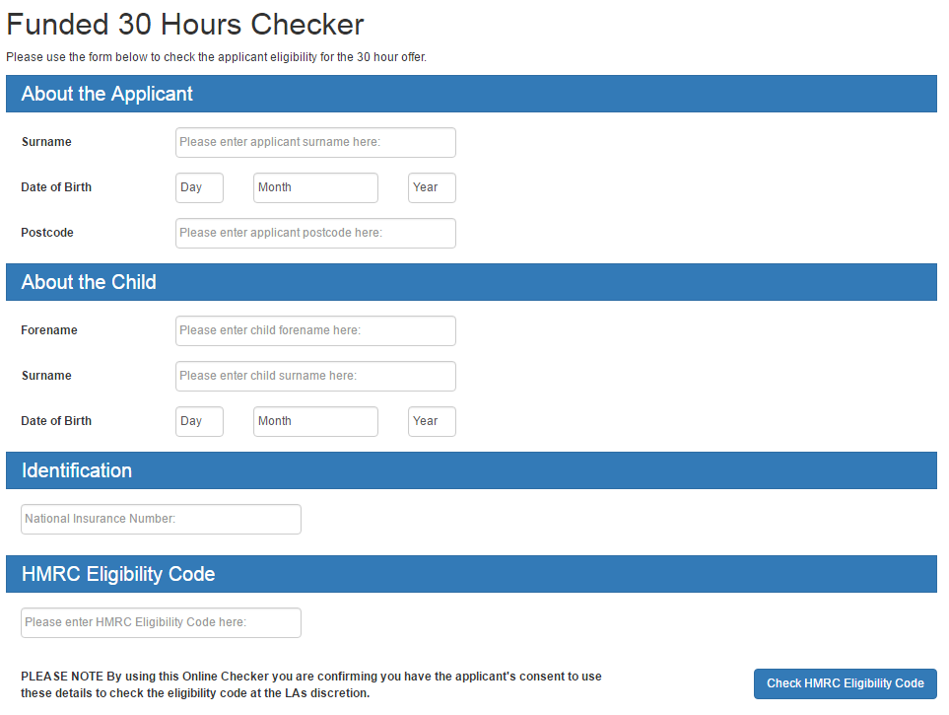

**FUNDED 30 HOUR checker RESULTS**

**There are 4 possible results**

1. **Found (with dates)**
2. **FOUND ( with Grace period message)**
3. **Not Found (with dates)**
4. **Not found**

**1. Found (with dates)**

This means the parents HMRC eligibility information was found and the parent is eligible for 30 hour extended entitlement.

Screenshot of a Found (with dates) this is for illustration purposes and not an example of dates

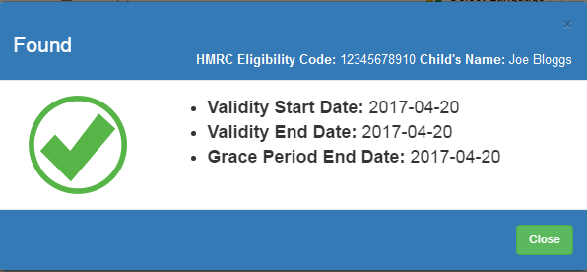

**2. FOUND (WITH Grace period message)**

This means the parents HMRC eligibility information was found but the end date is before the date the code was checked which means the code is in a grace period and a place can not be offered as children can not start accessing the 30 hour entitlement in a grace period.. Refer to Grace Period Guidance for action a provider should take.

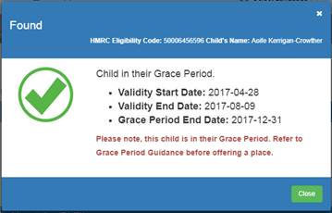

**3. Not Found (with dates)**

This means the parent’s HMRC eligibility information was found but the eligibility code has expired.

There are several reasons for an expired code.

* Parent and Partner has fallen out of eligibility i.e. either has lost their job
* Child is no longer qualifying i.e. too old
* Parent has failed to attempt reconfirmation on HMRC system when requested.

Providers must not offer a place.

If a parent believes they are still eligible providers should inform the parent to contact HMRC Childcare Service helpline for support to reapply.

Screenshot of a Not Found (with dates) this is for illustration purposes and not an example of dates

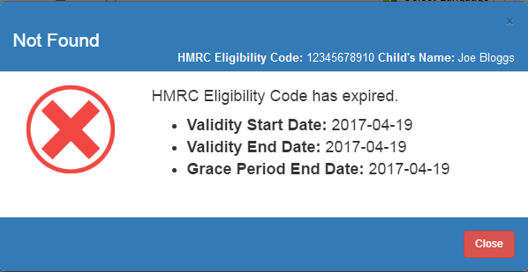

**4. Not Found**

This means the parents HMRC eligibility information was not found meaning the information entered did not return a positive result.

Providers should double check that the parent and child’s information is correct and carry out another check

Following a recheck if the result remains Not Found the provider should advise the parent to check the details they have provided and/or contact HMRC for support. Providers must not be offer a place until they have a positive check.

Screenshot of a Not Found

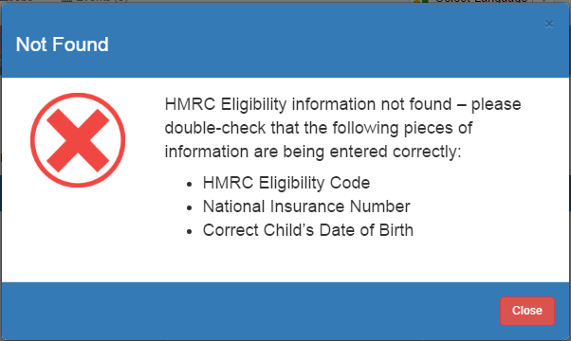

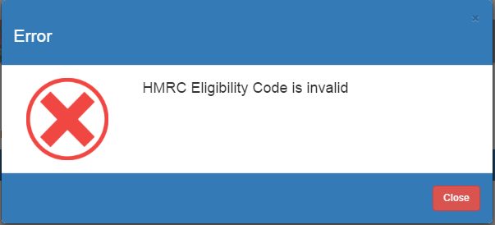

**Found checks will include the child’s name, the eligibility code and 3 dates, details on what the dates mean are sets out in the table below.**

|  |  |
| --- | --- |
| **Validity start date** | **This is the date the parent was issued the code.**  The funded hours can be offered from the start of the following term of the code date, subject to the child being of correct age which is a term after their 3rd birthday.  e.g. validity start date of a code of the 20th August then funded hours can start from the 1st September,  or a valid start date of the 1st September then funded hours can start from the 1st January  However if a child is in full time school including reception class then they are not entitled to the extended hours. This is regardless of a positive code check as the system does not check if a child is in full time school, providers must confirm with parents their child is not in full time school. |
| **Validity end date** | **This is the date the eligibility code is valid until**  The ‘validity end date’ is the parent’s ‘deadline’ for reconfirming. The parent is responsible for reconfirming and will be alerted by HMRC prior to the date.  Parents must reconfirm by this end date or they will enter the grace period.  Bradford Council will inform the provider when a child they are claiming funding for goes into a grace period and when the funding will end. Please refer to the Grace period guidance for detail.  If a code has a valid end date that is before the date the check was carried out a message will appear *Please note, this child is in their Grace Period. Refer to Grace Period Guidance before offering a place*.  Children can not start the additional funded hours when a code is in a grace period  Provider should advise parents to contact HMRC and apply again and then providers must recheck the code. |
| **Grace period end date** | **This is the date the parent becomes ineligible for the extended hours they are accessing.**  A grace period end date is issued if   1. Parent and Partner has fallen out of eligibility i.e. either has lost their job 2. Child is no longer qualifying i.e. too old 3. Parent has failed to attempt reconfirmation on HMRC system when requested   This date will be one of the HMRC grace period end dates set out in the Statutory Guidance 31st March, 31st August, 31st December.  Please note the grace period is not applicable for funding if a child hasn’t started accessing the hours when the code expired which is the valid end date. |

*Early Year Service Update November 2017*