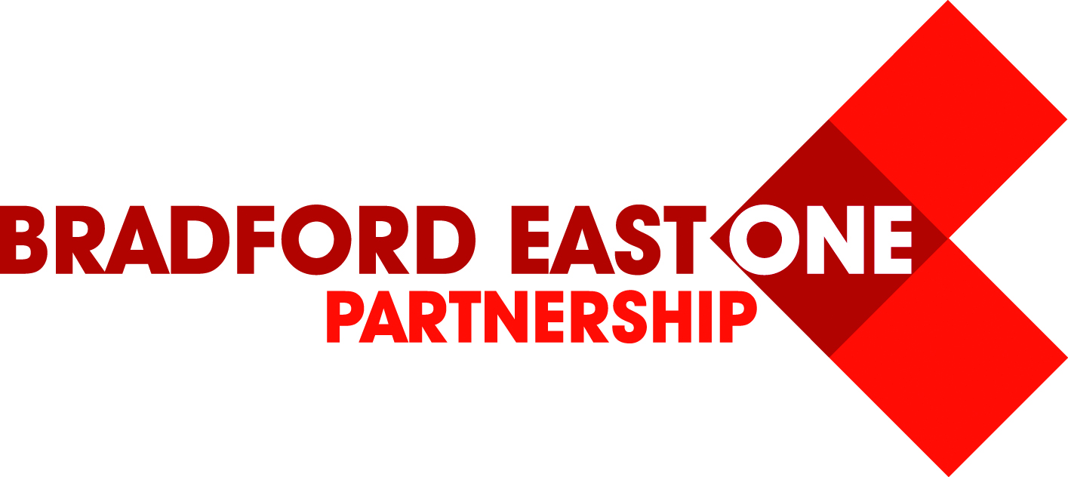Bradford East One Partnership Conference – Booking Form
“Motivating the Motivators”
Monday 29th & Tuesday 30th June 2015
Hollins Hall Hotel, Baildon, Shipley, BD17 7QW
At a time when working in Education can seem like an increasingly difficult task, the aim of this year’s Bradford East One Partnership conference is to inspire, energise and motivate teachers, in order for them to be outstanding, engaging motivators themselves.
Keynote Speakers: Sir John Jones World renowned educational speaker
Andy Cope Professional trainer, qualified teacher and author
Shonette Bason –Wood Professional speaker, educator and author
Workshops: Choose from a range of workshops. Please see programme of the day and pack information for details.
I will be attending the conference on: Monday 29th June 2015 Or
Tuesday 30th June 2015
Name
School Name
School Telephone Number
E-mail Address
Dietary Requirements (if applicable)

Workshops: 1 – The Art of being Brilliant
2 – James Langley ICT
3 – Isabella Wallace
4 – Shonette Bason-Wood
5 – Book Arts

Please indicate your 1st and 2nd choice for workshop 1 (am) and workshop 2 (pm)
Workshop 1 (am) | 1st Choice
 | 2nd Choice
Workshop 2 (pm) | 1st Choice
 | 2nd Choice
The workshop sessions will be allocated on a first come, first served basis subject to availability. We will confirm your workshop choices via e-mail prior to the conference.

To secure your place, please complete the booking form and return to:
Louise Knights, Swain House Primary School, Radcliffe Avenue, BD2 1JL or by e-mail to, Louise.knights@swainhouse.bradford.sch.uk , or by fax to: 01274 627059

