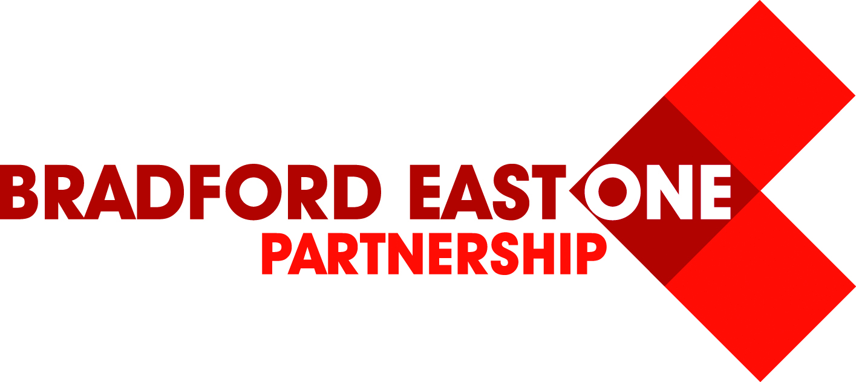
Bradford East One Partnership Conference
“Motivating the Motivators”
Monday 29th & Tuesday 30th June 2015
Hollins Hall Hotel, Baildon, Shipley, BD17 7QW

Programme

8.30am – 8.55am | Tea/Coffee & Breakfast sandwiches
8.55am – 9.00am | Welcome
9.00am – 10.15am | Keynote Speaker – Andy Cope ‘The Art of Being Brilliant’
10.15am – 10.45am | Tea/Coffee Break
10.45am – 12.00pm | Keynote Speaker – Shonette Bason-Wood
12.00pm – 1.00pm | Workshops  - Andy Cope - Art of Being Brilliant (Brilliant)  - James Langley – Magic of Chroma Key (Chroma)  - Isabella Wallace – Outstanding Teaching (Outstanding)  - Shonette Bason-Wood – ‘Squiggle Whilst you Wiggle’ (Squiggle)  - Frank Driessen – Book Art (Book Art)
1.00pm – 2.00pm | Lunch
2.00pm – 3.00pm | Workshops  - Andy Cope - Art of Being Brilliant (Brilliant)  - James Langley – “Appsmashing” (Apps)  - Isabella Wallace – Outstanding Teaching (Outstanding)  - Shonette Bason-Wood – ‘Making Maths Magic’ (Maths Magic)  - Frank Driessen – Book Art (Book Art)
3.00pm – 4.30pm | Keynote Speaker – Sir John Jones
4.30pm | Close

