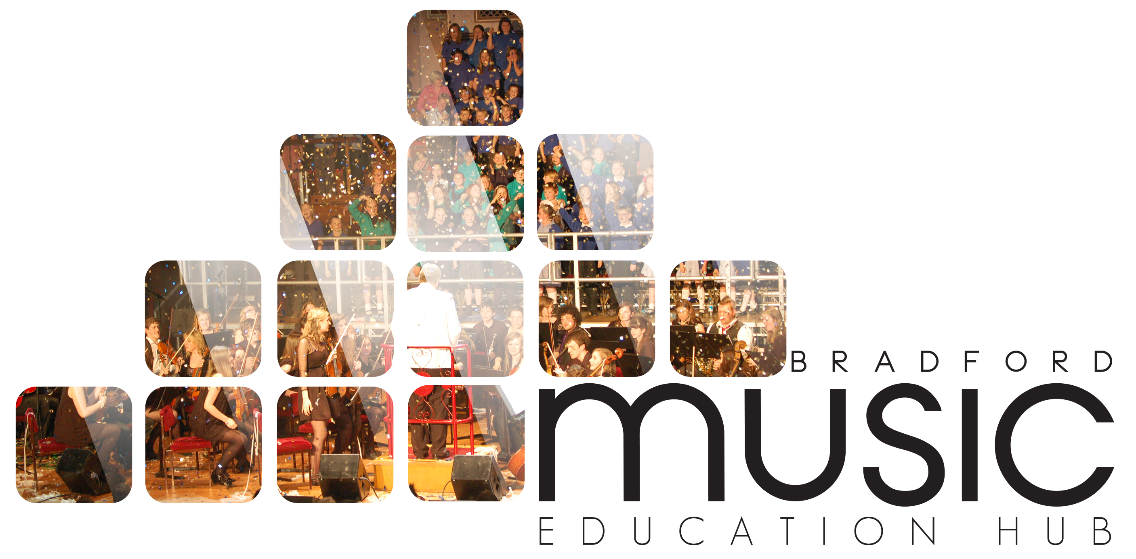

Music & Arts Service Future House, Bolling Road, Bradford, BD4 7EB
Tel: 01274 385554 Fax: 01274 385588

BBC MUSIC DAY - FRIDAY 5 JUNE 2015

Application to perform at event – return slip

Name of School: ………………………………………………………………………………………………………………….

Name of Act: ………………………………………………………………………………………………………………………

DESCRIPTION OF PERFORMANCE:

………………………………………………………………………………………………………………………………………………………………………………………………………………………………………………………………………………………………………………………………………………………………………………………………………………………………………………………………………………………………………………………………………………………………………………………………………………………………………………………………………………………………………………………………………………………………………………………………………………………………………………………………

ANY FURTHER INFORMATION:

………………………………………………………………………………………………………………………………………………………………………………………………………………………………………………………………………………………………………………………………………………………………………………………………………………………………

NAME OF CONTACT PERSON: …………………………………………………………………

TELEPHONE NO : ………………………………………EMAIL ADDRESS: ……………………………………………

Please complete and return by Friday 1 May 2015 to:

Music & Arts Service, Future House, Bolling Road, Bradford, BD4 7EB

Or fax to 01274 385588/ email schoolsmusicandarts@bradford.gov.uk

