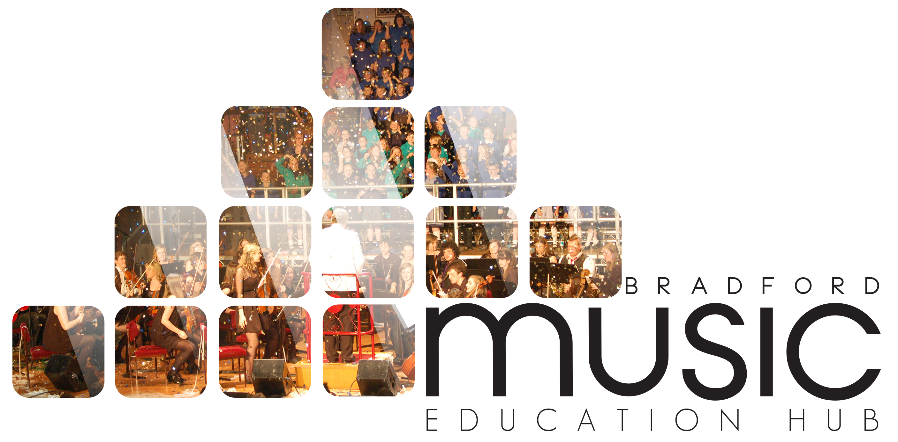

Music & Arts Service Future House, Bolling Road, Bradford, BD4 7EB
Tel: 01274 385554 Fax: 01274 385588

BBC MUSIC DAY

FRIDAY 5 JUNE 2015

How to get your school involved

BBC Music Day will connect communities and generations with an inspirational celebration of music across the UK. This inaugural, nationwide initiative takes place on Friday June 5th 2015.

In a celebration of the musical passion and creativity of the UK, there will be large scale musical events as well as locally-organised activities; intergenerational singing and a wealth of musical innovation from classical to pop.

Coverage is planned across the whole day via Local and Network BBC TV & Radio, culminating in BBC Music Night. Live from Glasgow, the BBC Scottish Symphony Orchestra will be joined by special guests across musical genres and broadcast simultaneously on BBC Radio 2 and BBC Radio 3.

With support from ambassadors and organisations including Music Education Hubs, music charities and local councils, BBC Music Day will become an annual fixture in the calendar, celebrating our diverse musical talent, forging new musical collaborations and inspiring new connections.

The event itself is to take part in City Park, Bradford. The event starts at 12.30 pm with various school and community acts taking to the big stage. Between 5 – 8 pm the main BBC event starts performers from BBC Introducing! - lots of up and coming bands/groups.

MAKE IT A FULL AFTERNOON

Your school is invited to come down to City Park from 12.30 pm as live music will be taking place and you will be able to use the BBC Experience Tent.

Bring lunch and enjoy entertainment from 12.30 pm – live bands/orchestras will be performing and the BBC Experience Tent is available to use (12 noon – 6 pm).

The BBC Experience is a pop-up stand that is touring the country and giving audiences across the regions the opportunity to interact with BBC content and services.

Come along and try your hand at reading the news and presenting the weather, making a radio drama and commentating on a sports match. Activities for visitors will also include a demonstration by the BBC Blue Room which showcases all the different ways that audiences can access the BBC, a chance to meet some of our CBeebies characters and an opportunity to come away with a photograph of Doctor Who.

This is a free event and families are welcome to come along as audience at any point during the day/evening.

