Assemble for BBC Music Day

Kick start your day with the Power of Music!
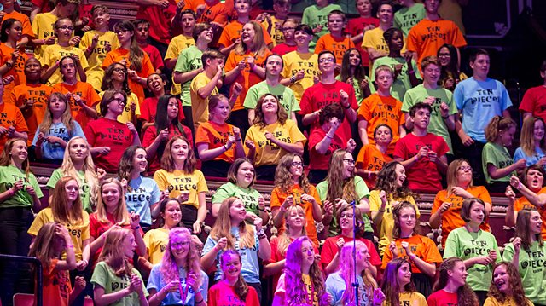
Whether or not you’re attending City Park for the BBC Music Day celebrations on 15 June, why not start the day with a BBC 10 Pieces Assembly?
All you have to do is listen to some fabulous music, enjoy creating a response to it, record/video/take pictures of it, and send it to the BBC and the Music Service!
You can sign up for the BBC Assembly Pack at www.bbc.co.uk/programmes/p04pc0j8 where you’ll also find some ideas to get you started. You can also find examples of other schools’ work and the brand new 10 pieces for this year.
You’ve got plenty of time to make a start so everything’s ready for BBC Music Day.
Suggestions that you could do in response to the BBC 10 pieces:
Set up an Art Gallery
Perform a play
Perform one of the BBC 10 Pieces
Perform a piece your students have made up
Create dance movement to the music
There is the possibility that recordings could be shown at the BBC 10 Pieces celebration in London, and the Music & Arts Service will create a digital showcase for them as well.
If you would like to provide your students with this fantastic opportunity, please sign up directly on the BBC website (address above) and also send me an email to let me know that you’ve signed up felicity.french@bradford.gov.uk
If you require any more information about the assemblies or BBC Music Day itself, please don’t hesitate to contact me.
Felicity French, Assistant Head, Music & Arts Service
01274 434970

