Asylum Seekers and Refugees-Information for schools.
Definitions
The definition of an asylum seeker, or someone seeking asylum, is a person who has left their country, often suddenly, because they are faced with persecution, war or violence and cannot get protection there and arrived in another country and asked for asylum. Until they receive a decision from the government considering their application as to whether they are a refugee, they are known as an asylum seeker. In the UK, whilst the government considers their application, asylum seekers are not given the same rights that a refugee or British Citizen would have. For example, asylum seekers are without access to public funds so cannot claim benefits, they are not allowed to work and they receive limited support. This can lead to destitution.

The 1951 Refugee Convention guarantees anyone the right to apply for asylum in another country that has also signed the Convention. It also guarantees that they can remain there until their claim has been processed.
Once submitted, an asylum request will have one of three outcomes:
- Full refugee status (indefinite leave to remain).
- Temporary leave to remain for between 1-5 years or until the age of 17½.
- A refusal, applicants may appeal against a refusal and can remain in the UK whilst appealing.

Cases can sometimes be pending an outcome for a significant amount of time, meaning that asylum seekers and their children can be uncertain about whether they will be granted refugee status for a long time.

Asylum seekers can be on different sections of support under part 6 of the Immigration and Asylum Act. Some of the common sections you may come across are:

- Section 98 is provision of temporary support for certain groups who appear to be destitute. Support may be provided under this section until it can be determined whether support should be provided under section 95.

- Section 95 is provision of support for certain groups of asylum seekers who appear to be destitute or likely to become destitute within a prescribed period of time.

- Section 4 is provision of accommodation for certain groups of asylum seekers dependent on their circumstances.

A refugee, according to the UN Refugee Convention, is someone who ‘owing to well-founded fear of being persecuted for reasons of race, religion, nationality, membership of a particular social group, or political opinion, is outside the country of his nationality, and is unable to or, owing to such fear, is unwilling to avail himself of the protection of that country’ (Article 1, 1951 Convention Relating to the Status of Refugees).

When a person is given refugee status in the UK, they have 28 days to find accommodation and apply for benefits before they are evicted from their asylum accommodation. Many refugees become homeless at this stage and need support from agencies to navigate through the systems for benefits and housing. In Bradford, the Refugee Integration Service provide support to new refugees.

Refugee resettlement schemes
Sometimes refugees have arrived on resettlement schemes, the current resettlement schemes are as follows:

- United Kingdom Resettlement Scheme (UKRS)- In July 2019, the Government introduced this new resettlement scheme as the Vulnerable Person Resettlement Scheme (VPRS) target had been met. Refugees resettled under the new, consolidated the UK Resettlement Scheme (UKRS) are granted five years of the Refugee Status. So far only around 1,882 people were resettled under the UKRS.
- Afghan Citizens Resettlement Scheme (ACRS)- The UK formally opened the ACRS on 6 January 2022. The government aim to resettle more than 5,000 people in the first year and up to 20,000 over the coming years. Anyone who is resettled through the ACRS will receive indefinite leave to remain (ILR) in the UK, and will be able to apply for British citizenship after 5 years in the UK under existing rules.
- Afghan Relocation and Assistance Policy (ARAP)- The ARAP was launched on 1 April 2021 and remains open. Those who are in the ARAP scheme, regardless of when they arrived, will be given indefinite leave to remain in the UK, rather than limited leave which has been the approach previously.
- Homes for Ukraine (HfU)- The UK Homes for Ukraine Scheme launched on 14 March 2022 and allows Ukrainian nationals and their family members to come to the UK if they have been invited by a sponsor, to stay in accommodation provided by the sponsor for 6 months. The scheme allows Ukrainians to stay in the UK for up to 3 years.

Some of the main countries that asylum seeker and refugee children have most recently come from, along with the language(s) they are most likely to know include:

Country | Main language(s)
Syria | Arabic
Sudan | Arabic
Afghanistan | Pashto/Dari
Iraq | Kurdish/ Arabic
Somalia | Somali
Iran | Persian (Farsi)
Congo DRC | French
Kenya | Swahili
Pakistan | Urdu
Kosovo | Albanian
Algeria | Arabic/ Tamazight
Eritrea | Tigrinya
Albania | Albanian
Nigeria | Yoruba
El Salvador | Spanish
China | Mandarin
Ethiopia | Amharic
Kuwait | Arabic
Namibia | Oshiwambo/ Afrikaans
Egypt | Arabic

Funding
Children who arrive on the ARAP, ACRS & UKRS schemes are eligible for funding which is allocated to the education establishment in which they attend upon enrolment. HfU funding has ended. Education establishments should contact the Education Access Team who are responsible for the allocation of the funding to education establishments for eligible pupils. Education establishments will need to provide the full name of the child, date of birth, which scheme they have arrived on and proof of status such as a letter from the Home Office.

The funding is as follows:
ARAP, ACRS, VPRS and UKRS
16 - 18 years of age-Post 16 college or sixth form | £3000.00
5 - 16 years of age-Reception to year 11 school or academy | £3700.00
3 – 4 years of age-Nursery school | £1850.00
*correct as of March 2024.
Funding is allocated for the purpose of supporting the child to settle into their new education environment and guidance will be issued upon allocation of the funds. Further information is available by contact 01274 439393 or education.access@bradford.gov.uk

Free school meals
Children receiving support under Part 6 (Support for Asylum Seekers) of the Immigration and Asylum Act 1999 are eligible for free school meals. This process is administered by the Education Access Team as family’s cannot apply via the usual online application for free school meals in Bradford. Applicants should provide a letter from the National Asylum Support Service (Home Office) (NASS) stating that they are receiving support under Part 6 (VI) of the Immigration and Asylum Act 1999. Letters that the family may be able to provide are their Asylum Support letter or accommodation/tenancy letter.

NASS numbers are usually 9 digits and in the format of ‘YY/MM/12345’. These numbers can be followed by /001, /002, /003 etc which identifies each individual member in the family. If the family are on section 98, they may not have a NASS number but should have a Home Office letter which states their port reference number to provide as evidence of asylum seeking status.

Individuals may also provide their Application Registration Card (ARC), this is proof of an on-going asylum application (if valid, see date in ‘valid until’ section).
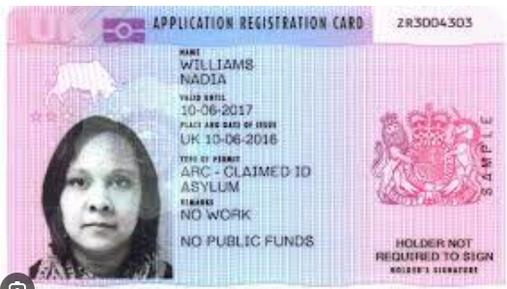

Sometimes asylum seekers may present a ‘Bail 201 letter’ which contains information about why this person has been granted ‘immigration bail’ (e.g. asylum seeker), they usually include a photo of the person named. It will also have information about the conditions of their bail – things that the Home Office require of them. Immigration bail can contain ‘conditions’, these can include asking someone to live at a certain address or report to the Home Office on a regular basis. It will also normally be a condition that a person is not allowed to work. The letter will state that the person named is liable for detention if they breach any of the ‘conditions’.
Once schools receive this evidence, they should submit a copy with full details of the parents and children including dates of birth to education.access@bradford.gov.uk The responsibility for checking the eligibility of applicants for free school meals rests with the individual school. Once this evidence has been confirmed by the team, they will send school and parents a letter confirming their eligibility for free school meals.
Schools should update this on their systems and seek regular updates from these families about their status. If their status changes, free school meal eligibility may change. If they are granted refugee status, they will need to apply through the usual online application. Refugees will usually have a biometric residence permit (BRP). They may also have an e-Visa which is an online immigration status. Resettled refugees through schemes such as UKRS will be known to us through the manifests we receive too so can be checked with us.
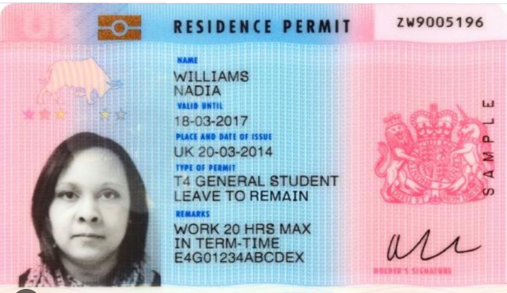
Refugee pupils may be eligible for free school meals (FSM) if they meet the benefit-related criteria for free schools meals which can be applied for through the online application form here: https://www.bradford.gov.uk/benefits/applying-for-benefits/free-school-meals/

Providing free schools meals to families with no recourse to public funds (NRPF)
The government have permanently extended free school meal eligibility to children in all households with no recourse to public funds (NRPF), subject to maximum income thresholds. In the same way that applies for asylum seekers, these applications cannot be made via the online application.
The government have provided examples of how families can demonstrate their NRPF status. This list is not necessarily exhaustive and families may be able to provide alternative evidence not listed. In all cases, the family should complete and sign the self-declaration form confirming both their immigration category and that they are not above the maximum income threshold required for their area. Schools should retain evidence of the application including the self-declaration and any supporting documentation for usual audit purposes.
There is a sample application form available on the government advice page which includes a self-declaration that schools can provide to families and carers for verifying eligibility.

Further guidance and information on free school meals for NRPF is available here.
Schools should record eligible free school meals pupils who qualify through the NRPF in the termly school census, in the same way as all other free school meals pupils.

