Our ref:  Your ref: | Department of  Children’s Services  – Aiming High for Children  Music & Arts Service  Fairfax Learning & Development Centre, Flockton Road,  Bradford, BD4 7RY  Tel: 01274 434970  Fax: 01274 408335  Email: schoolsmusicandarts@bradford.gov.uk
For the attention of
The Headteacher
Art Co-ordinator and Bursar
20 February 2017

Dear Headteacher

ACADEMIC YEAR 2017-18 – ART PACKAGES BUY BACK

If you wish to renew or book a new art provision for 2017-18 then please complete the booking form attached.

The following documents can also be found on www.bradfordmusiconline.co.uk and http://bso.bradford.gov.uk/Schools/CMSPage.aspx?mid=2164

- Art Provision Information (also attached)
- Art provision booking form (also attached)
- Pupil Premium information
- Academic Year schedule

Please return this form by 31 March 2017.

Yours sincerely

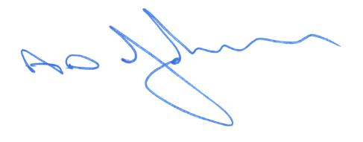

Tony Johnson
Head of Music & Arts Service

