Areas of need – defining individual Special Educational Needs
The SEND Code of practice details that all SEND needs are categorised into 4 areas:
- Cognition and Learning
- Communication and Interaction
- Social, Emotional and Mental Health difficulties
- Sensory and/or Physical needs
References to areas of need are contained in the SEND Code of Practice, 2015 at section 6.28 – 6.35
Schools are required to record a child’s primary need within the school census. They should also identify any secondary needs, of which a child may have more than one. It is important that all needs are clearly identified and recorded by schools as part of any SEND Support Plan or within the EHC Plan. Needs recorded in the school census will link to one of the 4 broad areas of need as defined in the SEND Code of Practice.
The following details all the codes available in the school census linked to the 4 broad areas of need.
Broad area of need | Code | Description
Cognition and Learning | SPLD | Specific learning difficulty
Cognition and Learning | MLD | Moderate learning difficulty
Cognition and Learning | SLD | Severe learning difficulty
Cognition and Learning | PMLD | Profound and multiple learning difficulty
Cognition and Learning | DS | Down Syndrome
Communication and Interaction | SLCN | Speech, language and communication needs
Communication and Interaction | ASD | Autistic spectrum disorder
Social, emotional and mental health | SEMH | Social, emotional and mental health
Sensory and Physical | HI | Hearing impairment
Sensory and Physical | VI | Vision impairment
Sensory and Physical | MSI | Multi-sensory impairment
Sensory and Physical | PD | Physical disability
Not defined | OTH | Other difficulty
Not defined | NSA | SEN support but no specialist assessment of type of need

Once a need has been added you will also need to apply a ranking to each need. This indicates which is the primary need and which are the additional needs. It is important that each need has a unique ranking otherwise there’s no way to distinguish which is the primary need.
Example:
Need | Ranking
PMLD | 1
SEMH | 2
SLCN | 3

This information is included in the Spring school census each year and if the information isn’t recorded data may not be a true reflection of the student’s needs, impacting on understanding and levels of support.
Your MIS support providers will be able to advise on how to correctly record needs and rankings within your system.

Frequently asked questions:
Which children should be recorded on the school census as SEN Support / K code?
Any child where you are putting in place special educational provision to meet their SEN should be recorded on the school census as SEN Support. Some children will move on and off this, depending on how needs are presenting and supported. The SEND Code of Practice details the support that should be in place for those with SEND provision. If this is not in place then it would be assumed that they should not be recorded as SEN Support. A flow chart is provided below which should help schools in determining who should be recorded as SEN Support. This has been developed by Dixons Academy and shared with permission. It is contained within the local area ordinarily available provision (due to be published early 2026).
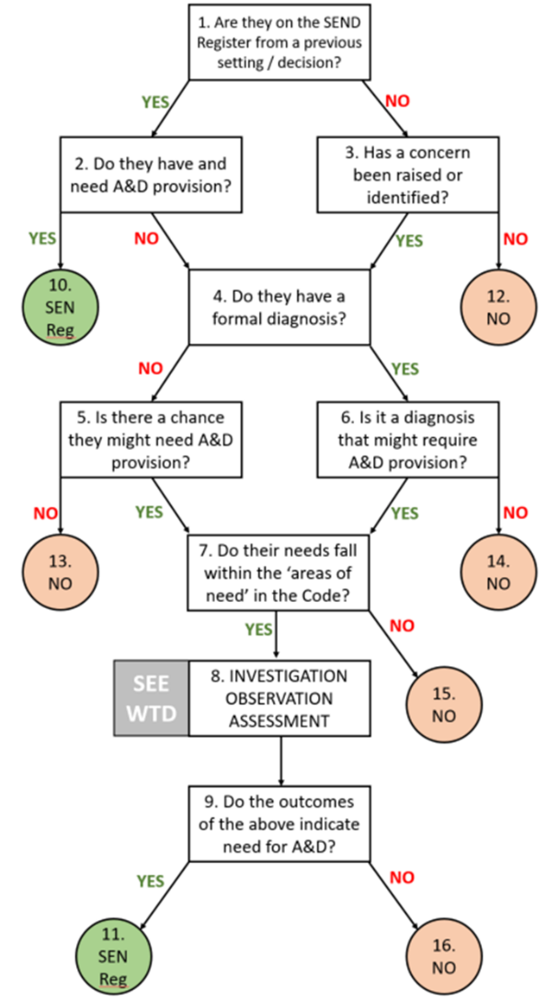
A child presents with needs that may be autism but doesn’t have a diagnosis. What should I record as primary need?
If the area of need is communication and interaction but a child does not have a diagnosis of autism you should record the need as SLCN.
Is primary need SLCN / ASD or SEMH?
There is often confusion as to whether a school should put primary need as SLCN / ASD or SEMH as they are often interlinked. The cause of the prevalent presenting need should be recorded as the primary need. It may be that the impact of a child’s sensory (ie how they interact with their environment) and communication needs are most prevalent. In which case primary need would be SLCN / ASD. If their most pressing need is around their social interaction and emotional responses then SEMH would be the primary need. It is often hard to differentiate between the two and you will often need to record a secondary need. Where a child has a diagnosis of Autism then this would most often be the primary need, unless their mental health or emotional responses and behaviours are clearly more prevalent and are causing underlying challenges. If in doubt, schools should ask advice from services such as the Educational Psychologist or SCIL team.
How do we define ‘sensory’ needs?
In the SEND Code of practice, the term ‘sensory’ is used to define visual, hearing or multi-sensory impairments. It is not used to define sensory needs related to responding to a child’s environment. Likewise physical disability is not used to define a physical response to the environment but a child’s own physical disabilities. Where a child has sensory needs relating to how they interact with their environment this should be recorded as communication and interaction needs; either SLCN / ASD.
When was Down Syndrome added as a category?
Down Syndrome was added as a category in January 2025. Where this is the case, you should consider what the secondary needs are to ensure clarity as to how a child is impacted in learning.
When would you use OTH or NSA codes?
The census returns include 2 categories that are rarely used: ‘Other difficulty’ and ‘SEN support’ but no specialist assessment of type of need (NSA)’. Schools should carefully consider why these would be used. In general these codes would only be used in the very rare circumstances where support is in place but the school is still assessing what the primary needs are.

