Dear Foundation Stage Colleagues
Welcome back to the start of the new term /school year. Over the next couple of weeks you will receive an envelope addressed to the Foundation Stage coordinator containing our recent publication “Approaches to Playing and Learning from Birth to 7”. The pack will contain either the full version or relevant insert to complete the pack (as some schools already have part of the document)
The completed document contains 3 sections,
1. Loving learning and developing (nurturing children under 3)
2. Playing and learning for 3-5 year olds
3. A study of successful practice
However, only schools with 2 year old provision will have section one.
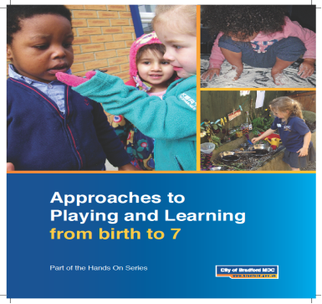
The document aims to support all practitioners working in the early childhood sector to develop high quality effective practice.

Kind regards
Early Years Learning Team

