My Transition Booklet

Here is a picture of me:

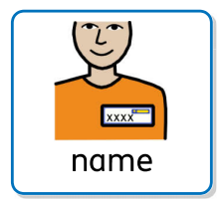
My name is: _________________________
I am __________ years old.
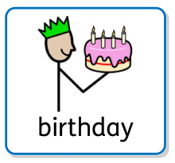
My birthday is___________________________.

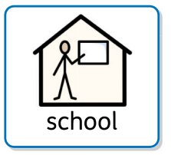
I go to ___________________________ school.
I am in Year ____________.
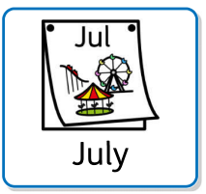
I will finish in Year _____ in July.
Then it will be the Summer holidays.

After the Summer holidays, I will move up to another Year group and a new class.
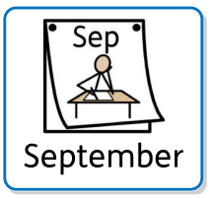
My New Class

In September I will be in Year ______.
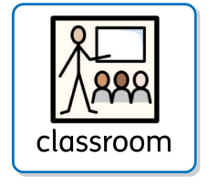
My new class is called: ______________________.
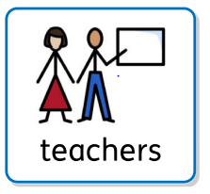
My new teacher is called: ___________________.

These are the other adults in my class who will help me:

________________ _______________ _______________

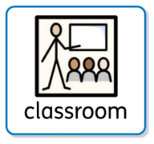
My classroom

Here are some pictures of my new classroom:

I will play outside in this playground:
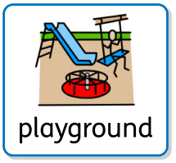

I will eat my lunch here:
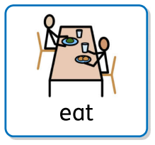
All About Me
This is how I communicate:

This is how you can communicate with me:
Other things you need to know about me:
I need a bit of help with:
I am really good at:
Things I don’t like:
Things I like:

