Timetable.
Visual timetables are an important tool for children on the autism spectrum. They have the potential to provide structure and support for your child during this time.
Here are some examples of how to present the structure your day. Your child may need this information presented through object of reference, symbols or a written list of the day. You may want to consider adding timings on there but if this causes additional stress you may just have the symbols.
Object of reference  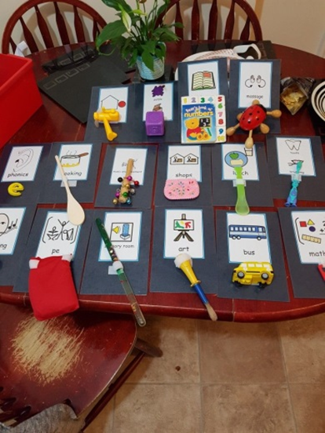 | 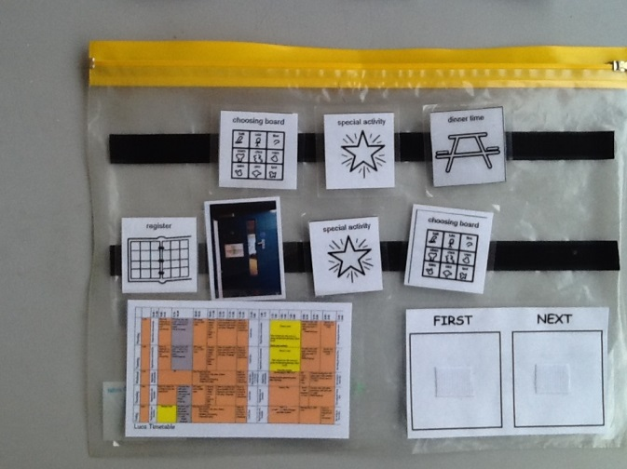  Symbols and First… Then
Symbols  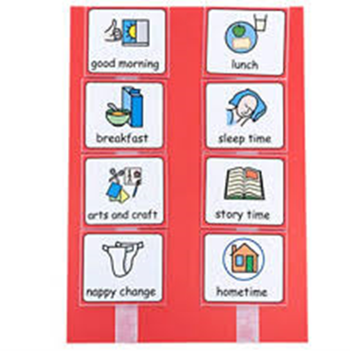 | 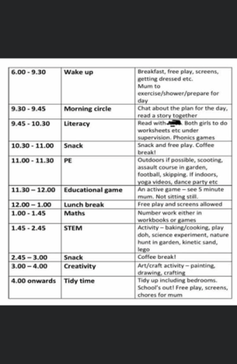  Written list.

