*Why I have to isolate*



City of Bradford MDC

**0-25 Specialist Teaching & Support Services**

Margaret McMillan Tower (Floor 3)

Princes Way, Bradford, BD1 1NN

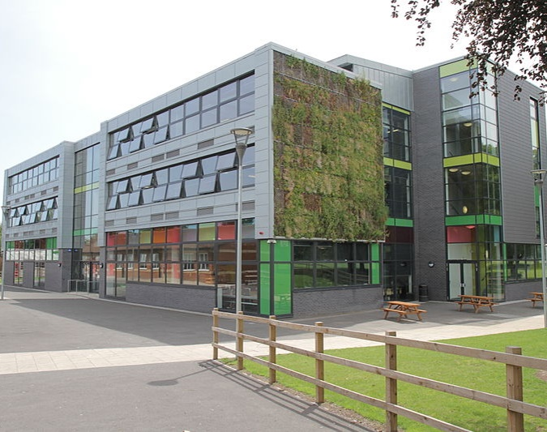

Coronavirus is a virus that makes people unwell. It is also called Covid-19.

There are lots of things we can do to make it very unlikely we will catch this virus.

My school is called ……………………....

My teachers are doing everything they can to keep me safe from the virus.

My teachers will explain anything to me that I don’t understand.

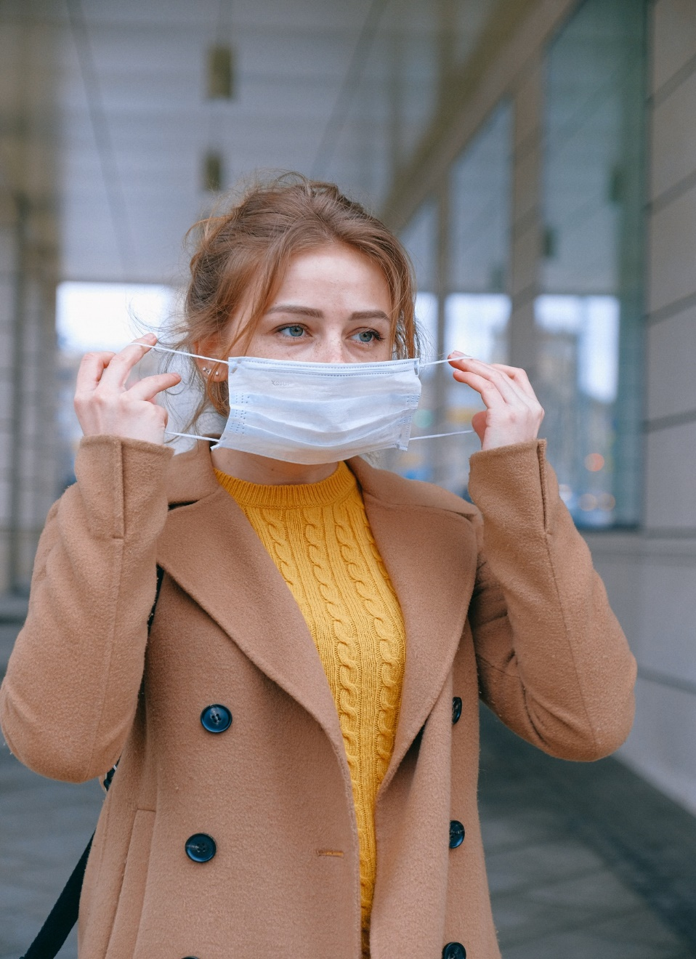

In school we have to wear masks in the corridors, wash our hands or sanitise often and socially distance* as much as possible.

The pupils in my school have been grouped into bubbles*. Scientists tell us that if we stay in our bubble, it is less likely that we will catch the virus.

My bubble is ………………………………….

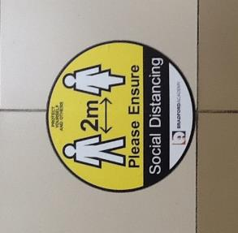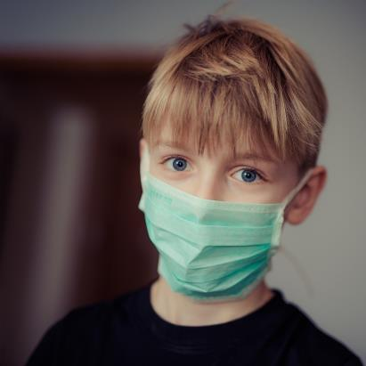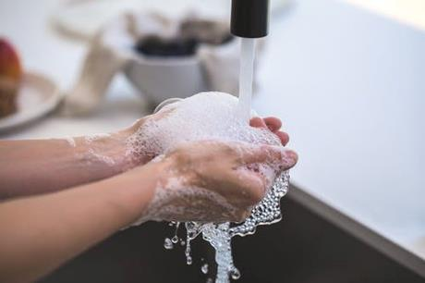

In the morning bubbles arrive at different times and at the end of the day they leave at different times too.

If someone in my bubble gets the symptoms* of Coronavirus, they will have to self-isolate* for at least 10 days and take a COVID19 test*.

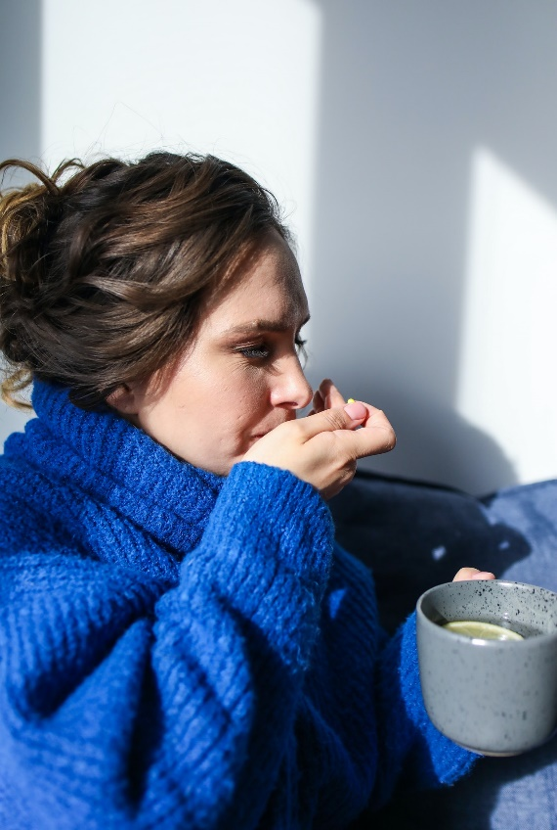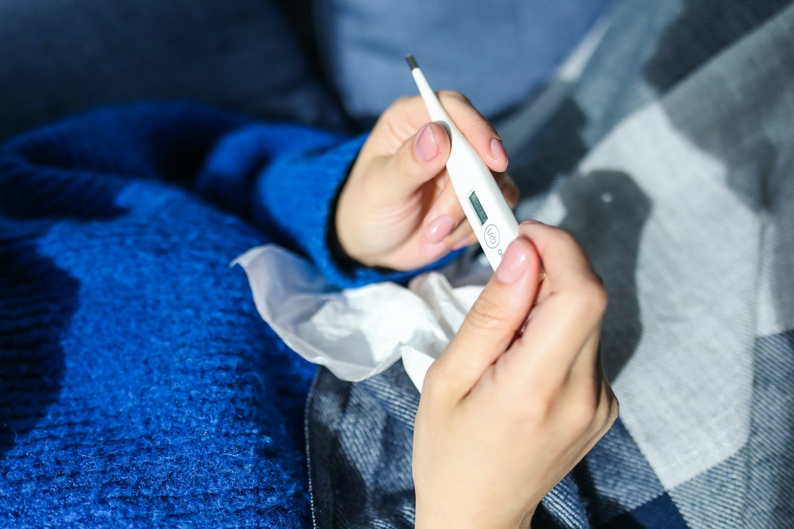

If the result is positive, other pupils and adults who have been in close contact will have to self-isolate for 14 days. The whole bubble may have to stay at home. Adults might say “the bubble has gone down” or “we have to shut the bubble down.”

These are rules that the government has made to make sure we are as safe as possible.

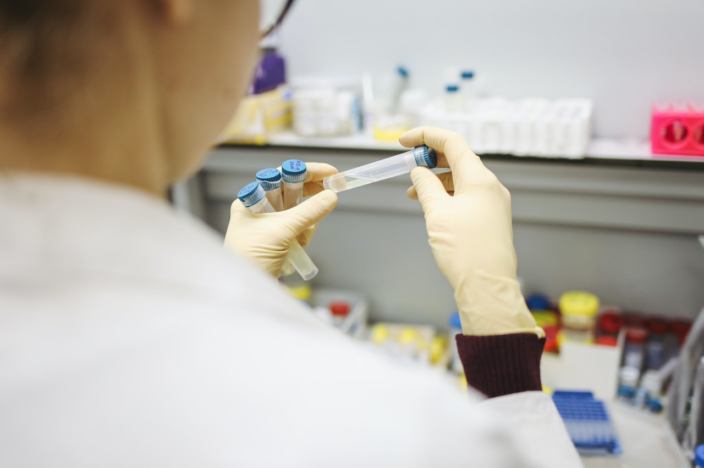

My teachers or family will explain anything to me that I don’t understand.

These rules are to keep me, my family and my friends safe.

This means that I won’t be able to go to school for up to 14 days at a time but I will still continue to do my learning at home.

It is important that I ask questions about anything I don’t understand.

I can talk to ………………………..

I can email ……………………………………..



Everyone is doing everything they can to stay safe from Covid-19.

That’s the smart thing to do.

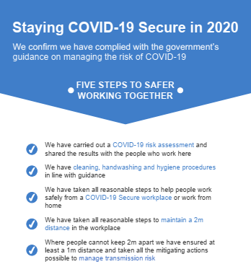

**Bubble** – a group of pupils that must not spend time with pupils outside their group.

**COVID19 test** – a swab is brushed along both sides of the throat and up both nostrils. The swab is then sent to a laboratory to be tested. People get their results by text message a few days later. It will be negative, positive or inconclusive.

**Self-isolation** – staying away from other people in case you have the virus.

**Social distancing** – keeping a safe space between myself and other people.

**Symptoms of Coronavirus** – a high temperature, a new and continuous dry cough and/or a loss or change to your sense of taste or smell.

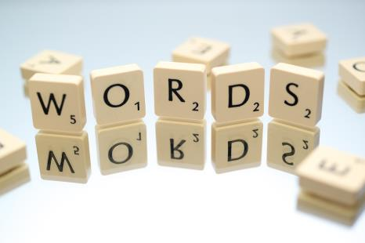

© Copyright applies to the whole document - Written and developed by City of Bradford MDC - Created 16.11.2020