I feel  happy | I can…  talk about why I feel happy | I can….  give a high five
 | I can…..  ask to go to a quiet place  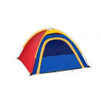 | I can….  ask for a fidget toy

I feel  wobbly  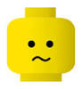 | I can…  talk about why I feel wobbly | I can….  get a drink
 | I can…..  ask to go to a quiet place  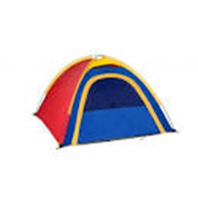 | I can….  ask for a fidget toy

I feel  angry | I can…  blow bubbles | I can….  ask to go to a quiet place
 | I can…..  ask for a fidget toy  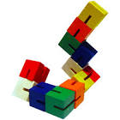 | I can….  talk about why I feel angry

