Using the Toilet at School
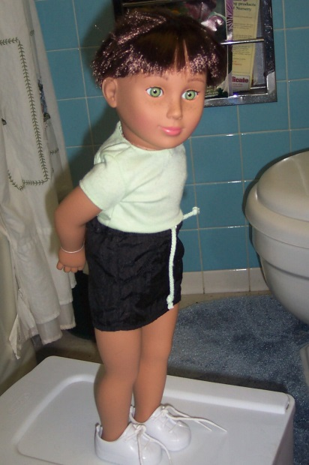
Sometimes I feel like I need to poo. I can do a poo in any toilet. I will try to do a poo in the toilet at school.
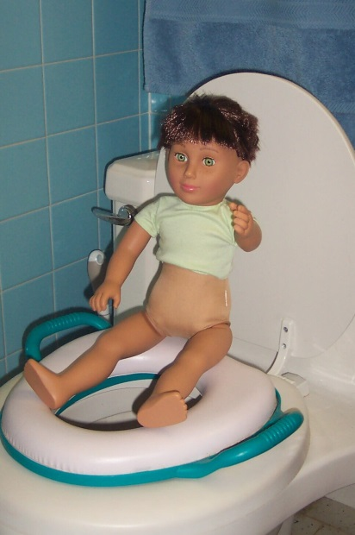
I go in to the toilet, pull my trousers and underpants down and sit on the toilet.
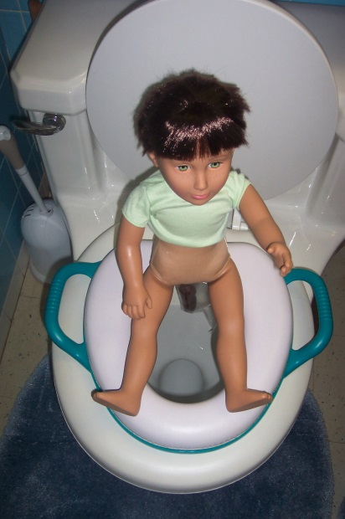
I might do a poo in the toilet. Then I can wear my gloves and use a wipe to wipe my bottom and throw the wipe down the toilet. This will make my bottom clean.
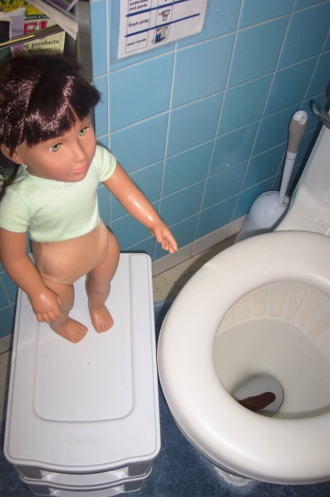
LOOK! There's my poo. Everybody’s poo goes in the toilet. This is OK.
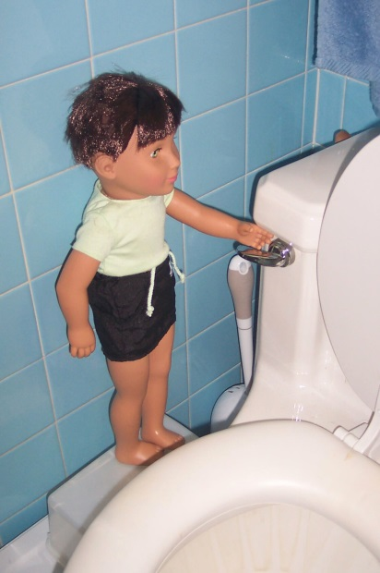
Next I flush the toilet, then wash and dry my hands.

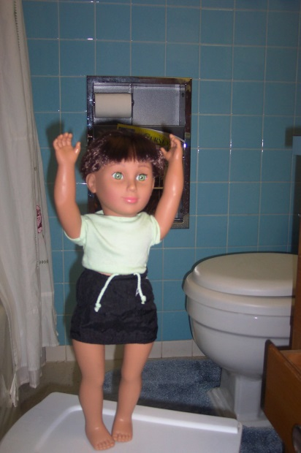
I can poo in the toilet at school and wipe my own bottom. I will feel happy. My teacher and my mummy and grandma will be happy. They might say ‘Well done William’.

If I poo on the toilet and wipe my bottom I will…..(insert reward –did we decide moving up the rainbow chart?)

