Communication and Interaction Team
Sensory

In this document:
Overview of Sensory Differences from the National Autistic Society | Link to further information | Click here to go the document link.
Making Sense of Sensory Behaviour | Booklet | Click here to go the document link.
Hand Washing Tips for People with Sensory Differences | Article | Click here to go the document link.
How to make slime | Recipe | Click here to go the document link.
How to make playdough | Recipe | Click here to go the document link.

Overview of Sensory Differences from the National Autistic Society
https://www.autism.org.uk/about/behaviour/sensory-world.aspx

Making Sense of Sensory Behaviour: A Practical Approach for Home and at School
https://www.falkirk.gov.uk/services/social-care/disabilities/docs/young-people/Making%20Sense%20of%20Sensory%20Behaviour.pdf?v=201507131117

A guide by Falkirk Council, looking at different sensory behaviours. Please note that not everything in this booklet will be relevant to your child/young person but can provide an overview of some possible strategies that could be used.

Hand Washing Tips for People with Sensory Differences
Taken from: https://sensoryintegration.org.uk/News [Accessed, 24.03.2020]

Hand Washing Tips for People With Sensory Difficulties

11 Mar 2020 18:04 | SIE News (Administrator)
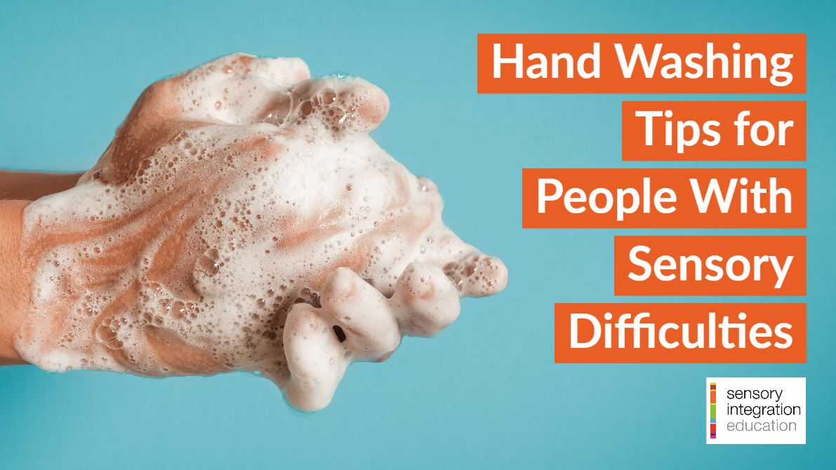
Hand washing is crucial in reducing the risk of contracting the Coronavirus (CORVID-19) but many people with sensory difficulties can experience distress or struggle with the experience of hand washing. We’ve collated some advice for encouraging and improving hand washing.
People with difficulties with sensory integration or sensory processing can experience aversion to the smells, images, sounds and the tactile sensations of hand washing; have problems with balance, tone or co-ordinating their hand movements; or not understand the step-by-step process of hand washing. The following suggestions should be tailored to specific sensory challenges or different abilities and age groups, as appropriate.

Explaining the Process of Hand Washing
Use an illustrated guide to the process of hand washing to explain each individual step and help the individual understand what to expect. The World Health Organisation has published this step-by step guide to cleaning hands to protect against infection but there are also simpler guides, or social stories, that may be more useful with younger children. There are many to choose from online (search “washing hands social story”) or you can make your own. Some individuals may have difficulty transferring skills learned from home to other environments: in this case it may be helpful to have a specific social story for both scenarios.

Washing for Long Enough
The NHS has provided this hand washing sequence using photos and a video which suggests washing hands for as long as it takes to sing the Happy Birthday song twice. Or you could count, use a timer or another song.
This Washy Washy Clean video demonstrates the correct technique accompanied by a song suitable for young children.

Prompting Hand Washing
You may need to prompt hand washing at all appropriate times, either verbally and/or by gesture (miming turning on a tap and rubbing hands together). It may help to have a handwashing poster or symbol on display by the sink. If required, you may need to physically help the individual to wash their hands. Remember to promptly give praise and acknowledgement each time.

Tackling Sensory Issues With Soap
Find out if the individual has a preference for liquid soap or bars of solid soap. Find out if a particular smell is preferred or if they prefer unscented soap. Some people find it easier to manage soap when it is inside a fabric pouch so they only touch the soap suds and not the soap itself. An automatic soap dispenser which doesn’t require you to pump the soap may be helpful. If you find a soap that is better tolerated, include it in your sensory kit when away from home.

Water Temperature
Assessing a safe water temperature may be difficult for some individuals and they will need assistance. Some people may find slightly warm water more tolerable than cold water.

Sink Height, Balance and Taps
Use a step to enable children to reach sinks easily. Consider using a chair or safe stool if they find it easier to sit down whilst washing their hands. You can fit handle extensions to some taps to make it easier to grasp and turn them.

Drying Hands and Noisy Hand Dryers
Some people can be very sensitive to the sound of electric hand dryers in echoing bathrooms. You could reassure the individual in advance that they don’t need to use the hand dryers, if this is the case, but emphasise the importance of still drying hands. Use paper towels instead (you may need to carry your own supply). When visiting public toilets to wash hands, you could try using ear plugs or ear defenders to limit the amount of distressing sounds.
When drying hands, some individuals prefer a slow, deep pressure with the towel rather than a light touch.

Antibacterial Hand Gel
If soap and water are really not an option or available, then use antibacterial hand gel. You may need to demonstrate how to use this and assist. Again, you may need to investigate whether scented or unscented ones, gel or spray ones are preferred.

Hand Lotion
Some individuals are distracted by the tactile sensation after they have washed their hands: investigate if this is eased by using a preferred hand lotion immediately afterwards.

Seek Specific Advice From Your Sensory Integration Trained Therapist
If your child has an SI therapist or SI trained occupational therapist, ask their advice on how to accommodate your child’s specific sensory needs when hand washing.

How to make slime
Taken from: https://www.bbcgoodfood.com/howto/guide/how-make-slime [Accessed: 23.03.2020]

There are lots of different recipes online for how to make slime. We’ve chosen this one but feel free to search online and find a recipe that uses ingredients that you have to hand.
(Please note that this recipe is not edible so please supervise closely as necessary.)

Slime recipe
This method makes a ball of flexible slime close to silly putty in texture. It stays clean in your hands, making it a good choice for little kids.
Makes 1 small ball
Takes 10 minutes
- 100ml PVA white glue (children’s craft glue or CE marked glue)
- ½ tsp bicarbonate of soda
- gel food colouring
- 1 tsp contact lens cleaning solution
- glitter (optional)

1. Squeeze the glue into a mixing bowl (look for a bottle in a 100ml size if possible so you won’t have to measure it out). Add the bicarbonate of soda and mix well.
2. Add a drop or two of your chosen gel food colouring. Less colouring gives a pastel colour; the more you add, the brighter the colour. Mix until well incorporated.
3. Add the contact lens solution and mix. The slime will begin to form, going stringy before coming away clean from the bowl into a ball.
4. Once it has formed, take it out and knead it with your hands. It will be sticky at first but after about 30 seconds you’ll have a smooth and pliable ball. Add glitter at this point, if desired, and work in with your hands. Store in a pot with a lid.

Please follow link above to see full instructions and extra advice.

How to make Playdough
Taken from: https://www.bbcgoodfood.com/howto/guide/playdough-recipe [Accessed: 23.03.2020]

There are lots of different recipes online for how to make playdough. We’ve chosen this one but feel free to search online and find a recipe that uses ingredients that you have to hand.

You will need
- 8 tbsp plain flour
- 2 tbsp table salt
- 60ml warm water
- food colouring
- 1 tbsp vegetable oil
Method
1. Mix the flour and salt in a large bowl. In a separate bowl mix together the water, a few drops of food colouring and the oil.
2. Pour the coloured water into the flour mix and bring together with a spoon.
3. Dust a work surface with a little flour and turn out the dough. Knead together for a few minutes to form a smooth, pliable dough. If you want a more intense colour you can work in a few extra drops of food colouring.
4. Store in a plastic sandwich bag (squeeze out the air) in the fridge to keep it fresh.

Please follow link above to see full instructions and extra advice.

